Time and Temperature Game Board
Master 49a

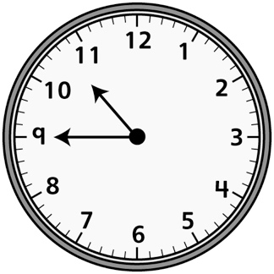 | Monday | Month after August | 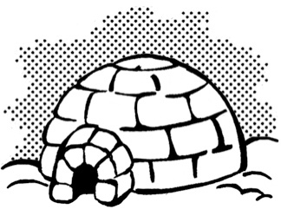
January |  | Day after Tuesday | 8:30
Saturday | Third month | 2:45
2:15 |  | 1st day of the week | April
 | 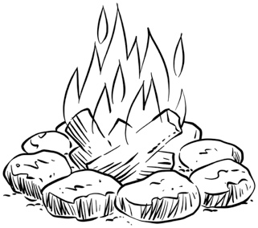 | 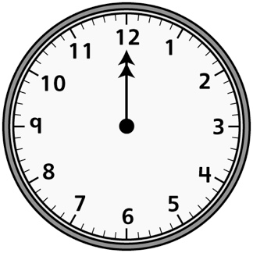 | Thursday

Time and Temperature Game Board
Master 49b
(for Accommodations)

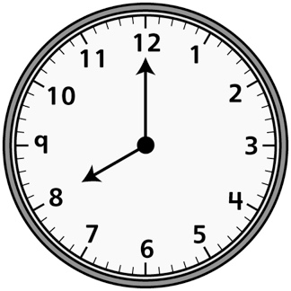 | Monday | 9th month
 |  | January | 8:30
Day after Friday | March | 2:30 | 10 o’clock

Time and Temperature Game Board
(for Combined Grades Extension)
Master 49c

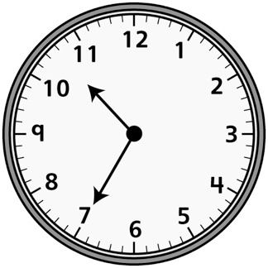 | Monday | Two months after July | 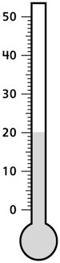
Water starts to freeze  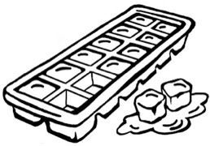 | Month after December | Three days after Sunday | 8:05
Saturday | Three months before July | 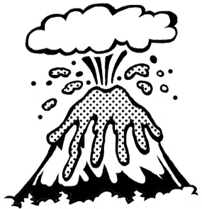 | Water starts  to boil  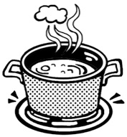
2:55 | March | 1st day of the week | July
June | Warm | 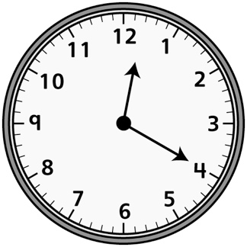 | Thursday

