Time and Temperature Measurement Behaviours/Strategies
- Student chooses a card, but  cannot read the days of the week  or months of the year on the  calendar. | - Student chooses a clue card, but  struggles to say the number name sequence starting with 1 and counting forward.  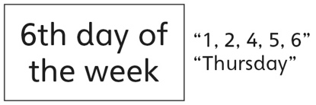 | - Student reads the days/months on the calendar, but struggles with the use of ordinal numbers in context.  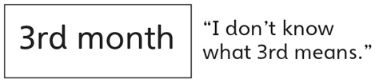 | - Student understands the use of  ordinal numbers in context, but  relies on a calendar to match  cards.
Observations/Documentation
- Student explores measurement of non-visible attributes (time), but struggles to skip-count by 5s.  “5, 10, 20, 30” | - Student explores measurement  of non-visible attributes (time),  but mixes up the hour and minute  hands on the analogue clock.  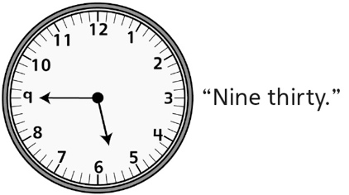 | - Student explores measurement of non-visible attributes (temperature), but does not know how much of a thermometer should be coloured. | - Student understands the relationship of units of time  (e.g., days and weeks, months and years), and successfully explores measurement of non-visible attributes (time, temperature).
Observations/Documentation

Big Idea |  |  |  |  | Indicators from Learning Progression
Curriculum Expectations addressed

Student Names
Student can read and identify the days of the week.
(Activities 13, 18)
Student can use ordinal numbers to identify a day in the month/month in the year.
(Activity 13, 14, 18)
Student understands the relationship of days and weeks.
(Activities 13, 18)
Student understands the relationship of months and years.
(Activities 14, 18)
Student can say the months of the year in order.
(Activities 14, 18)
Student can use a pendulum to measure time intervals.
(Activity 15)
Student can tell and write time to the quarter-hour on analogue and digital clocks.
(Activity 16, 18)
Student can relate a temperature to the level of liquid in a thermometer.
(Activities 17, 18)

Name: _______________________

 | Not Observed | Sometimes | Consistently
Reads and identifies the days of the week.
(Activities 13, 18)
Uses ordinal numbers to identify a day in the month/month in the year.
(Activity 13, 14, 18)
Understands the relationship of days and weeks.
(Activities 13, 18)
Understands the relationship of months and years.
(Activities 14, 18)
Says the months of the year in order.
(Activities 14, 18)
Uses a pendulum to measure time intervals.
(Activity 15)
Tells and writes time to the quarter-hour on analogue and digital clocks.
(Activity 16, 18)
Relates a temperature to the level of liquid in a thermometer.
(Activities 17, 18)

Strengths:

Next Steps:

