**Hundred Charts (101–200)**

**Master 3a**

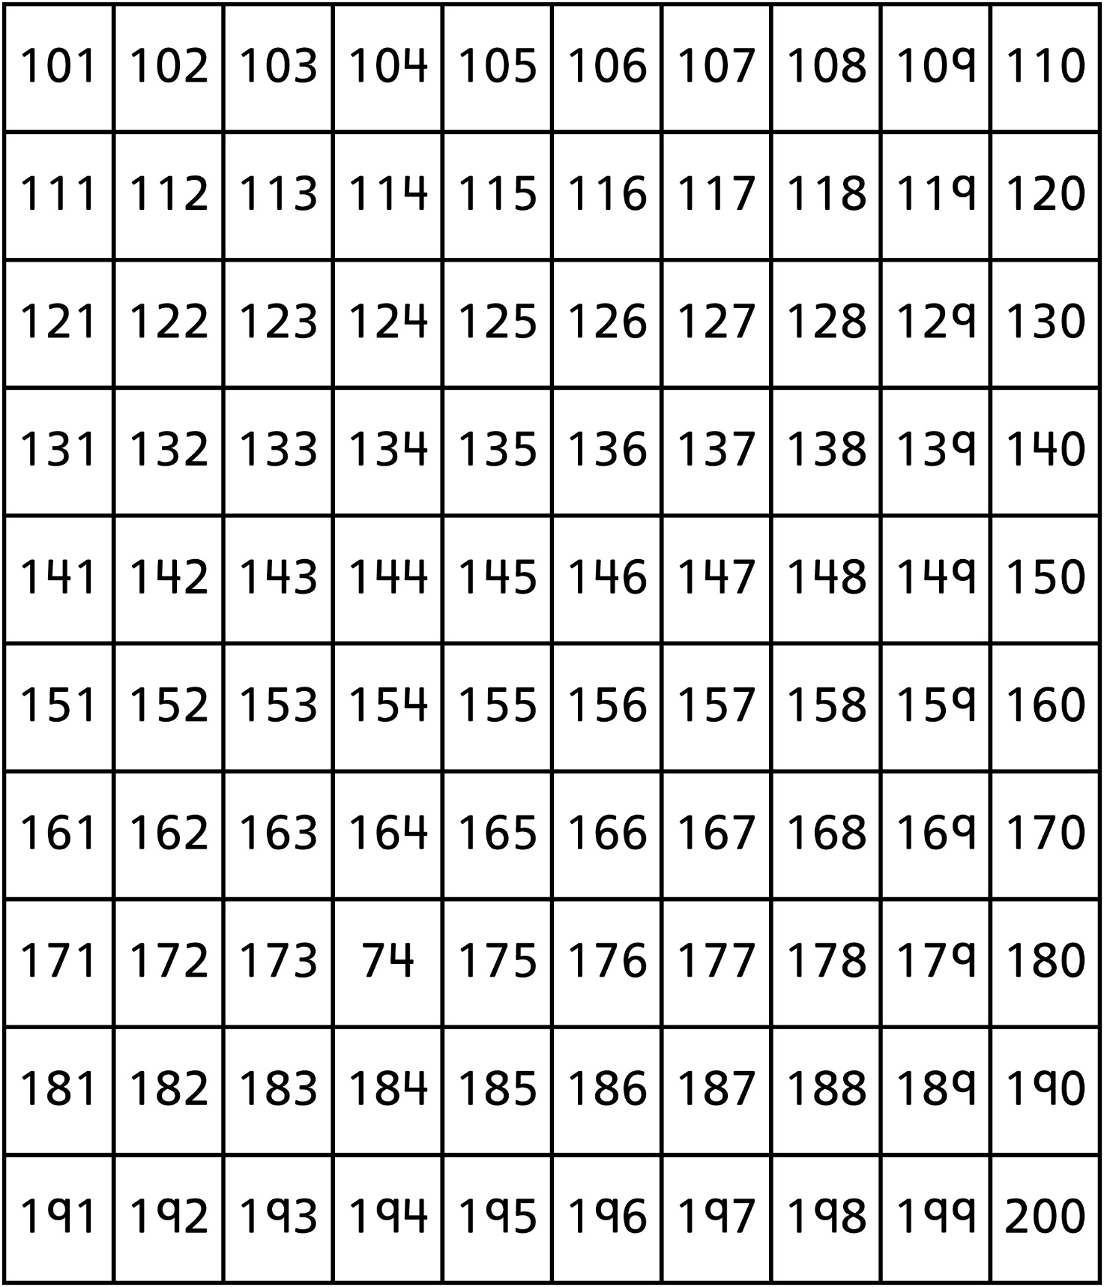

**Hundred Charts (201–300)**

**Master 3b**

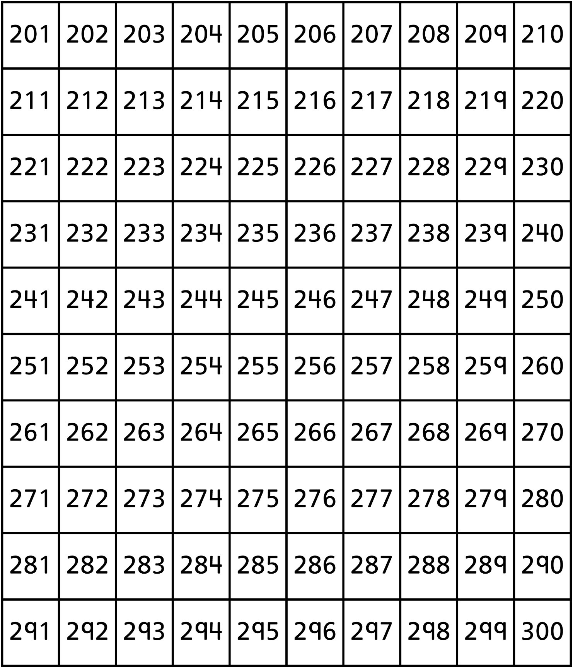

**Hundred Charts (301–400)**

**Master 3c**

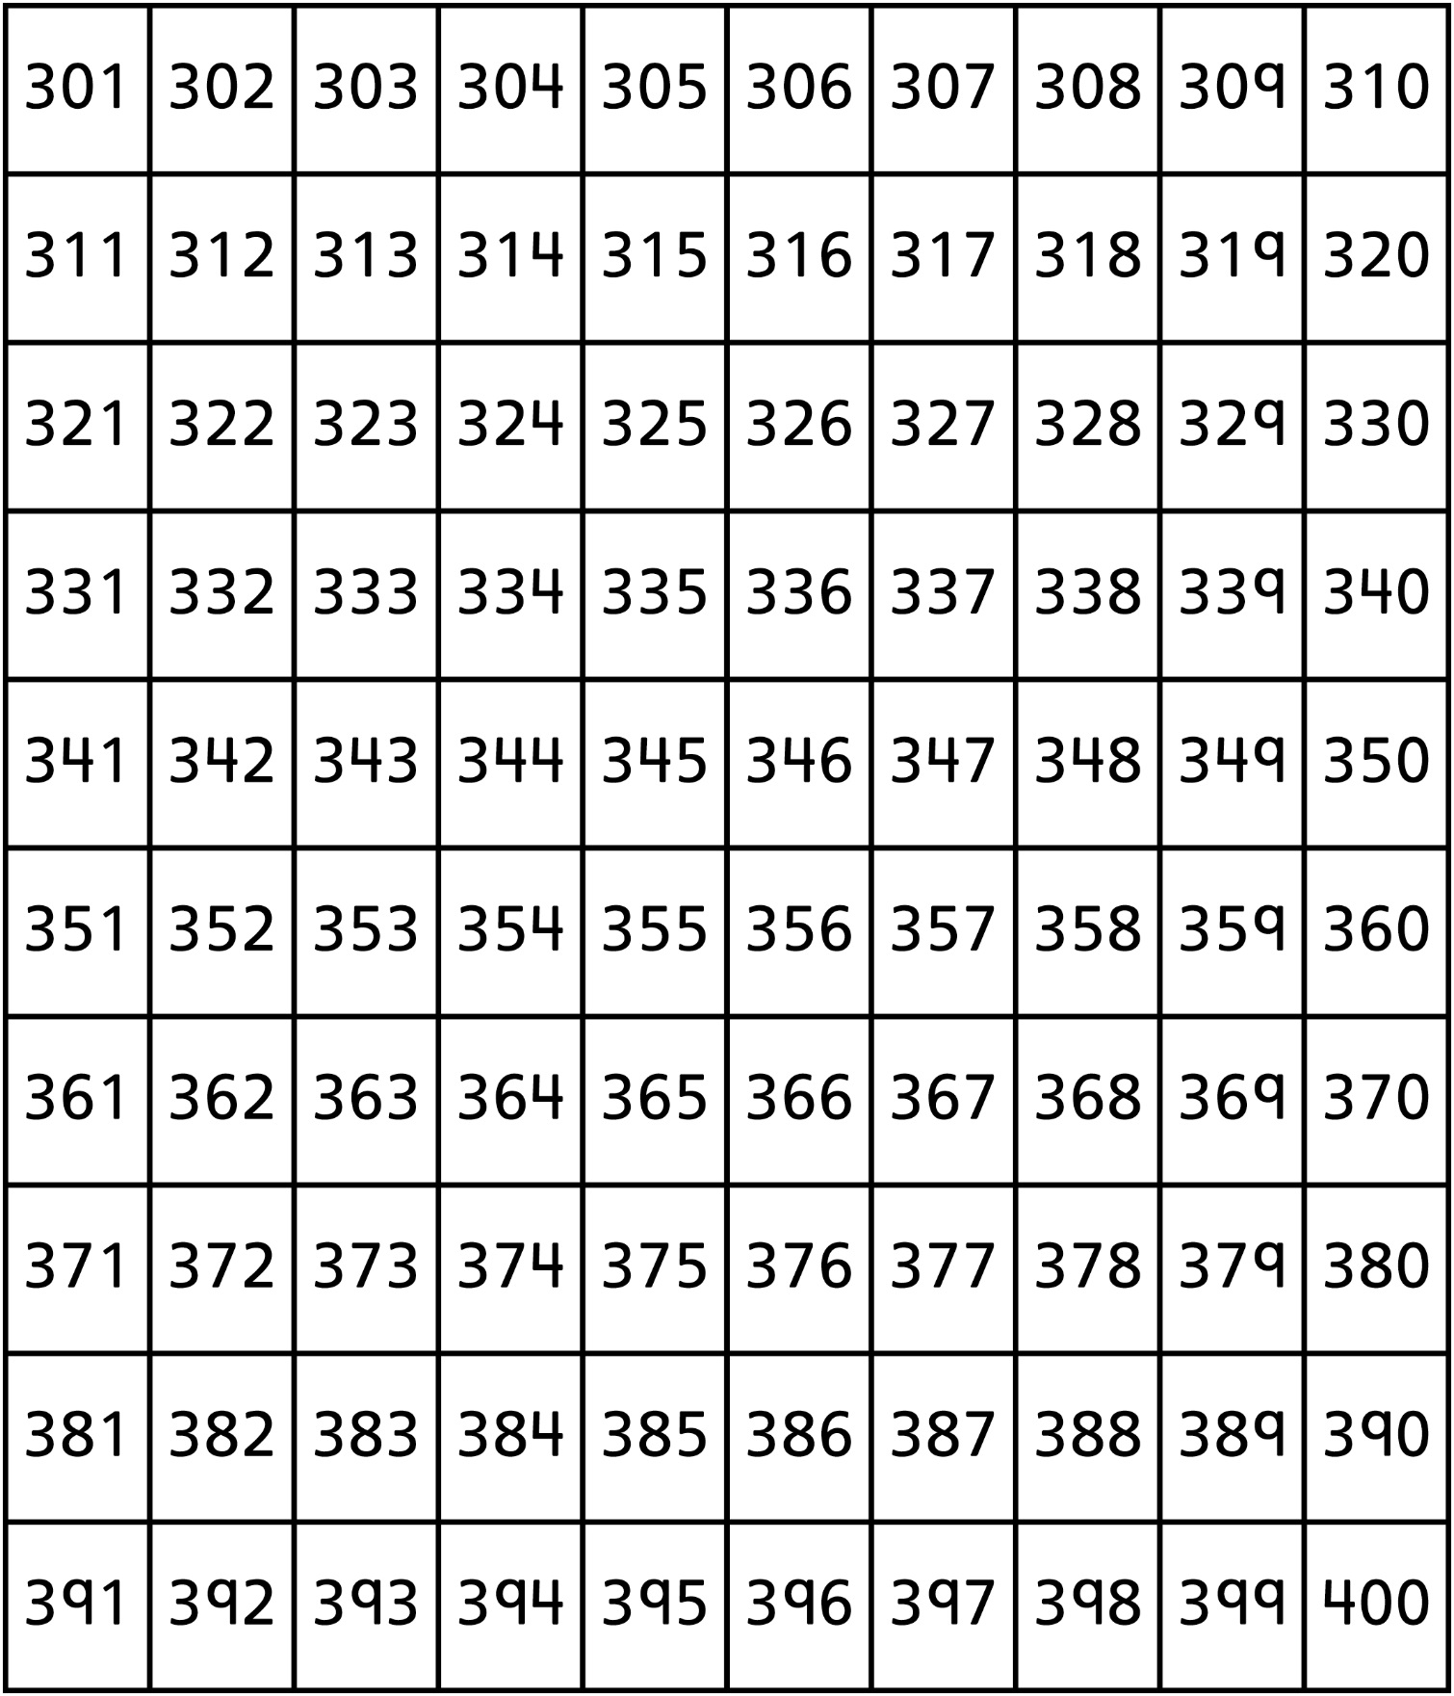

**Hundred Charts (401–500)**

**Master 3d**

