Skip-Counting Forward Behaviours/Strategies
- Student knows the number to skip-count by,  but struggles to thread the yarn through the  holes (lacks fine-motor skills). | 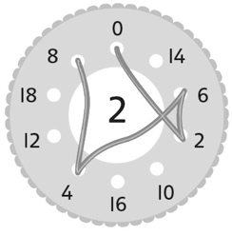  - Student threads the yarn through the holes, but mixes up the numbers in the skip-counting  sequence when skip-counting by factors of 10. | - Student fluently skip-counts by 2s and 10s, but has difficulty skip-counting by 5s.  “I find it hard to count by 5s.”
Observations/Documentation
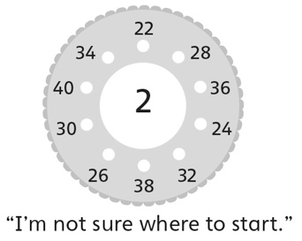  - Student skip-counts by factors of 10 (e.g., 2, 5, 10), but struggles when the start number is a multiple of 2, 5,  or 10. | - Student fluently skip-counts by factors of 10,  but struggles to notice and explain patterns in  the skip-counting numbers.  “I don’t see patterns in the numbers.” | - Student fluently skip-counts by factors of 10  and notices and explains patterns in the skip-counting numbers.
Observations/Documentation

