Solving Equal-Sharing Problems Behaviours/Strategies
- Student solves equal-sharing  problem, but miscounts and does  not start with the correct number  of items. | - Student solves equal-sharing  problem, but does not share the  items equally. | - Student solves equal-sharing  problem, but does not share all of  the items. | - Student solves equal-sharing  problem, but does not share the  items among the correct number  of children.
Observations/Documentation
- Student successfully solves equal-sharing problem by sharing  items one at a time, but is only  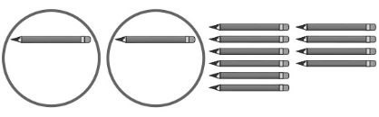  comfortable sharing between  2 children. | - Student successfully solves equal-sharing problem by sharing items one at a time among any number of children. | - Student successfully solves equal-sharing problem by sharing more than one item at a time but, in his or her own problem, uses a number that cannot be shared equally. | - Student successfully solves equal-sharing problem and, in her or his own problem, uses a number that can be shared equally.  “Betty has 36 coins. She wants to share them equally among  6 children.”
Observations/Documentation

