Using Repeated Addition to Solve Problems Behaviours/Strategies
- Student chooses a problem set, but miscounts  or mixes up numbers in the counting sequence.  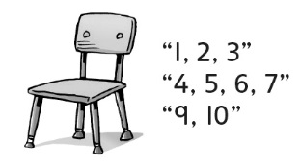 | - Student uses repeated addition of groups to  solve problems, but loses track of the count  when counting or skip-counting.  “I’m not sure if I counted the wheels on  3 bicycles or 4 bicycles.” | - Student uses repeated addition of groups to  solve problems, but counts all the items by 1s.  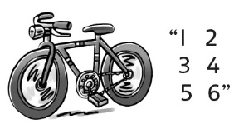
Observations/Documentation
- Student uses repeated addition of groups and  skip-counts to solve problems, but struggles to  write or match repeated addition sentences.  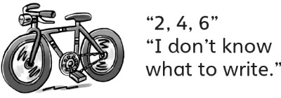 | - Student uses repeated addition of groups, skip-counts to solve problems, and writes/matches repeated addition sentences.  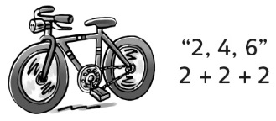 | - Student uses repeated addition of groups to  solve problems (using what is known from  previous problems) and writes/matches  repeated addition sentences.  “There are 8 legs on 2 chairs, so there are  8 and 4 more legs, or 12 legs, on 3 chairs.”
Observations/Documentation

