Skip-Counting from Any Number Behaviours/Strategies
- Student uses correct start number, but reverts  to the skip-counting from 0 sequence when  skip-counting by factors of 10 (i.e., 2, 10) from  any given number.  “3, 10, 20, 30, …” | - Student uses correct start number, but mixes  up the numbers or omits numbers in the  skip-counting sequence when skip-counting by factors of 10 from any given number.  “3, 13, 33, 43, …” | - Student skip-counts by factors of 10 from any  given number and uses fingers or the hundred  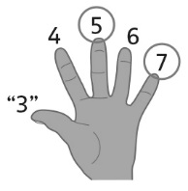  chart to help.
Observations/Documentation
- Student skip-counts by factors of 10 from any  given number, but loses track of number of  times counted.  “3, 5, 7, 9. Can I stop yet?” | - Student skip-counts by factors of 10 from any  given number, but struggles to identify errors  or missing numbers in partner’s skip-counting  sequences.  “5, 7, 9, 10, 12, …”  “I’m not sure if she is correct.” | - Student fluently skip-counts by factors of 10  (i.e., 2, 10) from any given number.  “3, 5, 7, 9, 11, …”  “4, 14, 24, 34, 44, 54, …”
Observations/Documentation

