**Money Cutouts**

**Master 115a**

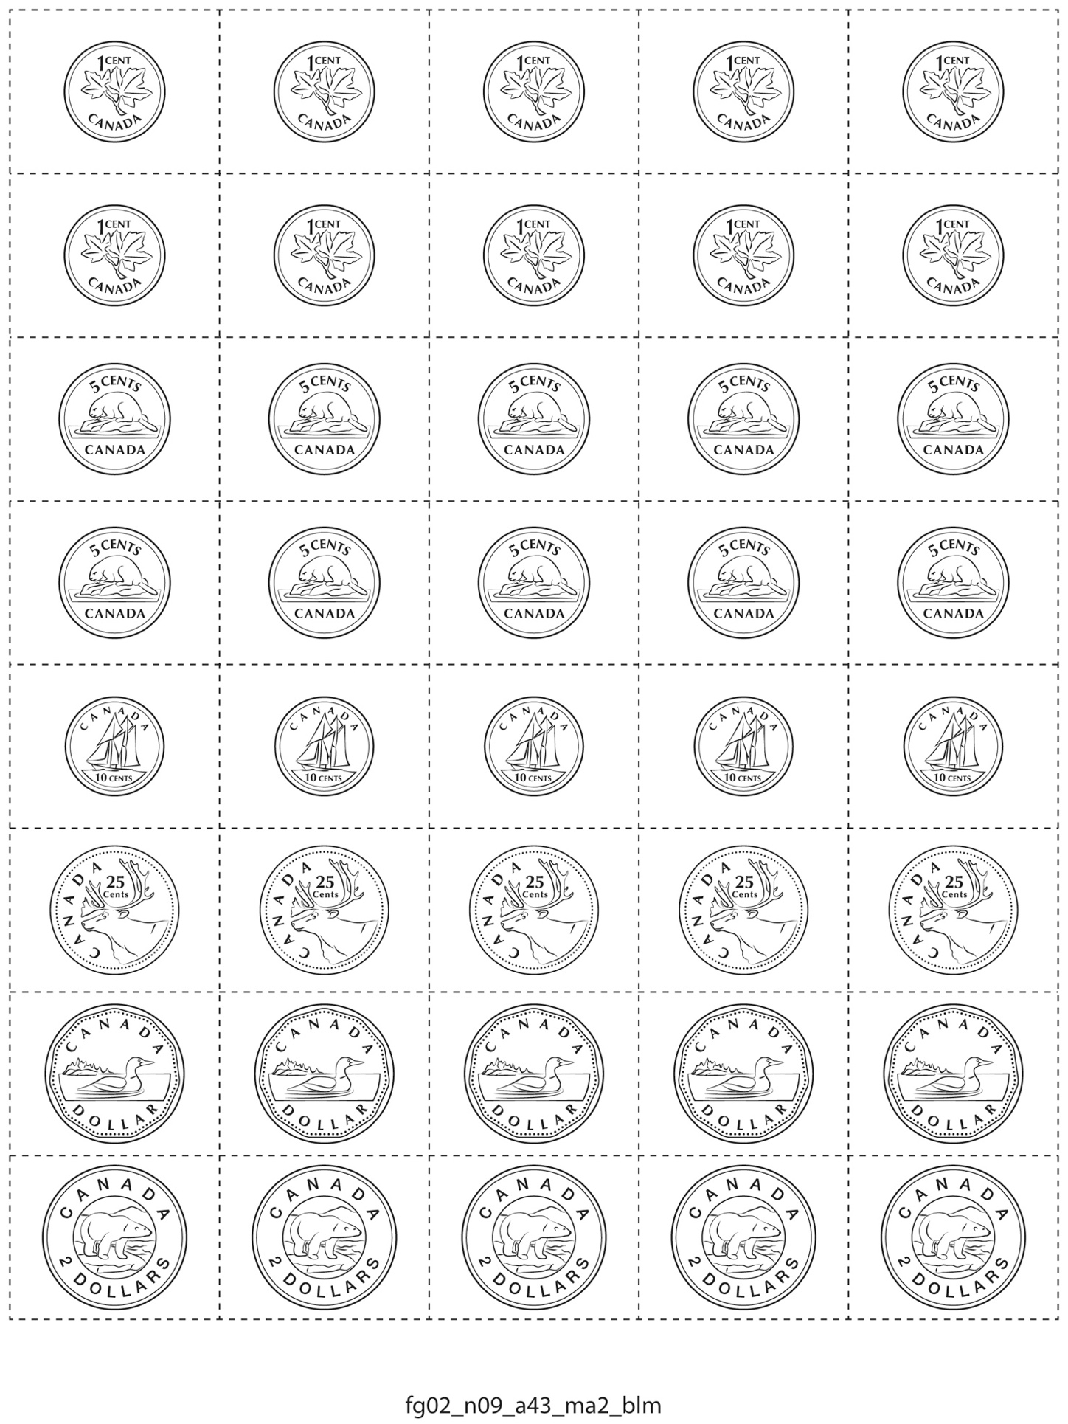

**Money Cutouts**

**Master 115b**

