Skip-Counting Backward Game Cards
Master 12a

(Part 1)
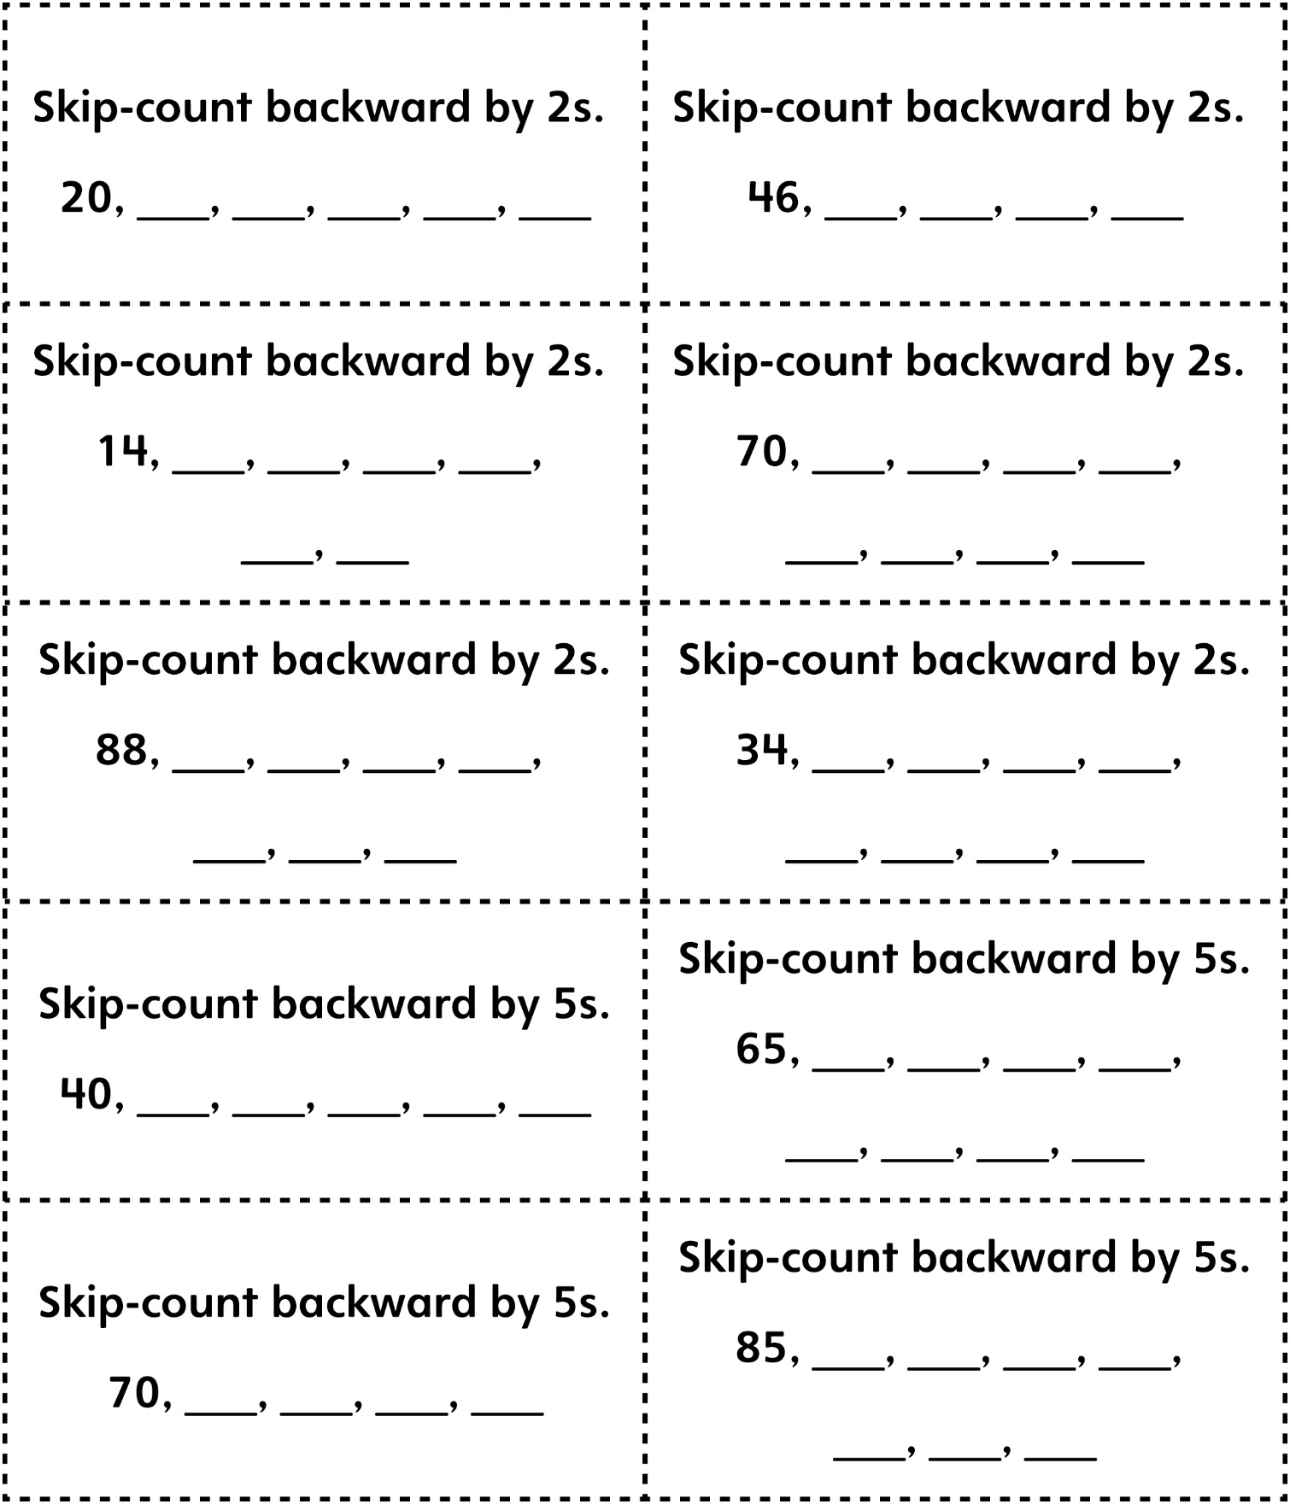

Skip-Counting Backward Game Cards
Master 12a

(Part 2)

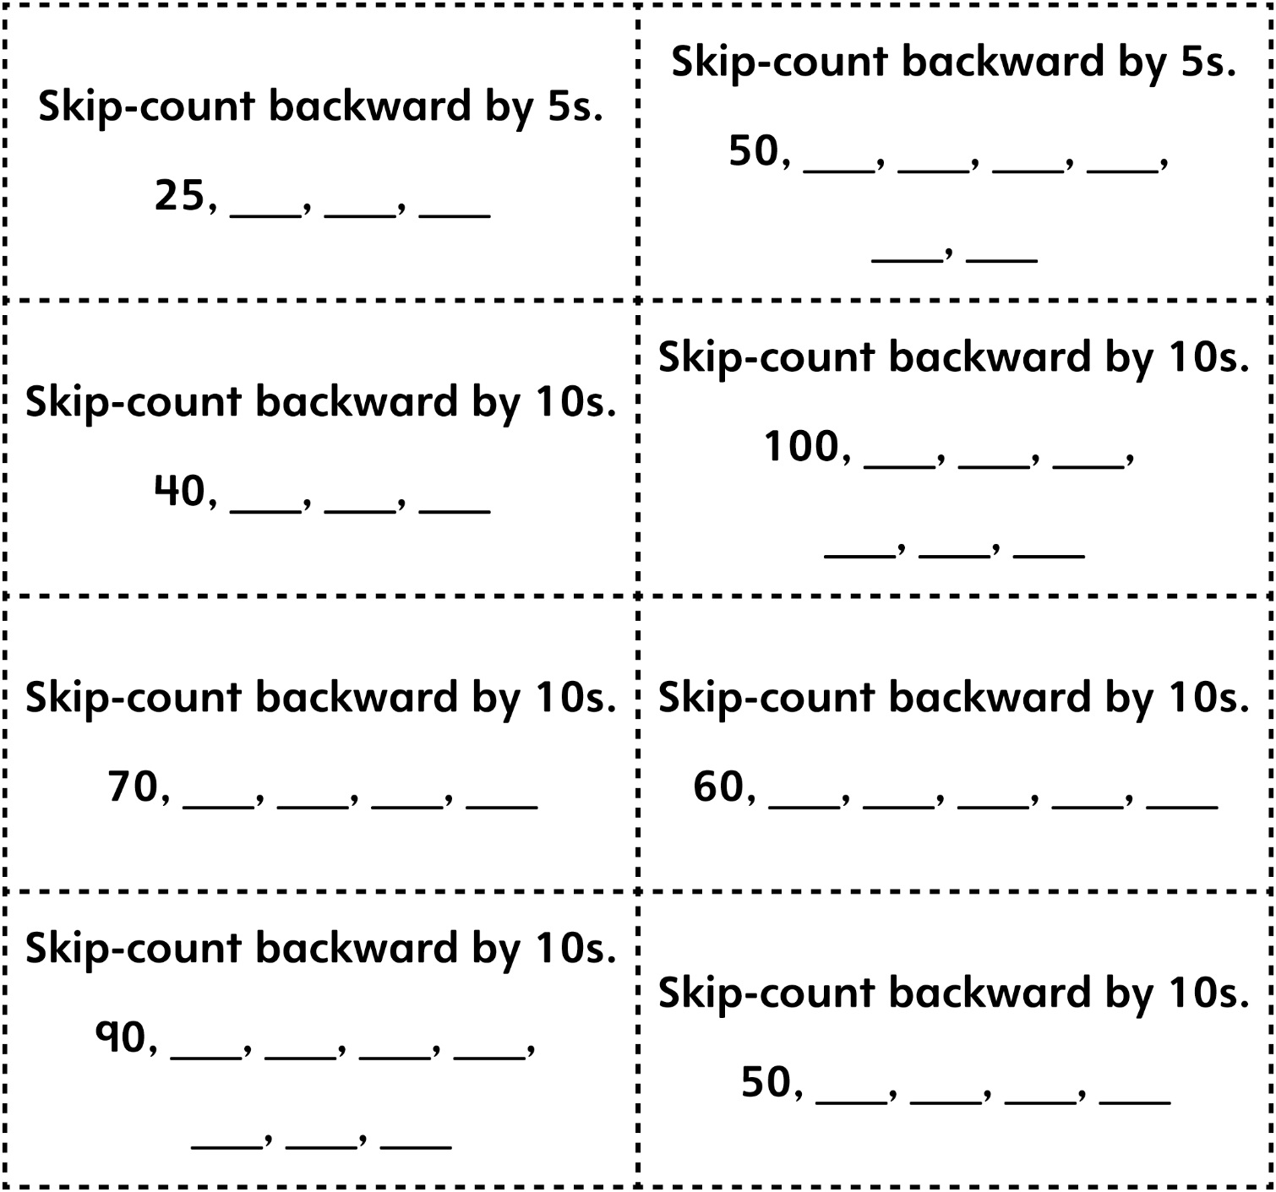

Skip-Counting Backward Game Cards (Extension) (Part 1)
Master 12b

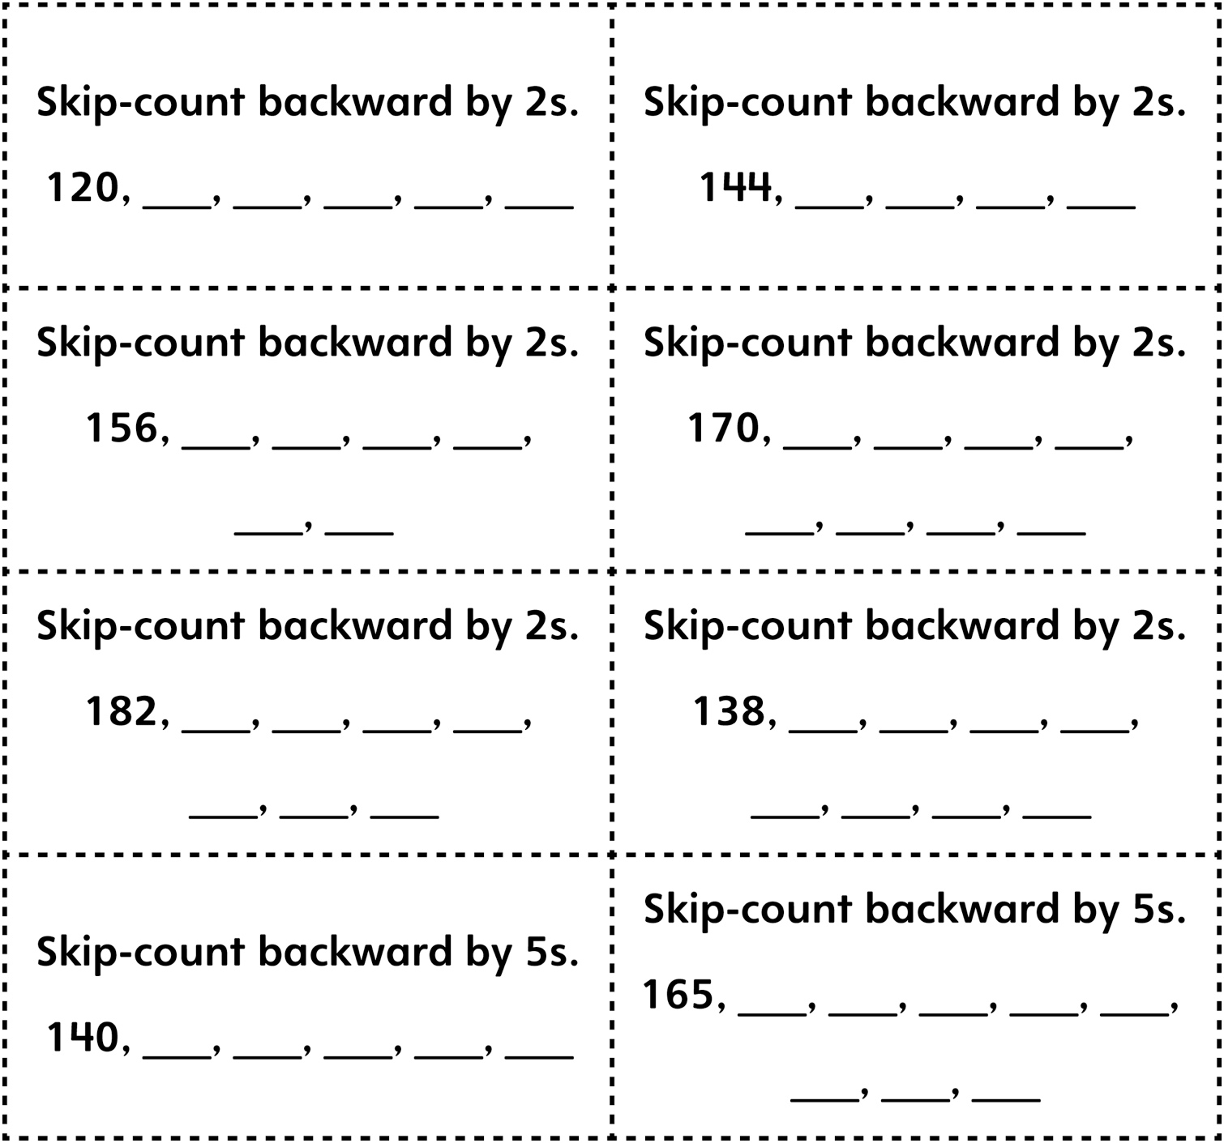

Skip-Counting Backward Game Cards (Extension) (Part 2)
Master 12b

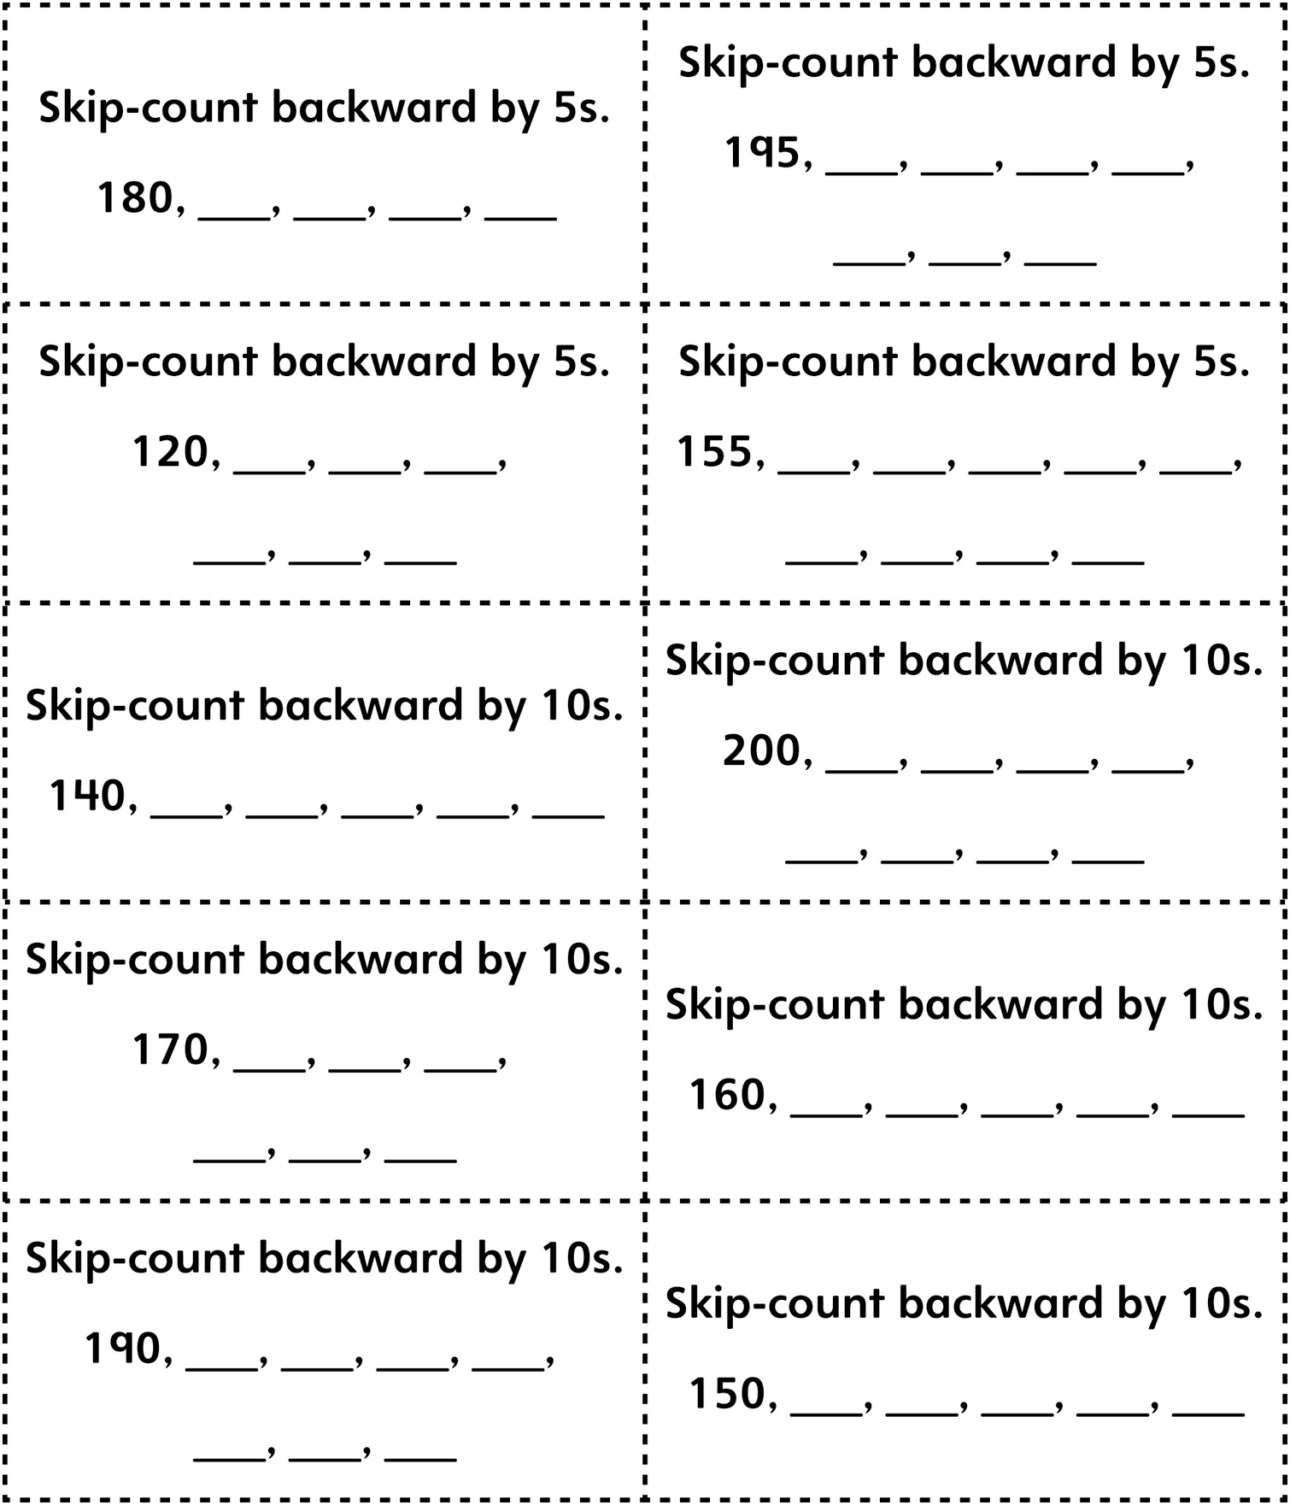
Skip-Counting Backward Game Cards (Combined Grades) (Part 1)
Master 12c

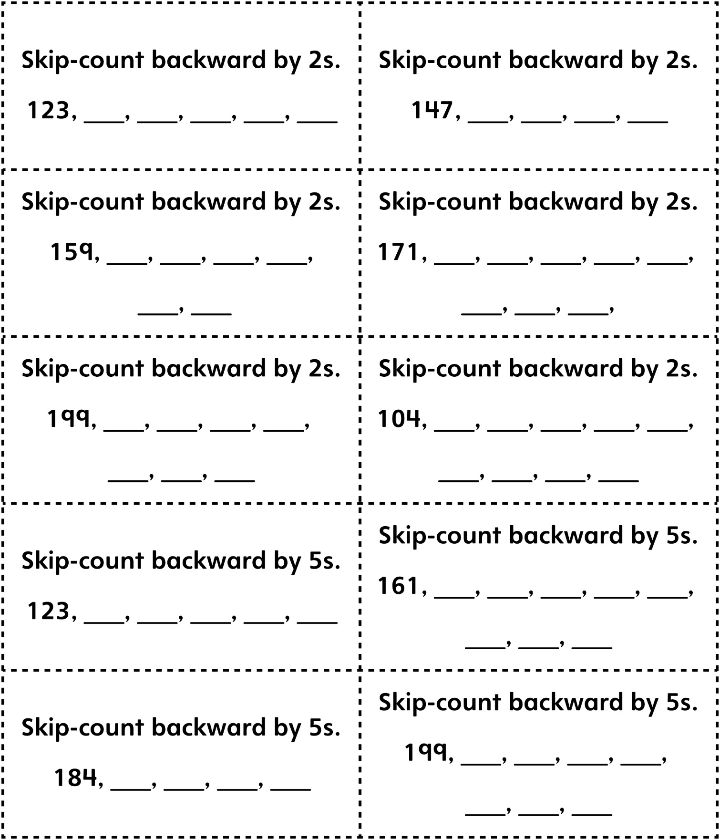
Skip-Counting Backward Game Cards (Combined Grades) (Part 2)
Master 12c

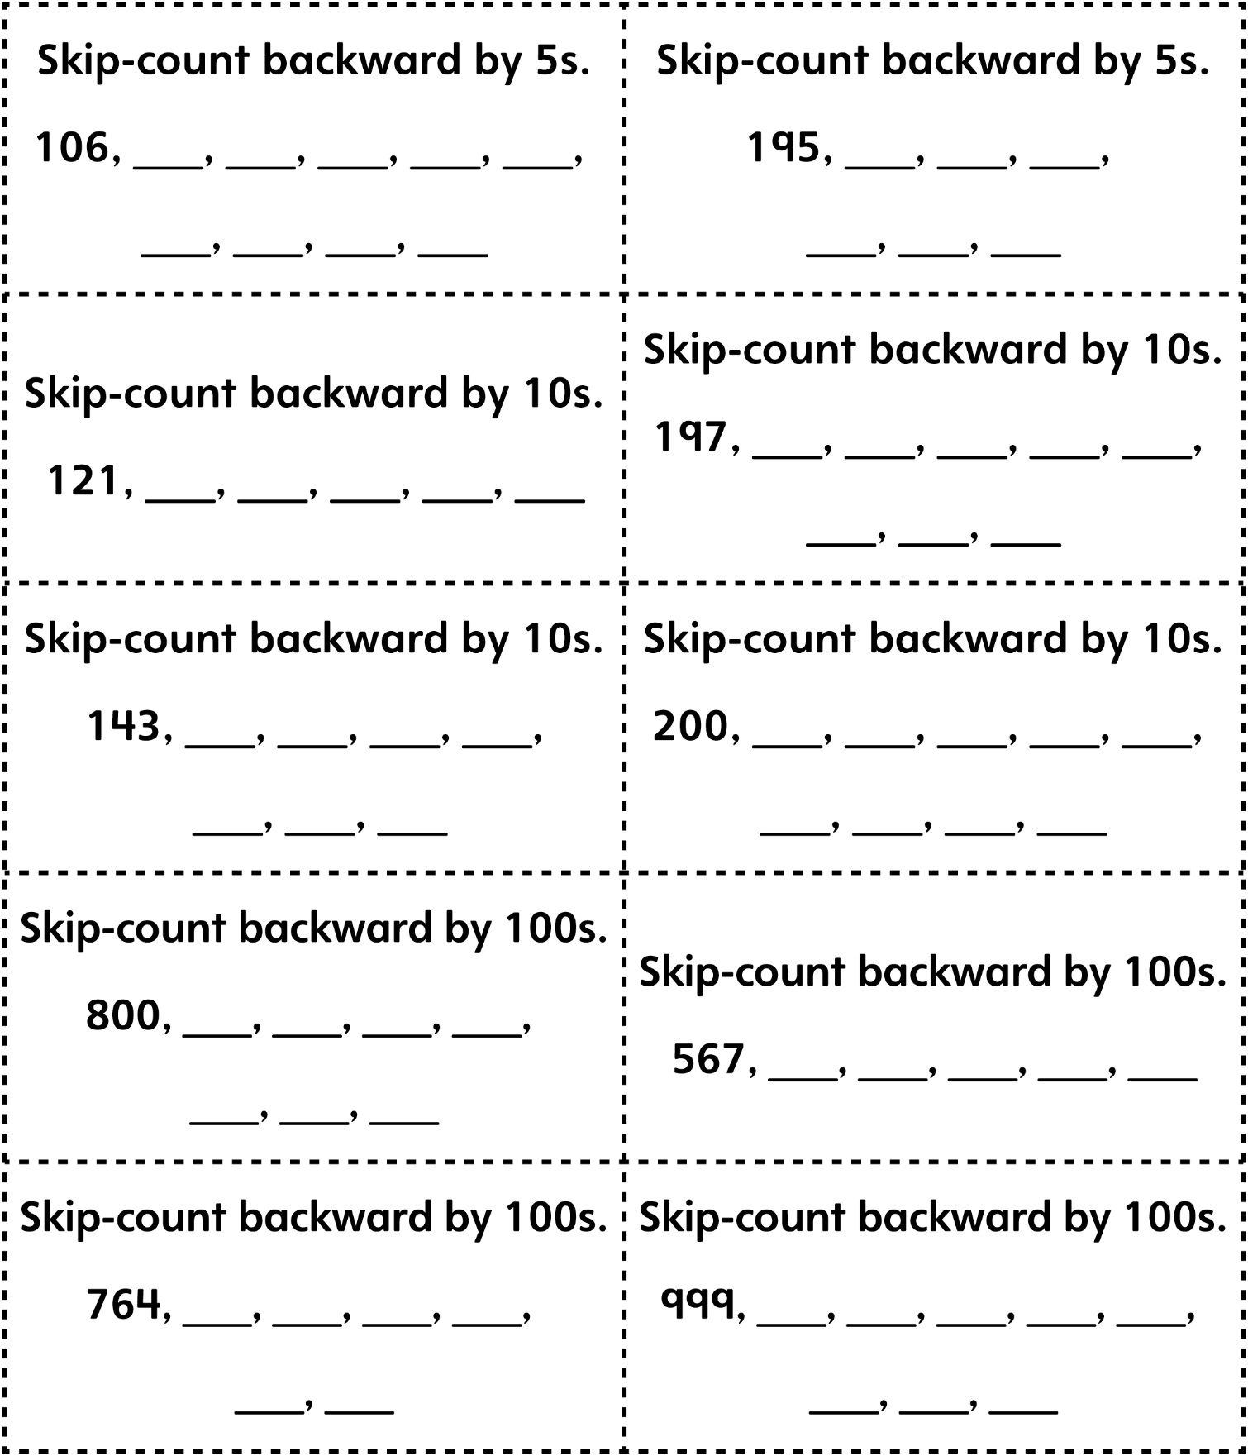
Skip-Counting Backward Game Cards (Blank Cards)
Master 12d

