Making a Savings Plan Behaviours/Strategies
- Student chooses an item to save  for, but cannot make a savings plan as he or she does not associate the cost of an item to a savings goal.  “I want the small puppet that is 20¢.  What is my goal?” | - Student chooses a job, but struggles to make a savings plan, as job will not allow savings goal to be met.  Item: Toy Car, 100¢  Job: Fill Water Bowl, 5¢ | 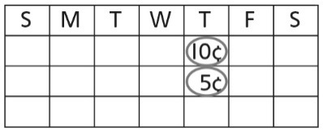  - Student makes a savings plan, but circles random dates, places wrong coin on calendar, or does not place same amount on each date. | - Student successfully makes a  savings plan that will allow a  savings goal to be reached.  Item: Toy Car, 100¢  Job: Get Mail, 25¢
Observations/Documentation
Adding, Subtracting, and Comparing Money Amounts Behaviours/Strategies
- Student gathers coins, but cannot add quantities to 100 to determine total savings.  “How do I find how much  was saved?” | - Student adds quantities to 100,  but struggles to compare and  order quantities to decide if goal  was met.  “How do I know if the goal  was met?” | - Student compares and orders  quantities, but struggles to  subtract quantities, to find how  much more needs to be saved.  “I need more but I don’t know  how much more.” | - Student successfully adds,  subtracts, and compares and  orders quantities to 100.  Item: 25¢  Savings: 20¢  Need to earn 5¢ more.
Observations/Documentation

