Counting On and Back Game Cards
Master 14a

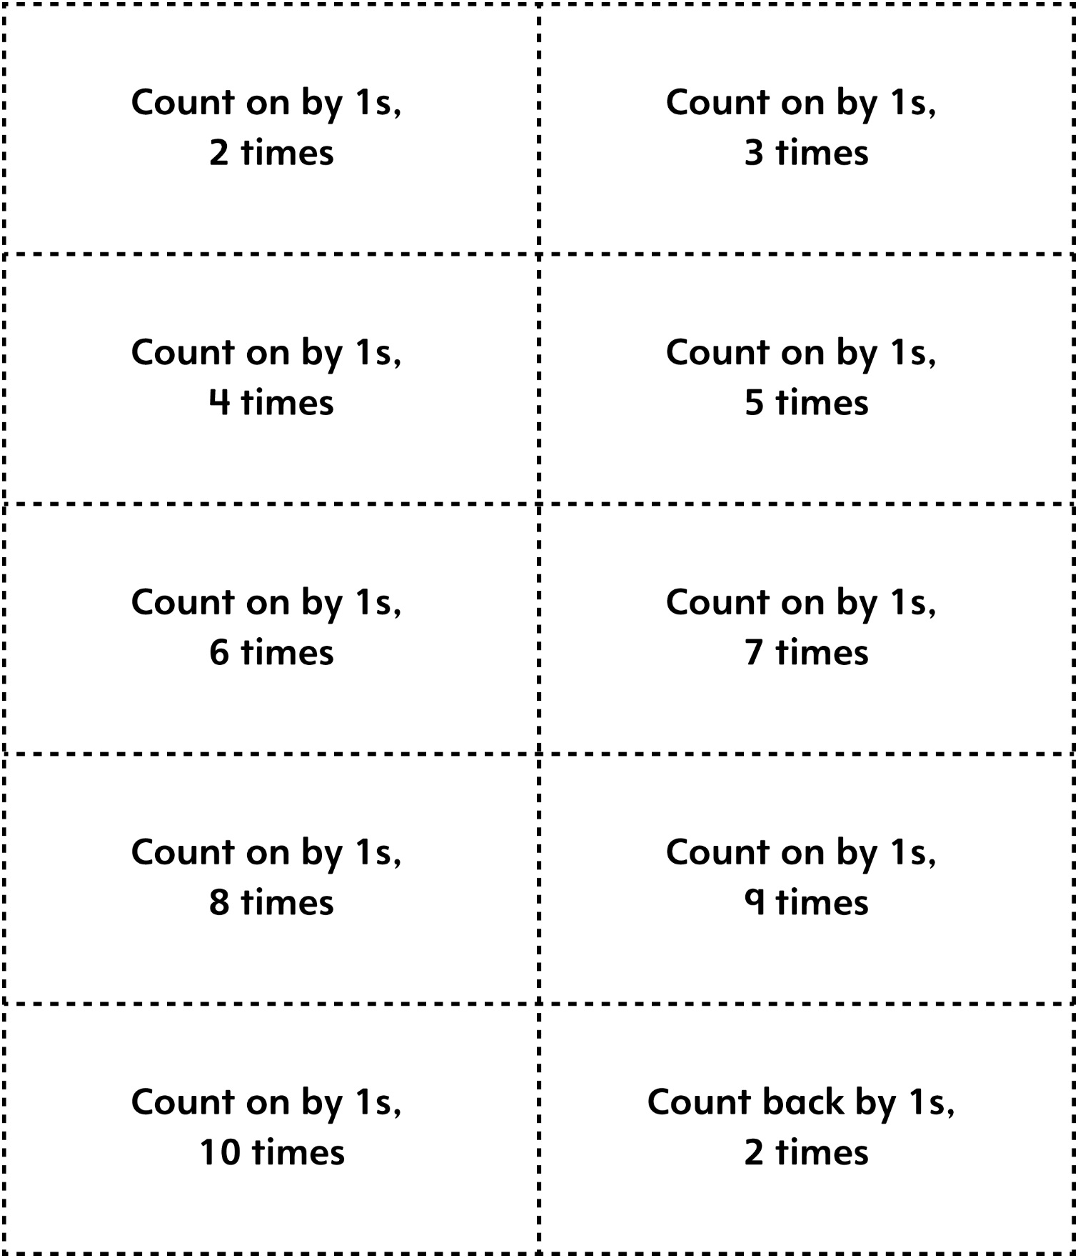

Counting On and Back Game Cards
Master 14b

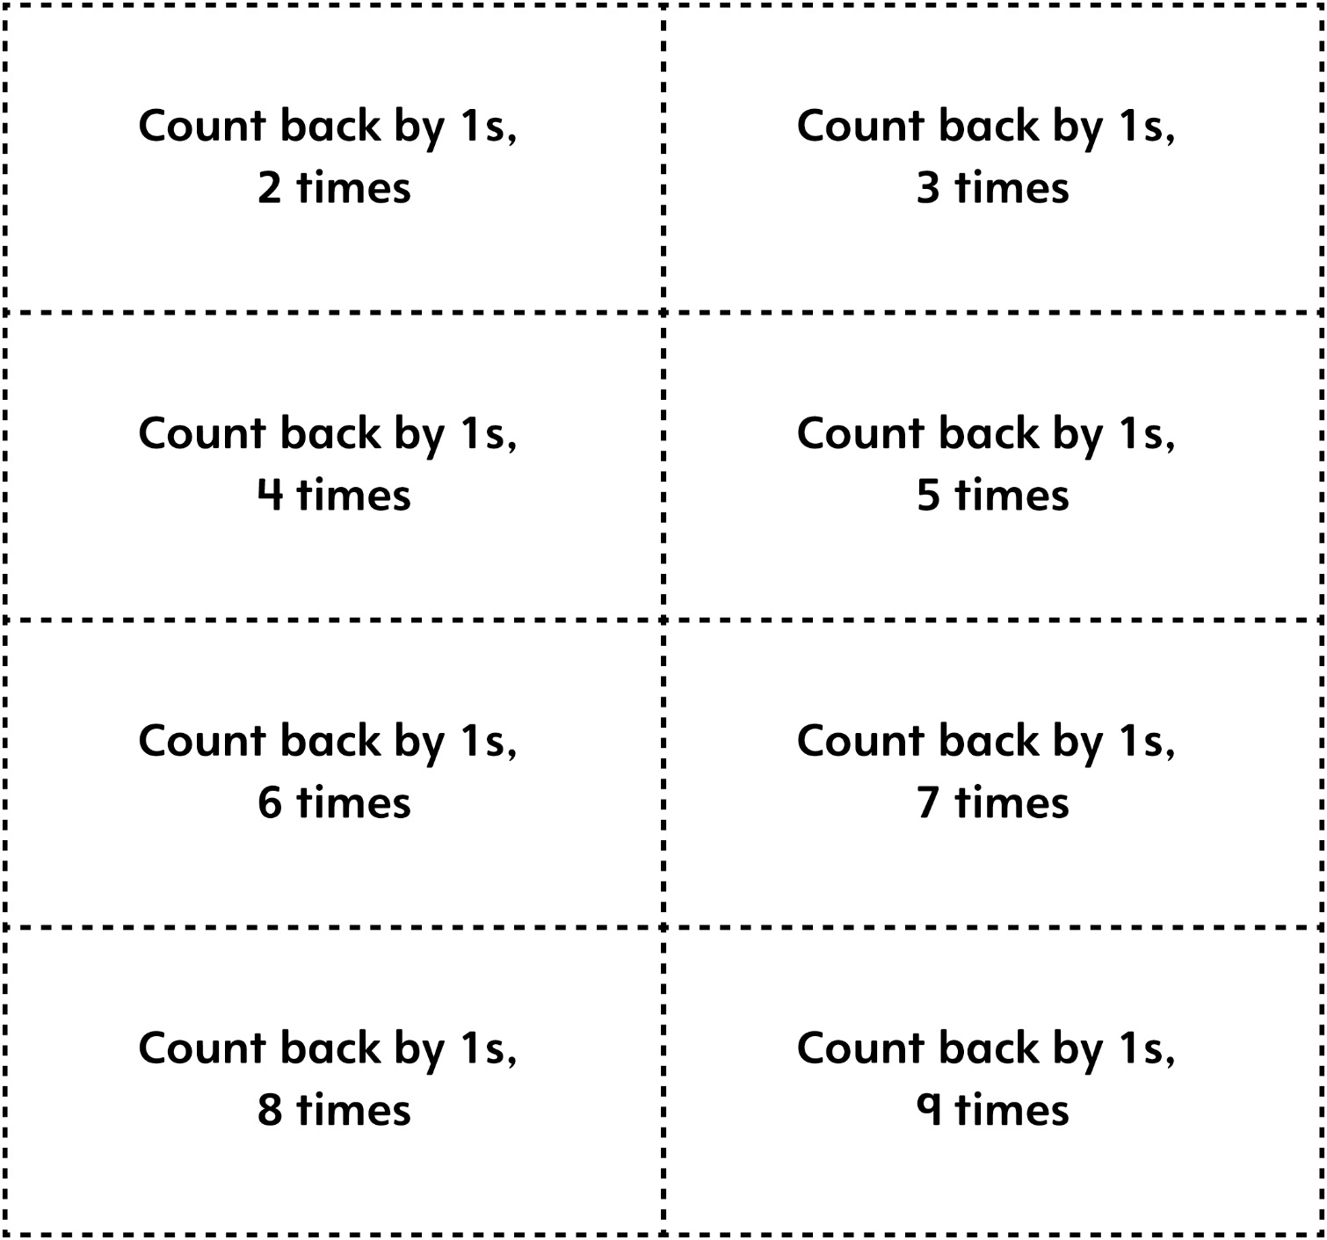

Counting On and Back Game Cards
Master 14c

(Blank Cards)

