Skip-Counting by 2s Game Cards
Master 15a

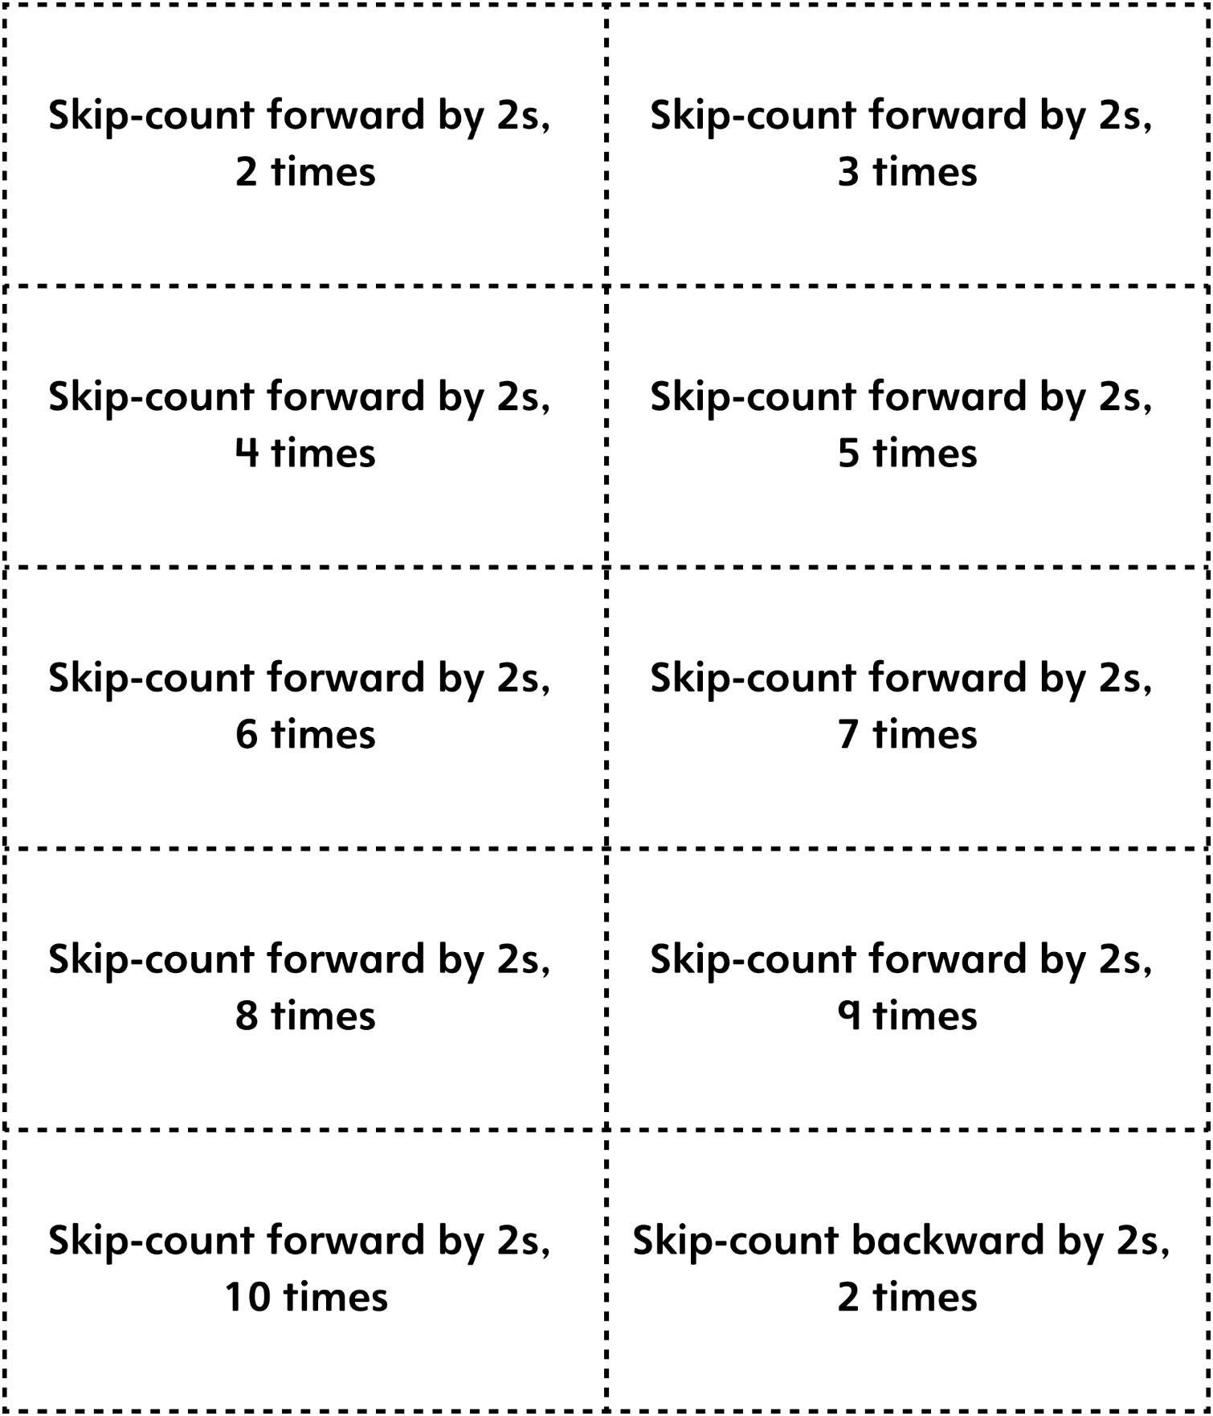

Skip-Counting by 2s Game Cards
Master 15b

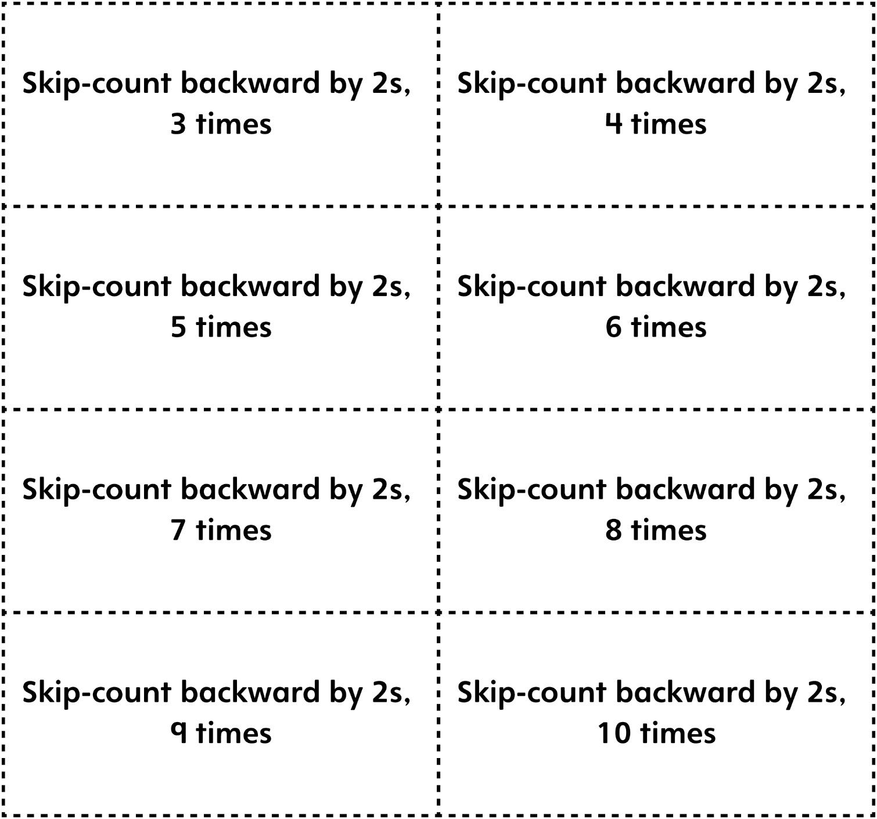

Skip-Counting by 5s Game Cards
Master 15c

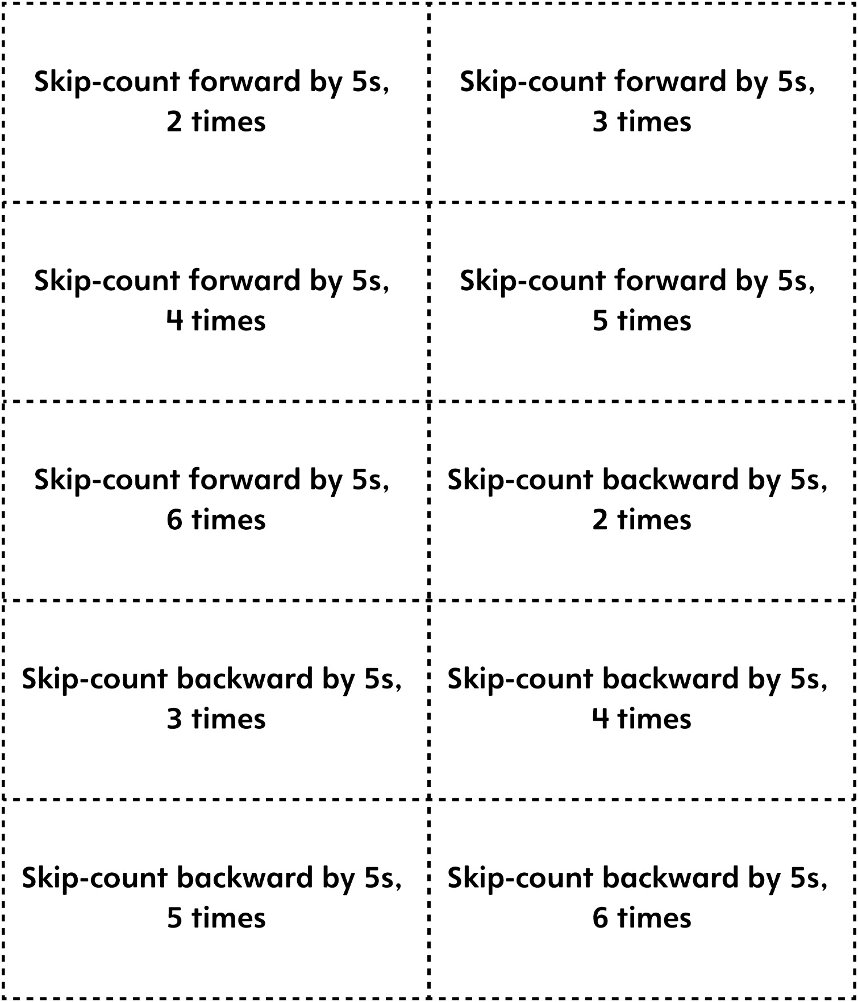
Skip-Counting by 10s Game Cards
Master 15d

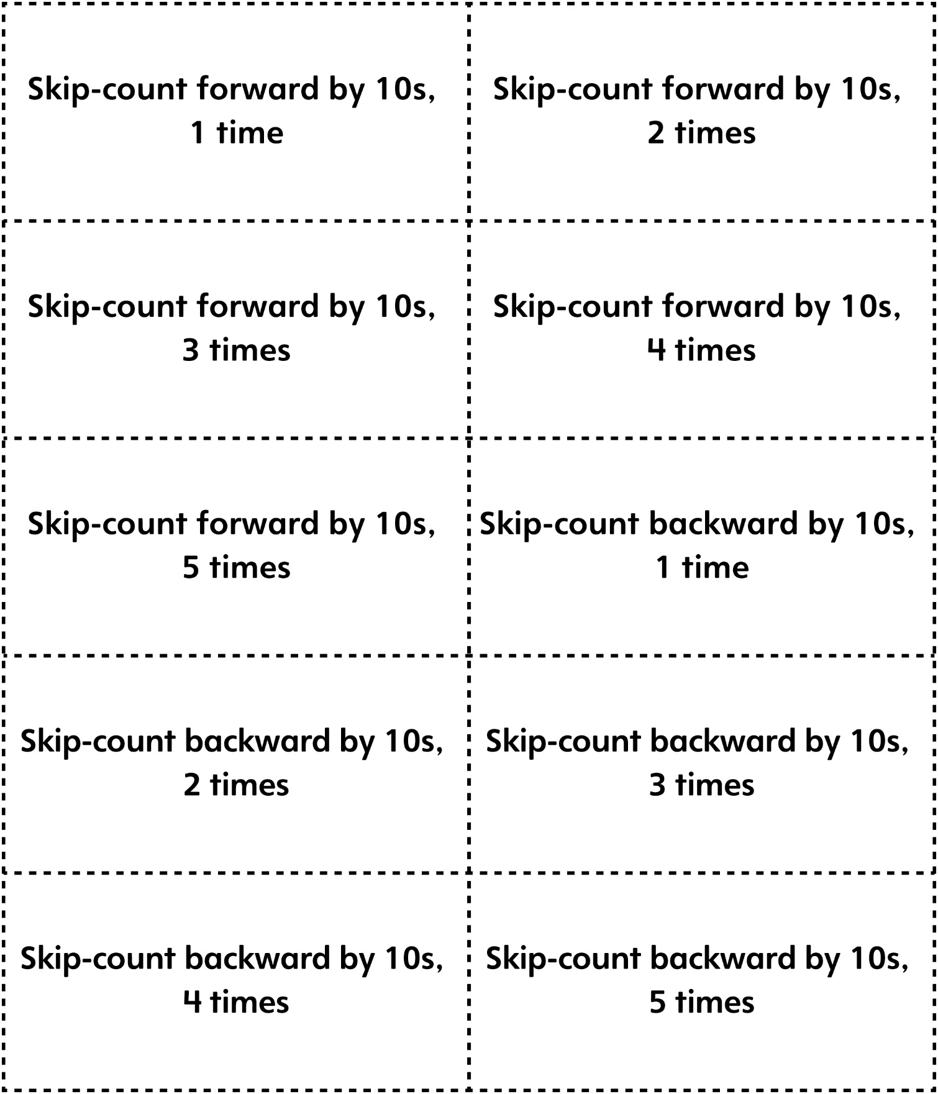

Skip-Counting Game Cards
Master 15e

(Blank Cards)

