**Number Cards (1–20)**

**Master 21a**

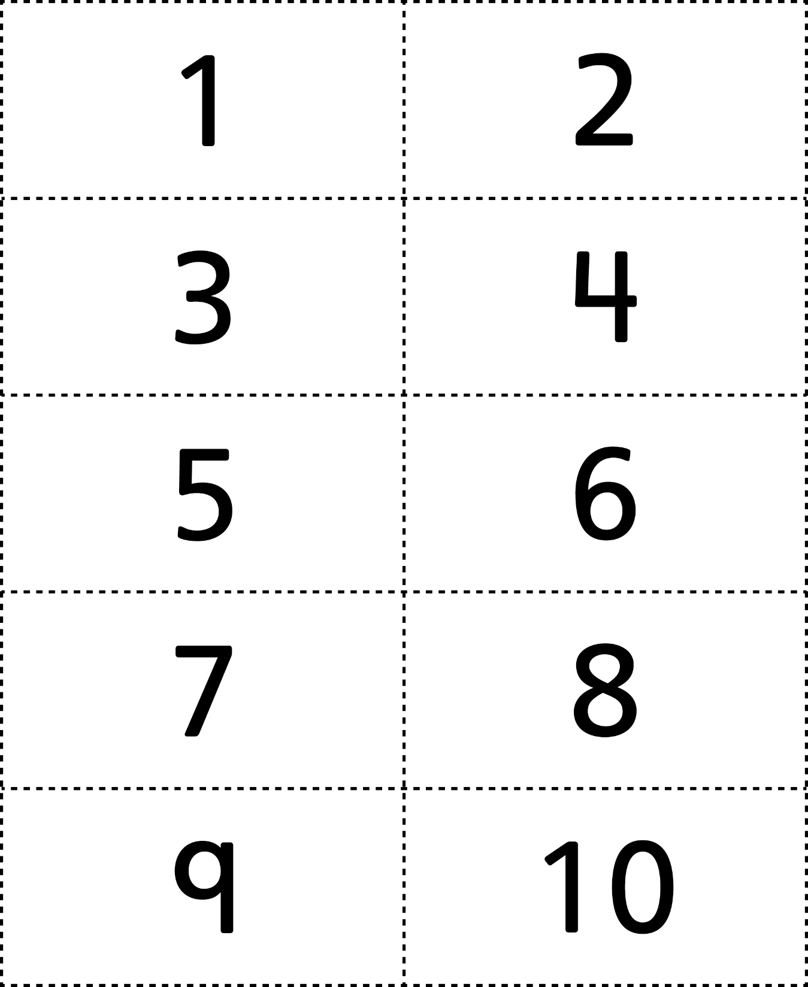

**Number Cards (1–20)**

**Master 21b**

