Ordinal Number Cards (to 20th)
Master 23a

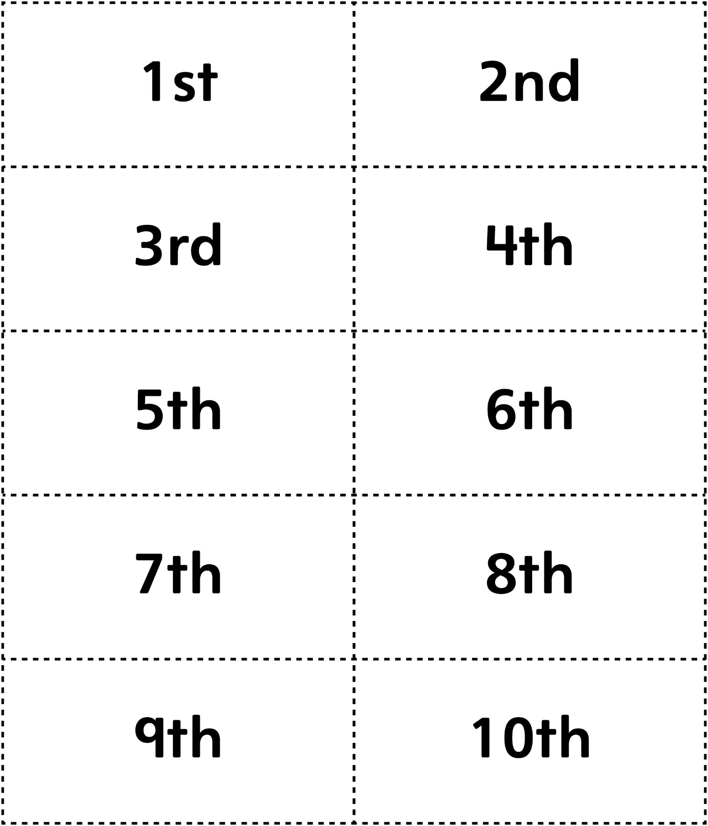

Ordinal Number Cards (to 20th)
Master 23b

