Counting Behaviours/Strategies
- Student makes a train of linking  cubes, but does not know that  rearranging the cubes does not  change the quantity (i.e., conservation of number). | - Student counts cubes by 1s to  determine how many in each part.  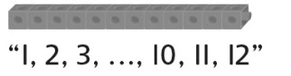 | - Student skip-counts to determine  how many in each part, but  continues to skip-count to count  the leftover cubes.  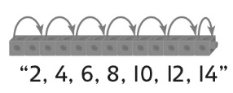 | - Student fluently skip-counts by  factors of 10 to determine how  many in each part.  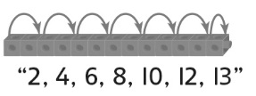
Observations/Documentation
Decomposing Behaviours/Strategies
- Student decomposes quantity  into two parts, but breaks train  randomly to find different ways. | - Student finds many ways to  decompose quantity into two parts, but does not consider zero.  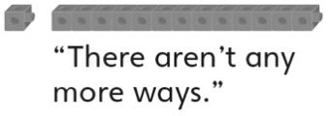 | - Student uses patterns to  successfully find different ways to  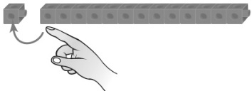  decompose quantity into two parts. | - Student uses known number  relationships to successfully find  all possible ways to decompose  quantity into two parts.  0 + 12 = 12 6 + 6 = 12  1 + 11 = 12 7 + 5 = 12  2 + 10 = 12 8 + 4 = 12  3 + 9 = 12 9 + 3 = 12  4 + 8 = 12 10 + 2 = 12  5 + 7 = 12 11 + 1 = 12  12 + 0 = 12
Observations/Documentation

