Task Cards: Odd or Even Numbers
Master 30a

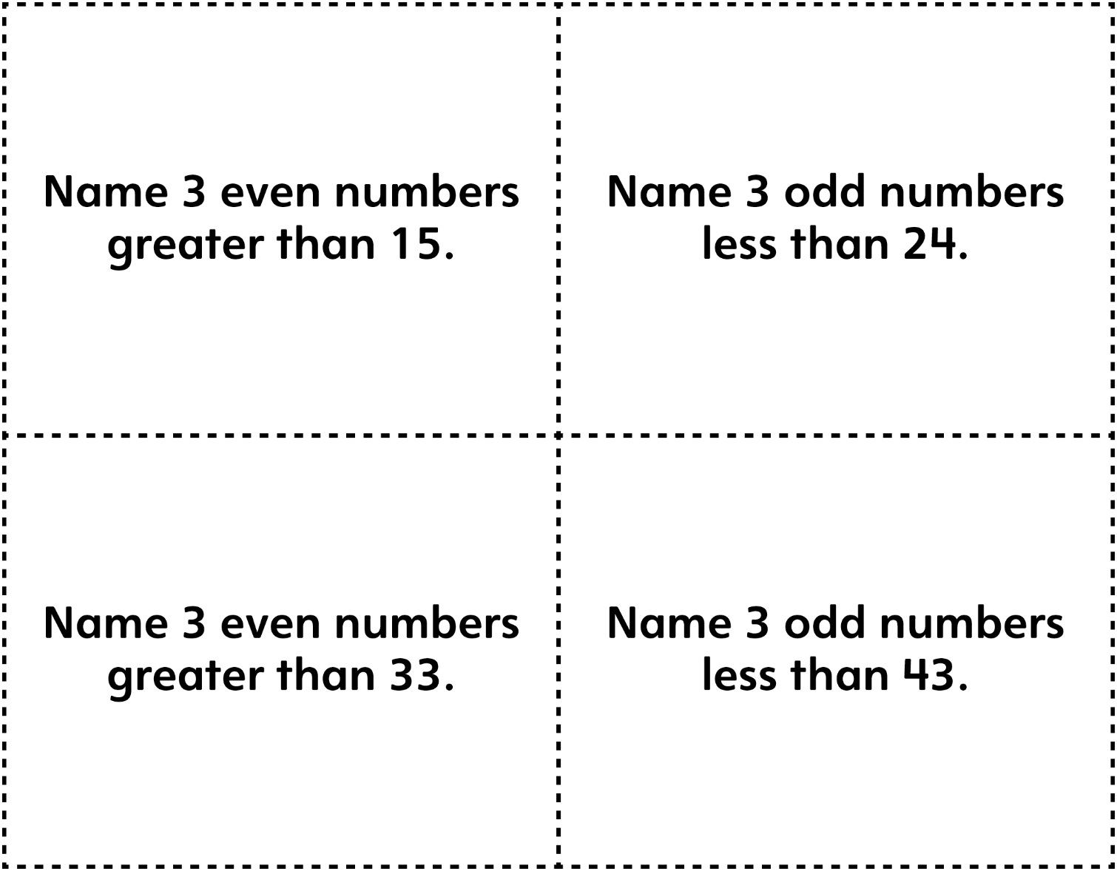

Task Cards: Odd or Even Numbers
Master 30b

(for Accommodations)

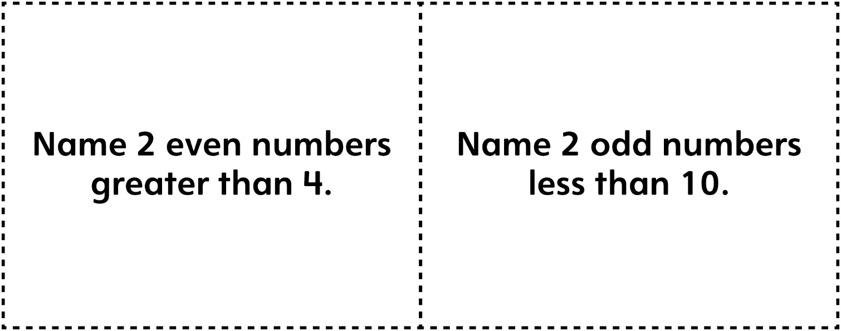

Task Cards: Comparing and Ordering
Master 30c

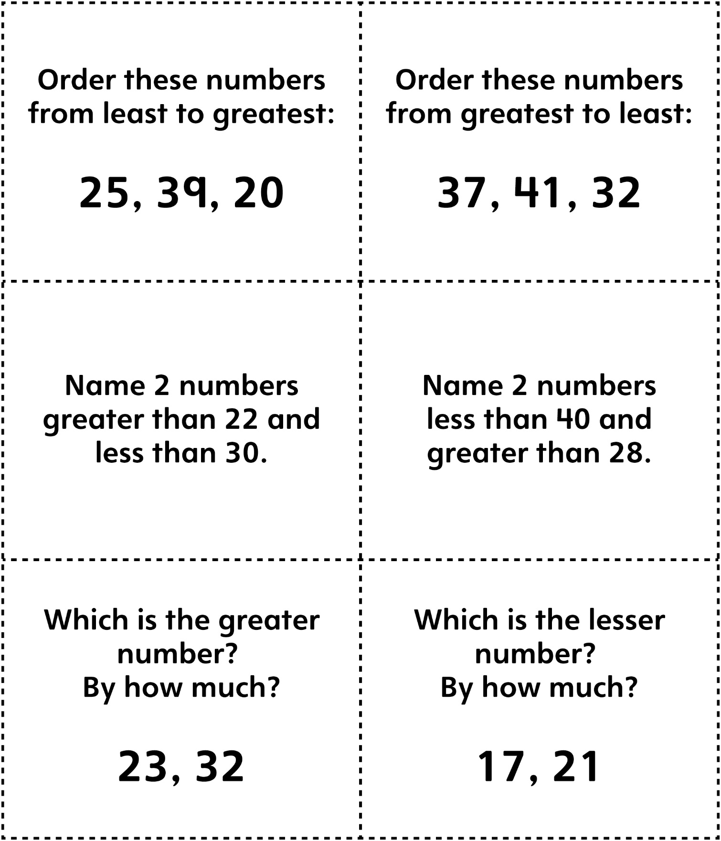
Task Cards: Comparing and Ordering
Master 30d

(for Accommodations)

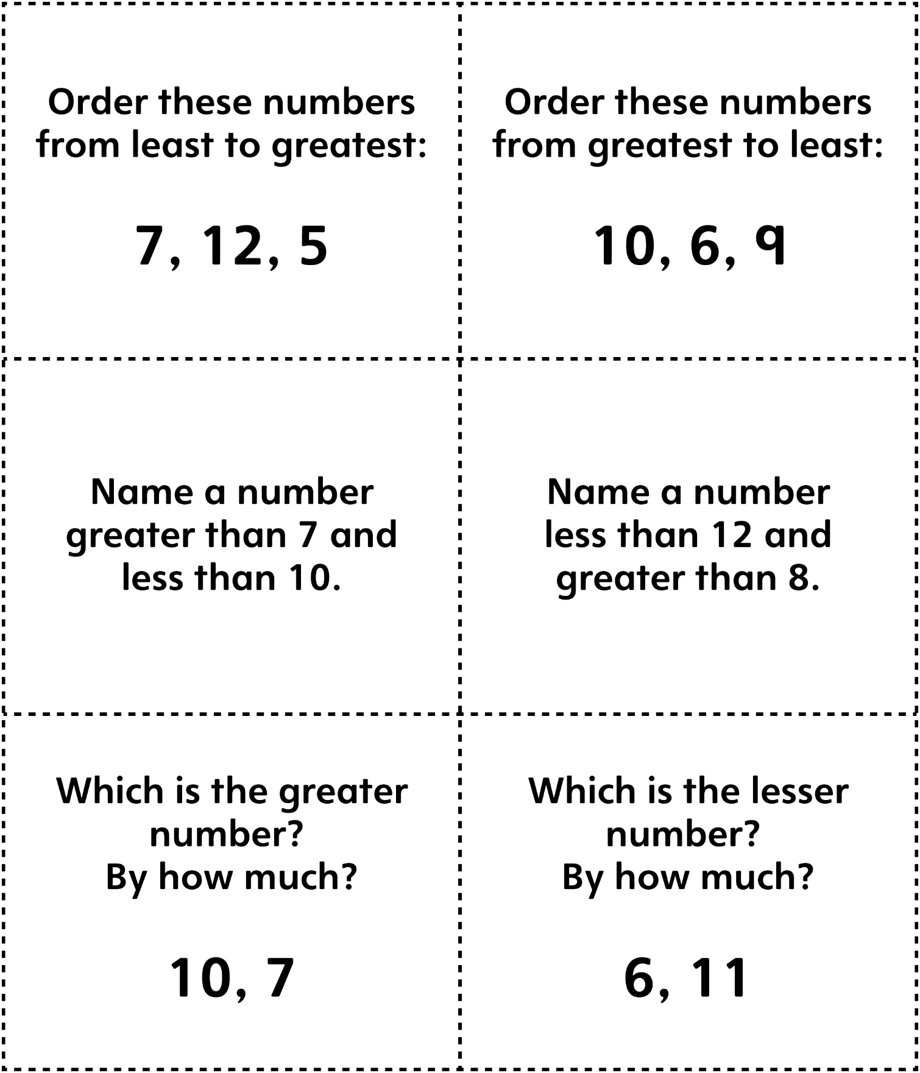
Task Cards:
Master 30e

Composing and Decomposing

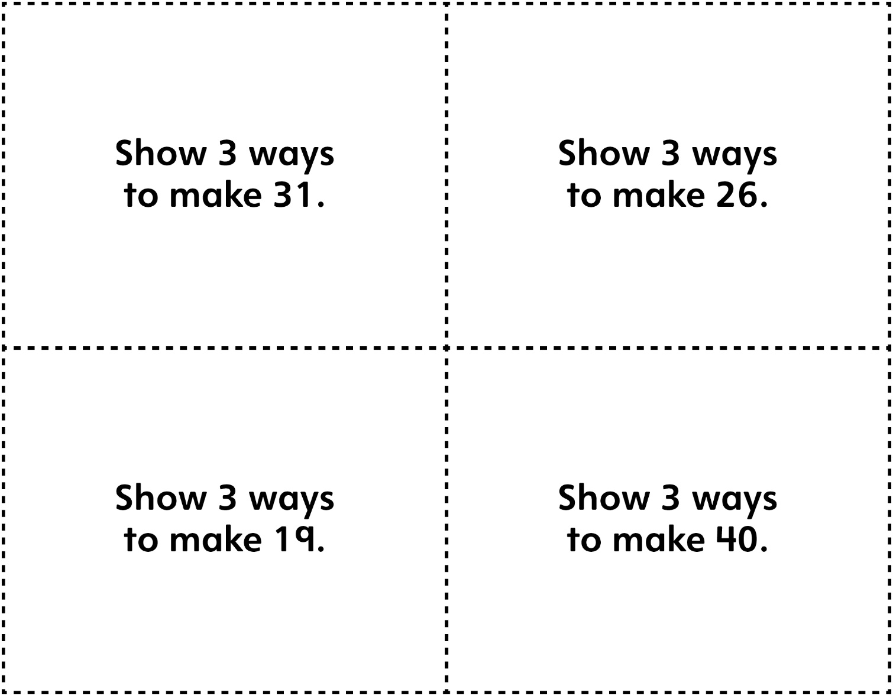

Task Cards: Composing and
Master 30f

Decomposing (for Accommodations)

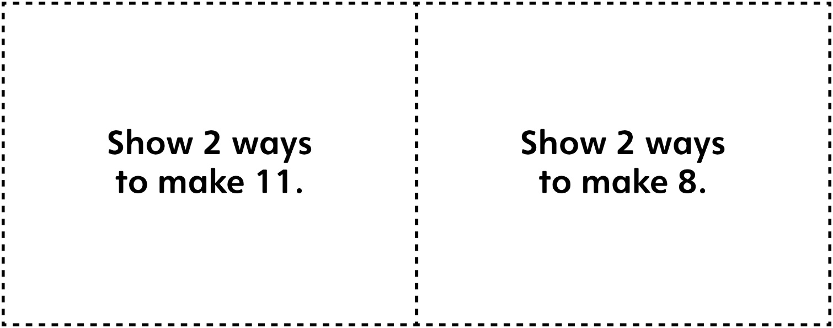

Task Cards: Ordinal Numbers
Master 30g

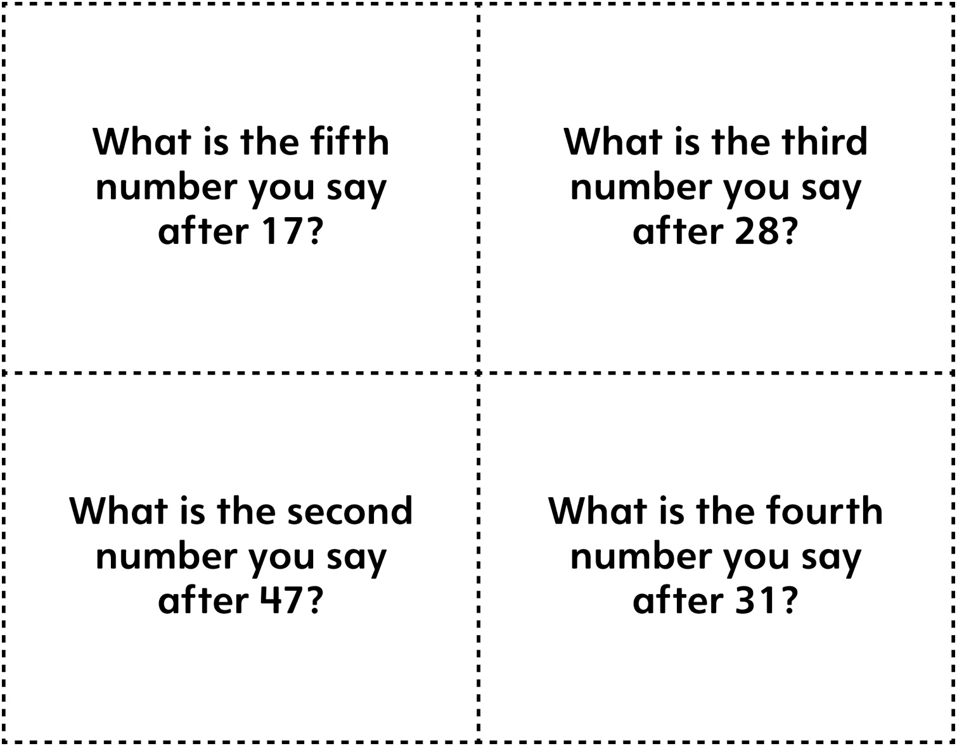

Task Cards: Ordinal Numbers
Master 30h

(for Accommodations)

