Number Relationships Behaviours/Strategies
- Student uses some ordinal  numbers, but has difficulty with  those that sound different from  the counting numbers (first,  second, third). | - Student partitions quantities  into groups of 2, but struggles to  identify even and odd numbers.  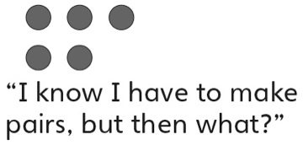 | - Student compares and orders  quantities using one-to-one  matching or counting (models  numbers with concrete materials).  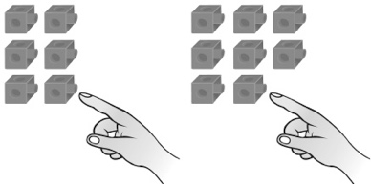 | - Student compares and orders  written numbers using  benchmarks.  “I know 25 is less than 30  and 39 is greater than 30.  So, 39 is greater than 25.”
Observations/Documentation
- Student determines how many  more/less by grouping (groups  cubes to make trains and then  aligns the trains).  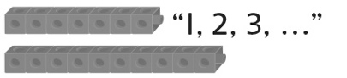 | - Student determines how many  more/less using counting (finds  distance between numbers on a  number line or hundred chart).  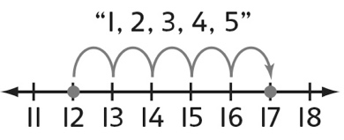 | - Student uses patterns to  successfully find different ways to  decompose quantity into two parts.  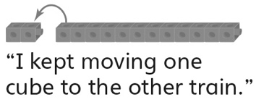 | - Student performs number  relationship tasks with ease and  communicates thinking using  math language.
Observations/Documentation

Big Idea |  |  |  |  | Indicators from Learning Progression
Curriculum Expectations addressed

Student Names
Student can compare two quantities to determine how many more/less.
(Activities 6, 12)
Student says one word for each object or group of objects counted (one-to-one correspondence/ tagging).
(Activities 6, 7, 11, 12)
Student can compare and order quantities to 100.
(Activities 7, 12)
Student uses math language when comparing and ordering quantities.
(Activities 6, 7, 12)
Student can identify even and odd numbers and explain thinking.
(Activity 8, 12)
Student can use ordinal numbers to describe relative position.
(Activities 9, 12)
Student can use benchmarks to estimate quantities to 100.
(Activity 10)
Student can decompose quantities to 20 into two parts.
(Activities 11, 12)

Name: _______________________

 | Not Observed | Sometimes | Consistently
Compares two quantities to determine how many more/less.
(Activities 6, 12)
Says one word for each object or group of objects counted (one-to-one correspondence/ tagging).
(Activities 6, 7, 11, 12)
Compares and orders quantities to 100.
(Activities 7, 12)
Uses math language when comparing and ordering quantities.
(Activities 6, 7, 12)
Identifies even and odd numbers and explains thinking.
(Activity 8, 12)
Uses ordinal numbers to describe relative position.
(Activities 9, 12)
Uses benchmarks to estimate quantities to 100.
(Activity 10)
Decomposes quantities to 20 into two parts.
(Activities 11, 12)

Strengths:

Next Steps:

