Who Am I? Cards
Master 67a

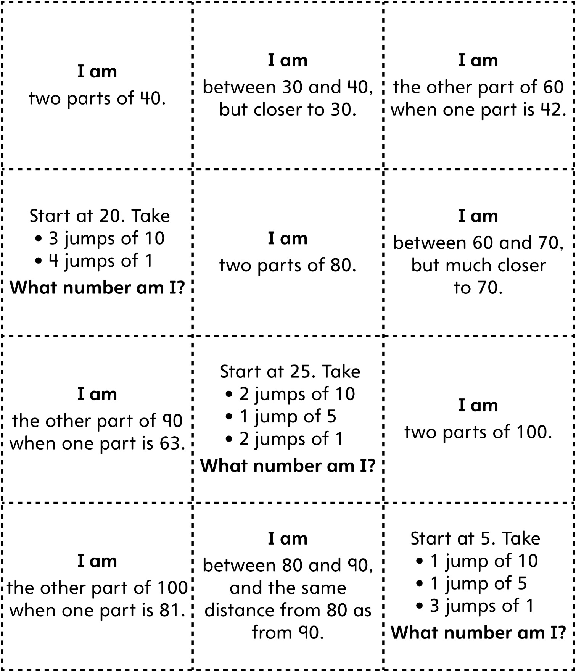

Who Am I? Cards (for Accommodations)
Master 67b

