Conceptual Understanding of Story Problems Behaviours/Strategies
- Student reads story problem, but is unable to model add-to situations with concrete materials.  “I don’t know what to do.” | - Student models and solves addition problems, but cannot use symbols and equations to represent the problems. | - Student models and solves addition problems and writes addition sentences, but struggles to represent thinking.  “25 + 11 = ?” or “25 + 11 = 36”  “What do I draw?” | - Student successfully models and  solves addition problem types, uses symbols and equations to represent the problems, and represents thinking on the Think Board.
Observations/Documentation
Addition Computational Behaviours/Strategies
- Student counts three times to add quantities. The answer may not be accurate.  “1, 2, 3, ..., 23, 24, 25”  “1, 2, 3, ..., 9, 10, 11”  “1, 2, 3, ..., 34, 35, 36” | - Student counts on to add  quantities.  “26, 27, 28, …, 34, 35, 36” | - Student counts efficiently to add  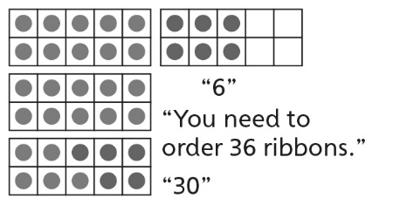  quantities (e.g., makes 10, subitizes). | - Student uses mental strategies  flexibly and accurately to add  quantities.  “25 + 10 = 35, and 35 + 1 = 36”
Observations/Documentation

