Adding and Subtracting Numbers to 20 Behaviours/Strategies
- Student uses ten-frames and  counters to add and subtract with  quantities to 20.  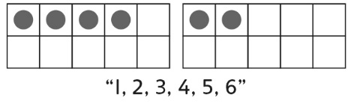 | - Student counts on or back to add  and subtract with quantities to 20.  7 + 9  “7” “8, 9, 10, …, 14, 15, 16” | - Student uses ten-frames and  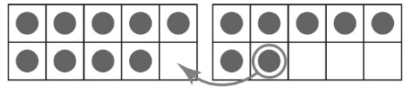  counters to make 10 when adding and subtracting with quantities to 20. | 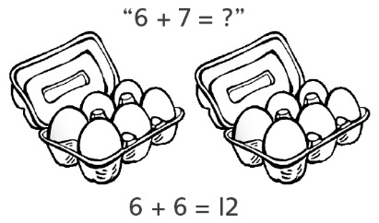  - Student refers to doubles pictures when extending known sums to add and subtract with quantities to 20.
Observations/Documentation
- Student uses the same strategy in every situation when adding and subtracting with quantities to 20.  “I like to count on!” | - Student fluently adds with  quantities to 20, but counts back  by 1s to subtract.  11 – 5 = ?  “10, 9, 8, 7, 6” | - Student adds and subtracts with  quantities to 20 and extends  known sums and differences  to solve other equations, but  struggles to explain thinking. | - Student fluently adds and subtracts with quantities to 20, extends known sums and differences to solve other equations, and explains  thinking.
Observations/Documentation

