Repeating Patterns Behaviours/Strategies
- Student chooses a core card, but struggles to  represent it with materials.  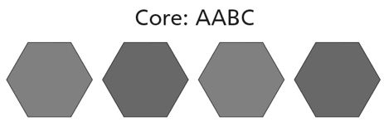 | - Student represents the core with materials, but struggles to use copies of the core to extend/create the pattern.  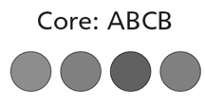 | - Student represents the core with materials, but  struggles to predict an element in the pattern.  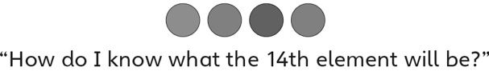
Observations/Documentation
- Student identifies the repeating unit (core) of a  pattern, but struggles to find errors or missing  elements. | - Student creates repeating patterns based on  one attribute, but struggles to create a core  based on two attributes.  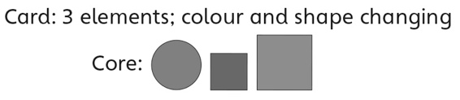 | - Student creates and extends repeating patterns  based on one or two attributes, and predicts  missing element(s) and corrects errors.
Observations/Documentation

Big Idea |  |  |  |  | Indicators from Learning Progression
Curriculum Expectations addressed

Student Names
Student can create repeating patterns based on copies of the core.
(Activities 1, 5)
Student can represent the core of a pattern with letters.
(Activities 1, 2, 4)
Student uses math language to describe patterns.
(Activities 1, 2, 3, 4, 5)
Student can identify the core of a repeating pattern.
(Activities 3, 4, 5)
Student can use the core of a pattern to make predictions.
(Activities 2, 5)
Student can extend a repeating pattern.
(Activities 2, 5)
Student can find and correct errors in a repeating pattern.
(Activities 3, 5)
Student can predict missing elements in a repeating pattern.
(Activities 3, 5)
Student can recognize, extend, and create repeating patterns involving two attributes.
(Activities 4, 5)

Name: _______________________

 | Not Observed | Sometimes | Consistently
Creates repeating patterns based on copies of the core.
(Activities 1, 5)
Represents the core of a pattern with letters.
(Activities 1, 2, 4)
Uses math language to describe patterns.
(Activities 1, 2, 3, 4, 5)
Identifies the core of a repeating pattern.
(Activities 3, 4, 5)
Uses the core of a pattern to make predictions.
(Activities 2, 5)
Extends a repeating pattern.
(Activities 2, 5)
Finds and corrects errors in a repeating pattern.
(Activities 3, 5)
Predicts missing elements in a repeating pattern.
(Activities 3, 5)
Recognizes, extends, and creates repeating patterns involving two attributes.
(Activities 4, 5)

Strengths:

Next Steps:

