Equal Match Cards
Master 41a

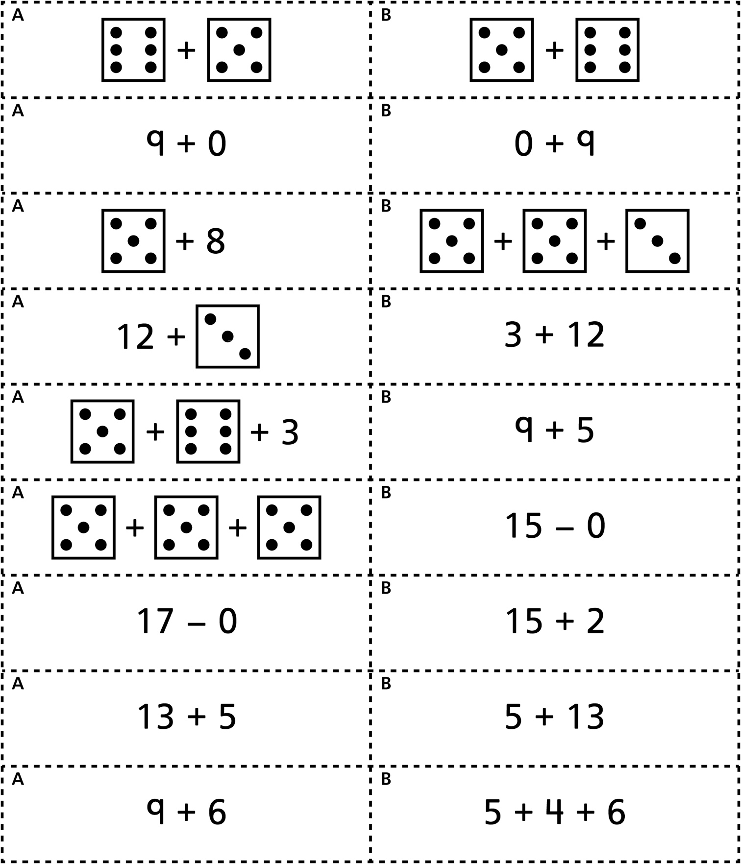

Equal Match Cards
(for Accommodations)
Master 41b

