A Class-full of Projects Line Master 1
(Assessment Master)

Name: _____________________________

Add and Subtract to 100 | Not observed | Sometimes | Consistently
Estimates sums and differences
Models and symbolizes addition and subtraction
Develops mental and personal addition and subtraction strategies
Develops complements of 100
Compose and Decompose Based on Units of 10
Writes, reads, and composes 2-digit numbers as 10s and 1s
Determines 10 (other multiples of 10) more/less than a given number
Strengths:

Next Steps:

Connecting Home and School Line Master 2–1



NOTE TO THE TEACHER

You may wish to send families an A Class-full of Projects letter outlining a familiar activity or two they can do at home with their children.

Create a letter using this template and select one or two activities from the suggestions on the next page. Simply delete these instructions and cut and paste the activities you have selected, adapting them to fit your needs.

Connecting Home and School Line Master 2–2

Dear Family:

We have been working on A Class-full of Projects, which focuses on adding and subtracting to 100, and composing and decomposing numbers based on units of 10. Try this activity at home with your child.
 – – – – – – – – – – – – – – – – – – – – – – – – – – – – – – – – – – – – – – – – – –
Reading the Story: As you read the story, enjoy figuring out together the progress of each group as they make and then reuse collections of 100. After you read, use small objects such as buttons, coins, or nuts and bolts to investigate making 100. Invite your child to grab a handful of the objects, and spill them onto the Math Mat (inside back cover of the book). Have your child estimate the number of items there are. Then, invite him/her to place the items in groups of 10 (10s) and a group of the leftovers (1s). Then, ask “How many more groups of 10 do we need to make 100?”
 – – – – – – – – – – – – – – – – – – – – – – – – – – – – – – – – – – – – – – – – – –
Race to 100: This game builds proficiency in adding and develops number sense to 100. You need a hundred chart, numeral cards for the numbers 1 to 9, and a small object for each of you, such as a coin. (Your child has the hundred chart and the cards.) Turn the numeral cards face down. To start the game, turn over 2 cards. Ask your child to help you to add the numbers on the cards. Then, place your marker on the sum on the hundred chart. For example, if you pick the numbers 7 and 8, you place your marker on 15. Turn the 2 numeral cards face down again and mix up all the cards. For the next turn, your child selects another 2 numeral cards, adds those numbers, and places his/her coin on the sum. Continue taking turns and moving your markers forward on the hundred chart by the amount of each sum. Get as close to 100 as you can!
 – – – – – – – – – – – – – – – – – – – – – – – – – – – – – – – – – – – – – – – – – –
That’s 100, Too! In class, we are looking for ways to make 100. We have found lots of ways, including 50 + 50, 10 + 90, and 35 + 10 + 55, just to share a few. There are lots of other ways! Encourage your child to investigate other ways to make 100. You can work along, too! Please have your child bring more ideas to make 100 to class by (date).
 – – – – – – – – – – – – – – – – – – – – – – – – – – – – – – – – – – – – – – – – – –

Sincerely,

___________________________
Hundred Chart Line Master 3

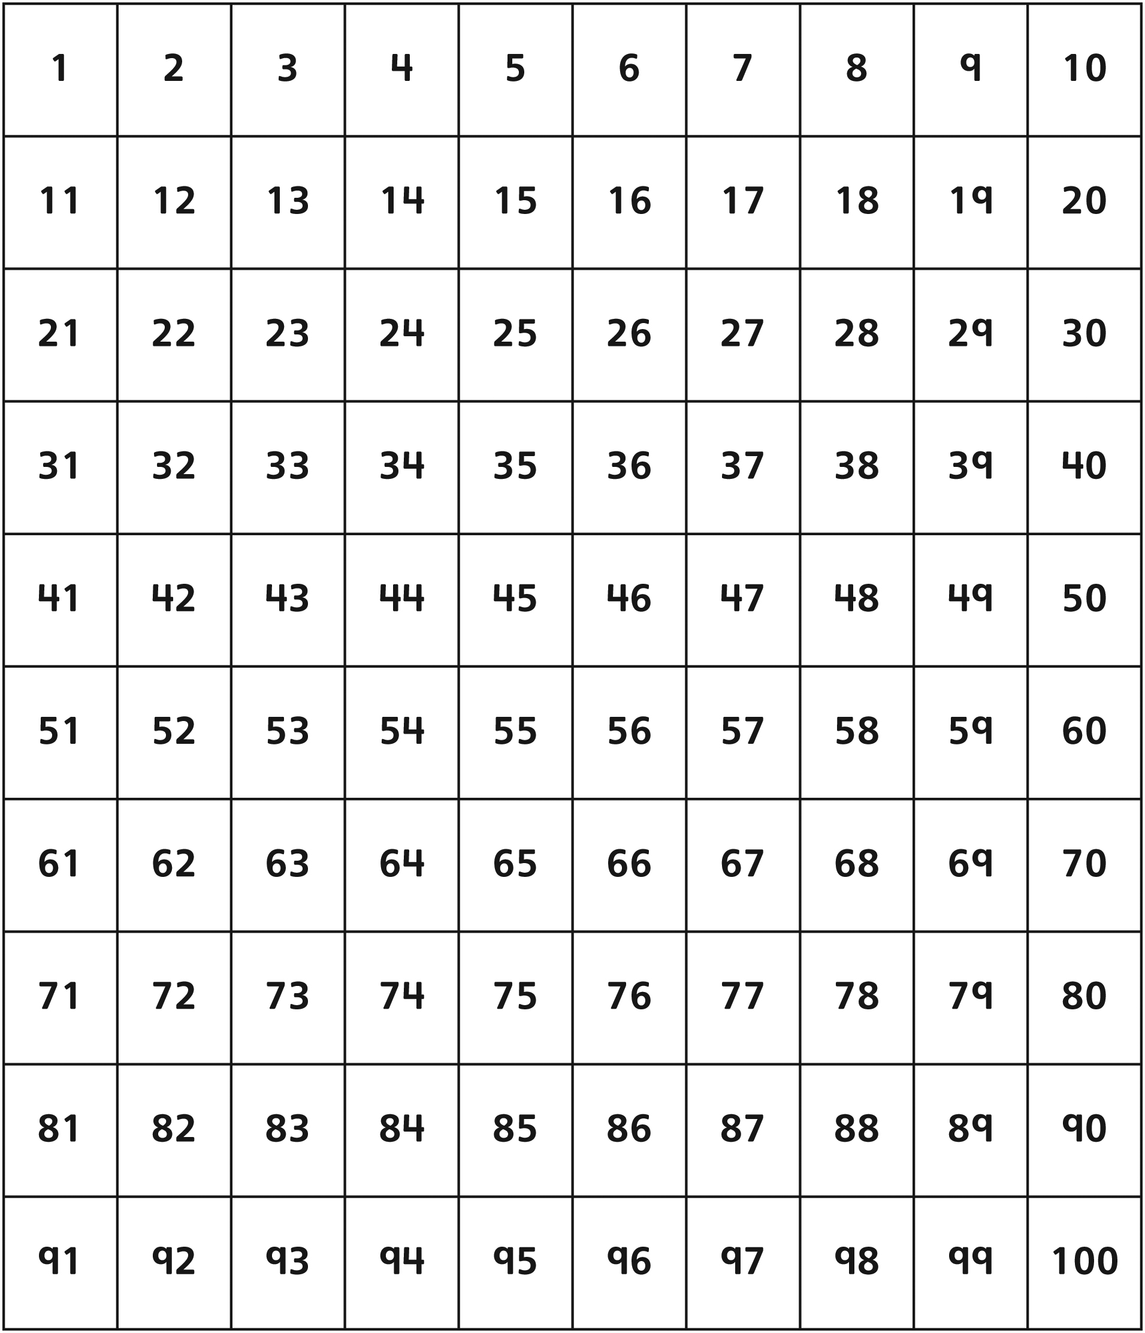
Number Lines Line Master 4

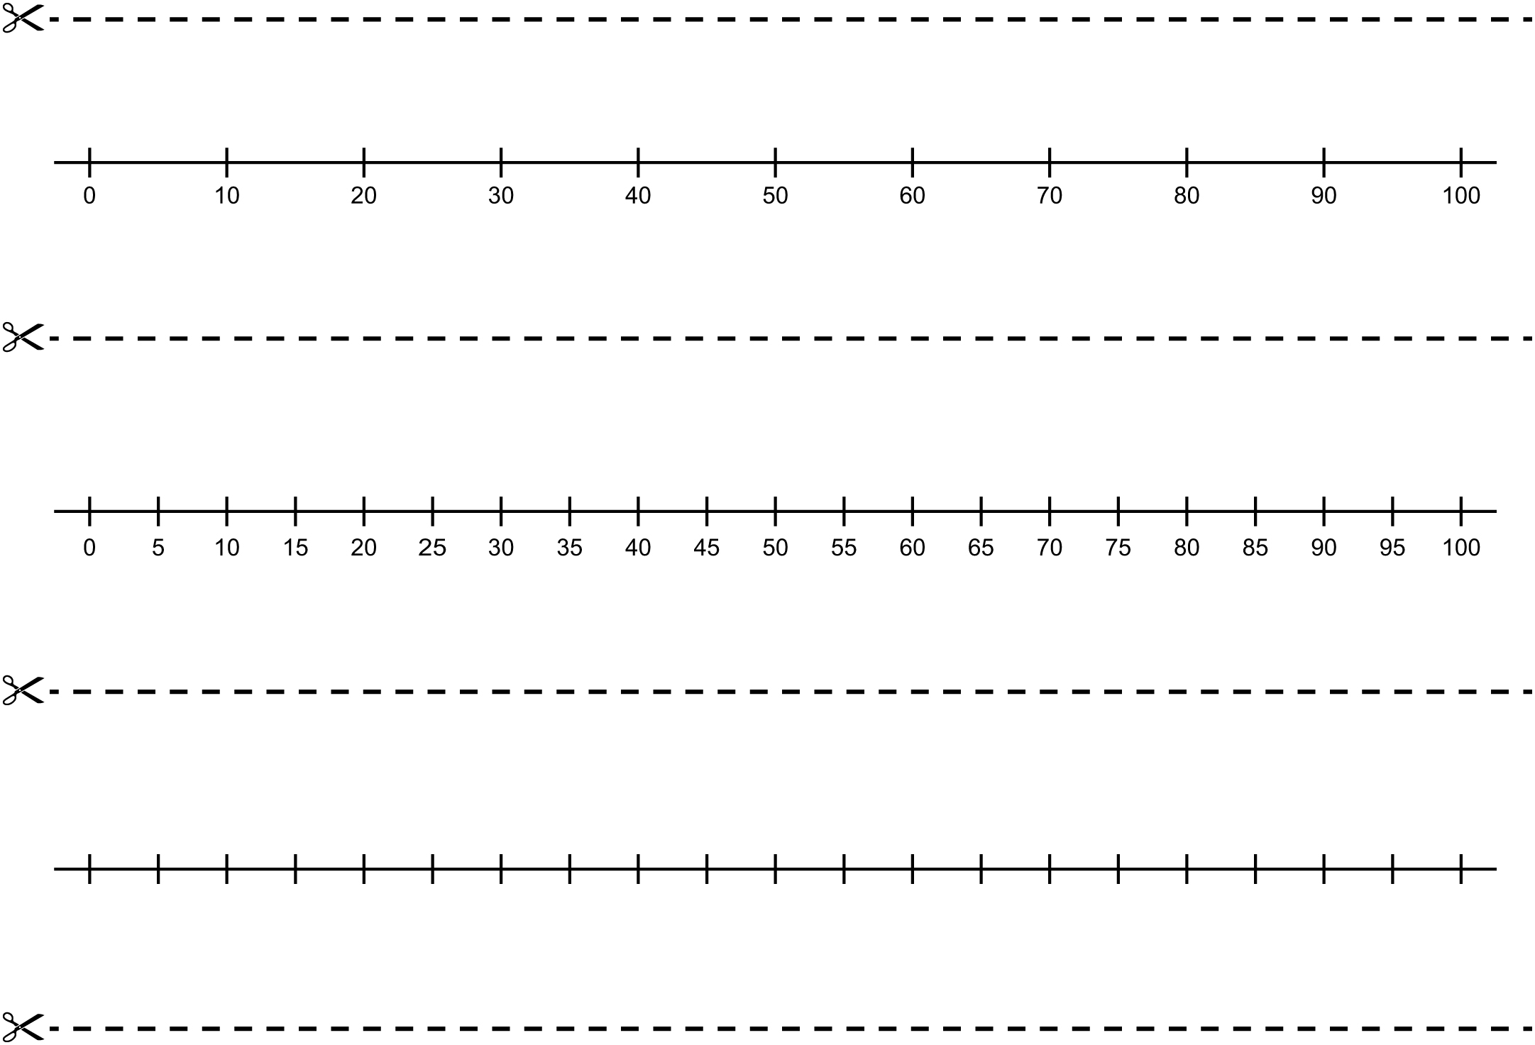
Make It 100 Line Master 5
Name: _____________________________

How many are in your collection?
Use numbers, words, and/or drawings to tell how many.

How many more do you need to make 100?
Show how you know using numbers, words, and/or drawings.

From 100 Line Master 6
Name: _____________________________

How many are in your collection? ___________________

How many are you taking from your collection? ___________________

How many are left in your collection? ___________________

Show how you know using numbers, words, and/or drawings.

A Class-full of Projects Line Master 7
Math Mat
Name: _____________________________

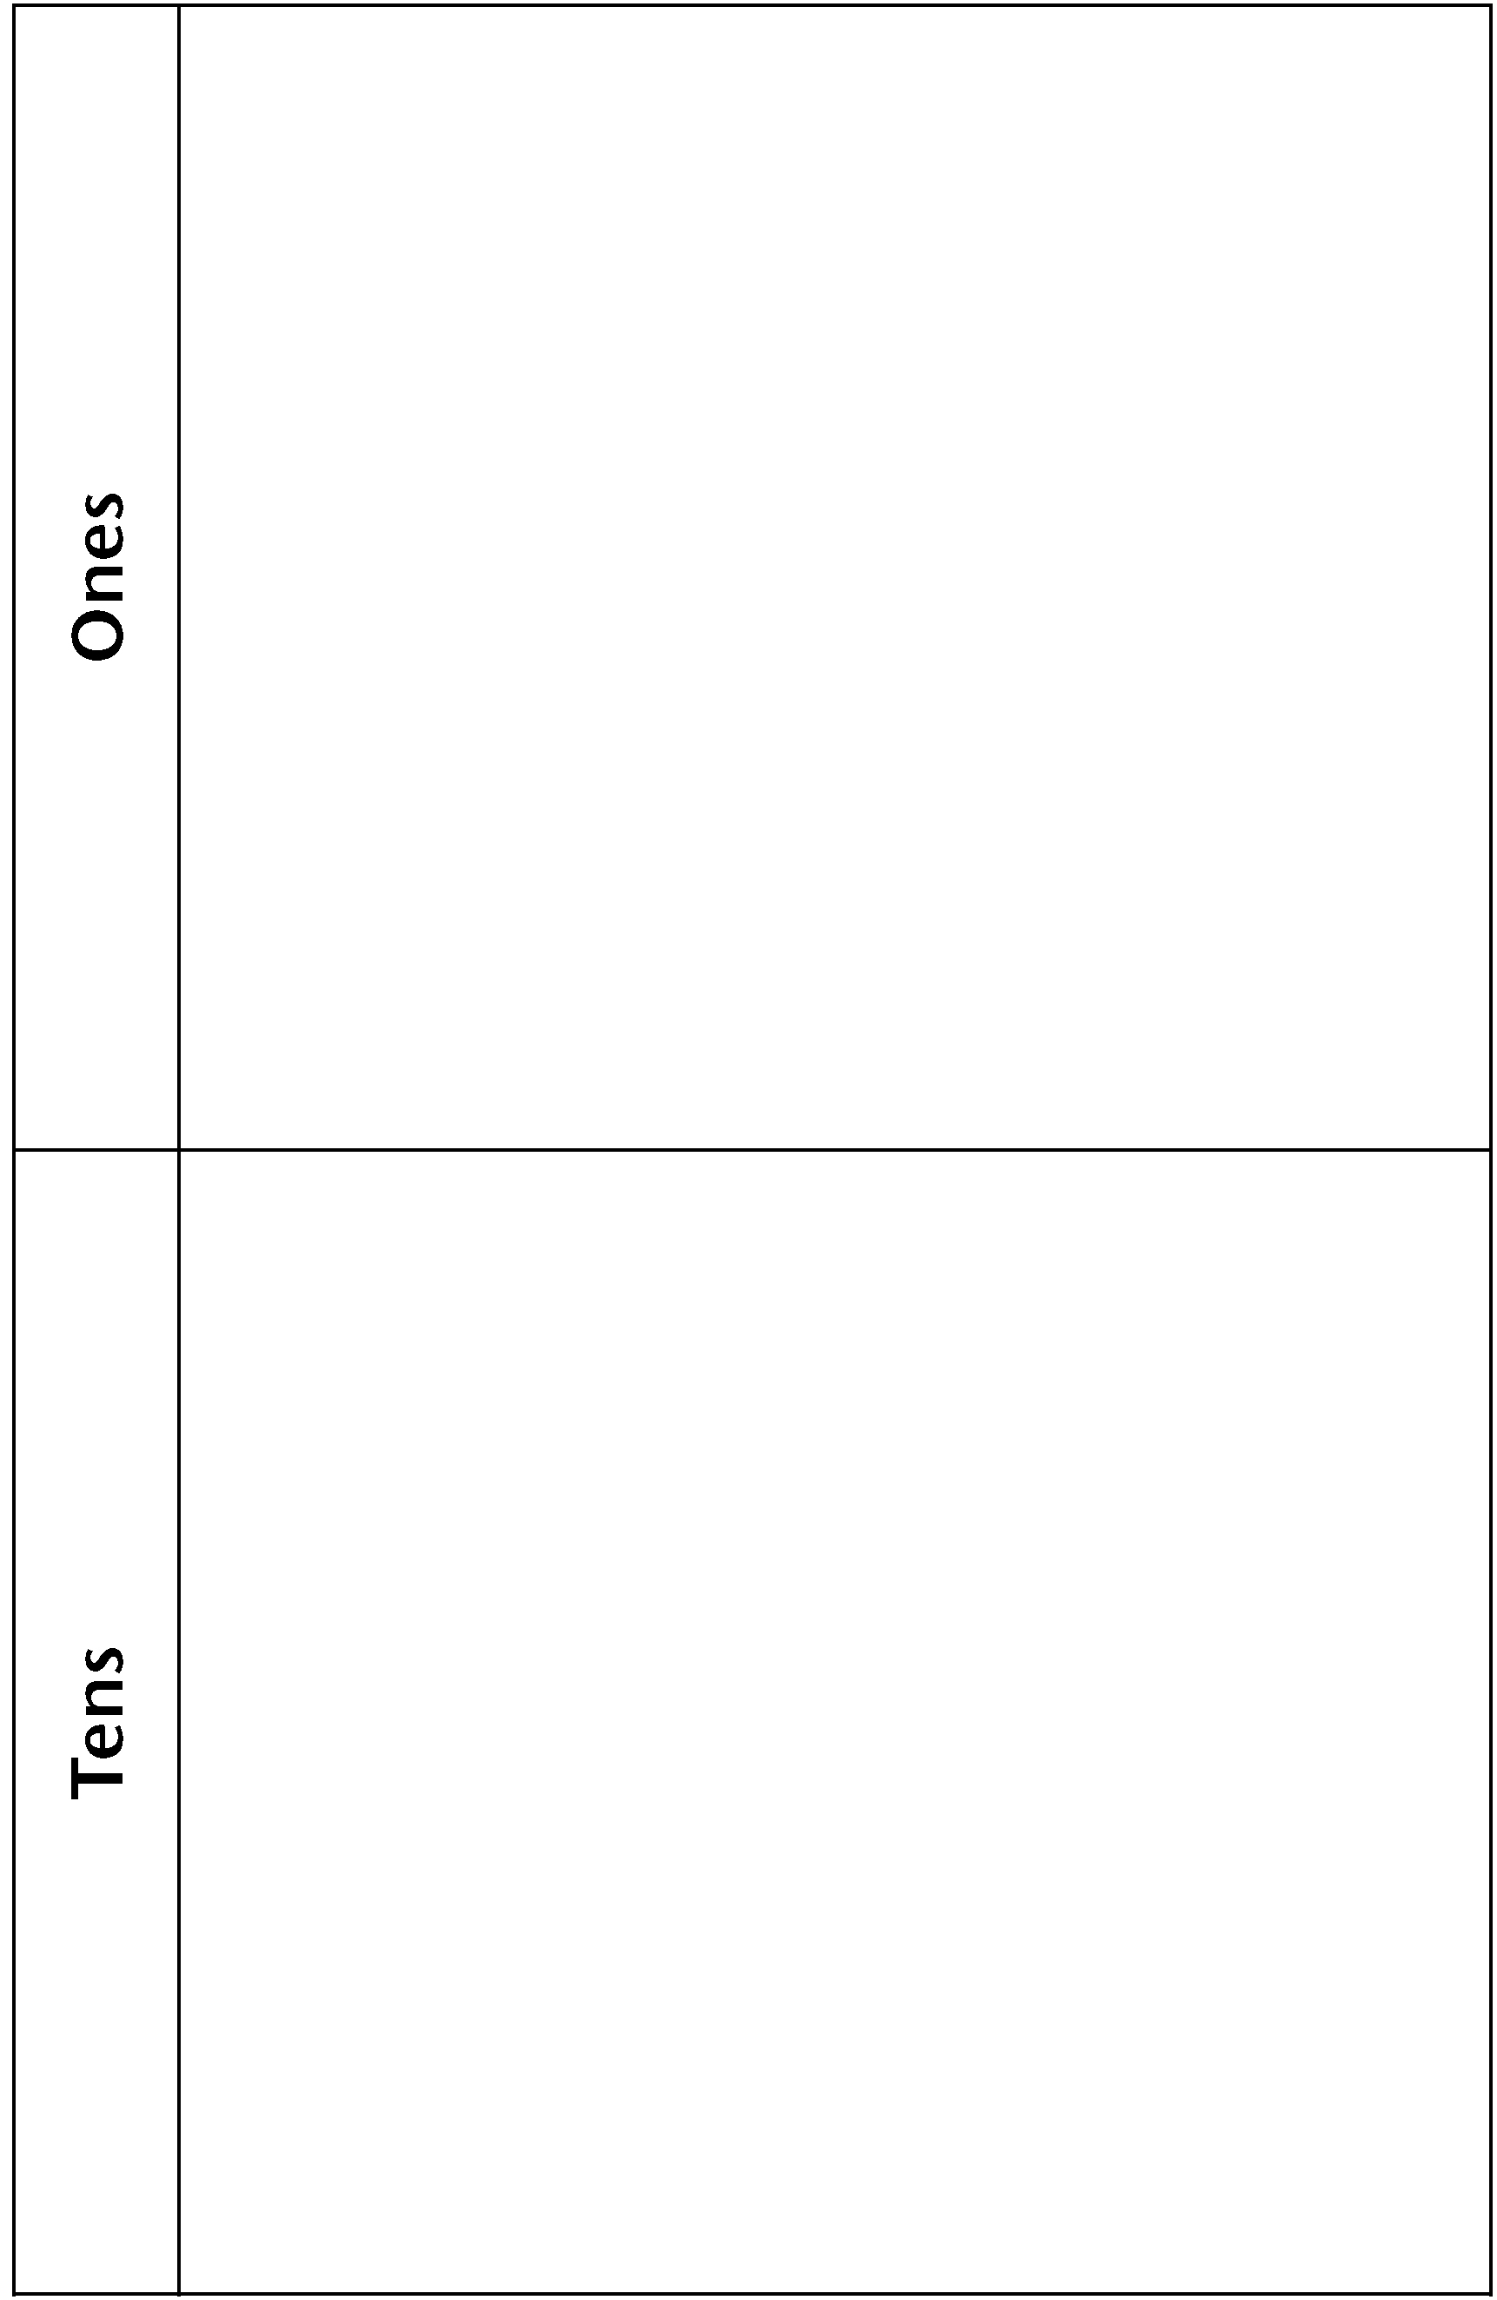

Get Close to 100 Line Master 8
Name: _____________________________

Roll | Tens | Ones
1
2
3
4
5
How many?

Numeral Cards Line Master 9

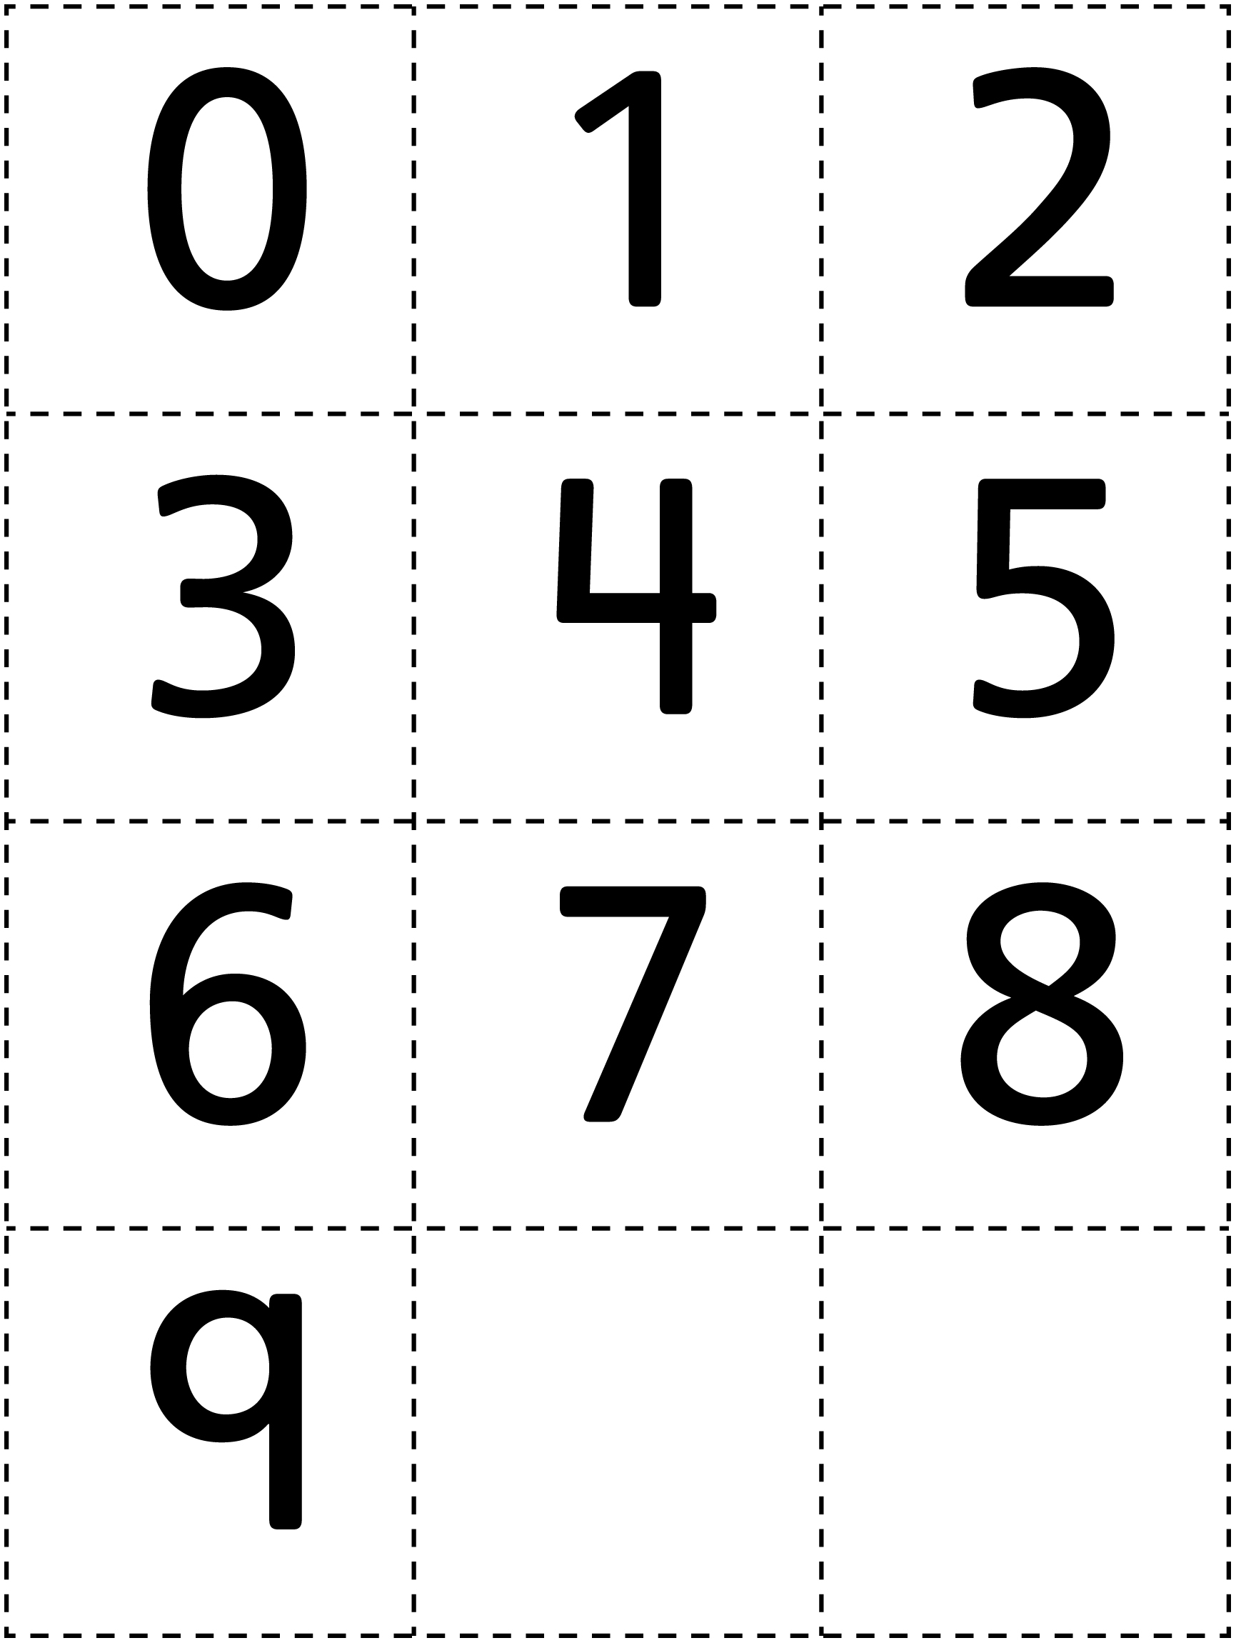

3 in a Row Line Master 10
Name: _____________________________

What You Need:
• cards for 0 to 9
• counters in 2 colours

How to Play:
1. Turn 2 cards face down. Use them to make a 2-digit number. For example, if your cards are 5 and 8, you can make the numbers 58 or 85.
2. Put a counter on the number you make. Or, you can put a counter on the number that is 10 greater or 10 less.
Example: If you made 58, you can put a counter on 58. Or on 58 + 10, which is 68. Or on 58 – 10, which is 48.
3. The player with 3 in a row WINS!

Turn | My Cards | My Number | Number I Put My Counter On
1
2
3
4
5
6
7
8
9
10

Solving Problems Line Master 11
 – – – – – – – – – – – – – – – – – – – – – – – – – – – – – – – – – – – – – – – – – –
Jordie wants to make a collection of 100 baseball cards.
She has 65 already. How many more does she still need?
 – – – – – – – – – – – – – – – – – – – – – – – – – – – – – – – – – – – – – – – – – –
Alexis collected 30 shells the first day at the beach.
The next day, she collected another 48.
How many does she have?
How many more does she need to collect to make 100?
 – – – – – – – – – – – – – – – – – – – – – – – – – – – – – – – – – – – – – – – – – –
Kyle collected 100 rocks. He decided to give some to his sister.
He gave her 28. How many does he have left in his collection?
 – – – – – – – – – – – – – – – – – – – – – – – – – – – – – – – – – – – – – – – – – –
Sam is excited because his Grandpa gave him 55 stamps for his collection.
He now has 100 stamps!
How many did he have before his Grandpa gave him 55 stamps?
 – – – – – – – – – – – – – – – – – – – – – – – – – – – – – – – – – – – – – – – – – –
Jonah, Luc, and Abby are working together to make a collection
of 100 stickers.
Jonah has 42 stickers. Luc has 35. Abby has 18. Do they have 100?
 – – – – – – – – – – – – – – – – – – – – – – – – – – – – – – – – – – – – – – – – – –

