Pattern Quest Line Master 1
(Assessment Master)
Name: _____________________________

Investigate Repeating Patterns | Not observed | Sometimes | Consistently
Compares repeating patterns and describes how they are alike
Recognizes, extends, and creates repeating patterns based on two or more attributes
Identifies the core of patterns
Investigate Growing and Shrinking Patterns
Identifies, reproduces, and extends increasing/decreasing patterns using repeated addition or subtraction
Creates an increasing/decreasing pattern and explains the pattern rule
Strengths:

Next Steps:

Connecting Home and School Line Master 2–1

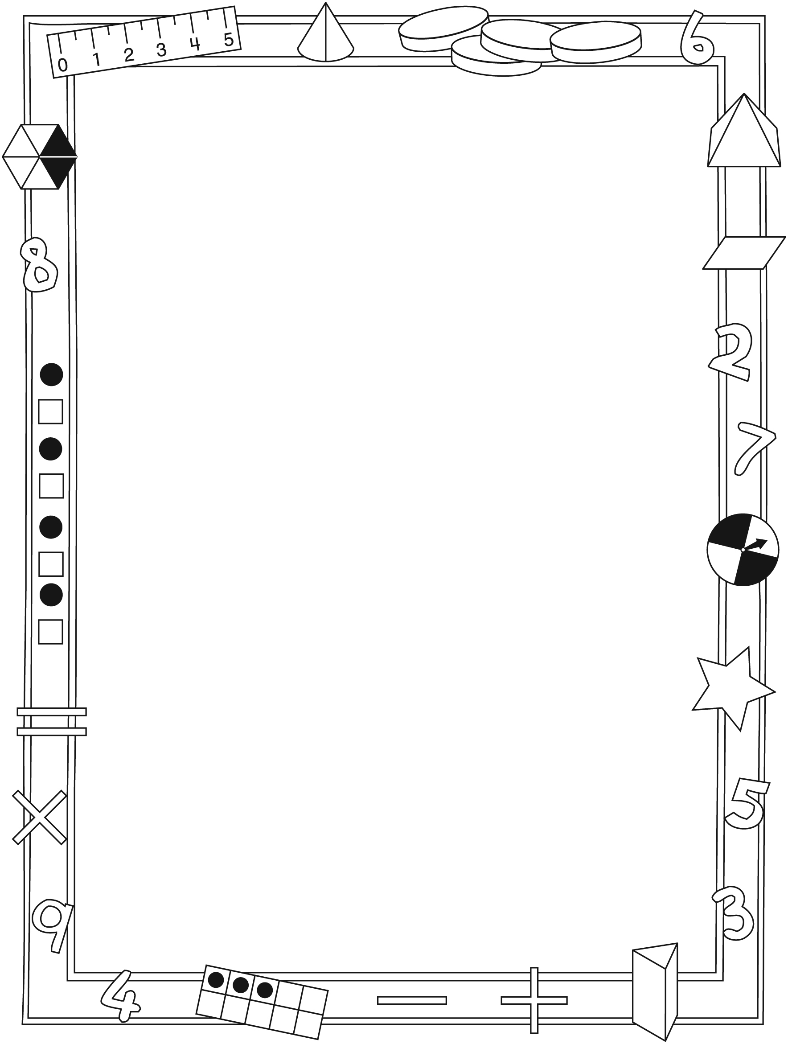

NOTE TO THE TEACHER

You may wish to send families a Pattern Quest letter outlining a familiar activity or two they can do at home with their children.

Create a letter using this template and select one or two activities from the suggestions on the next page. Simply delete these instructions and cut and paste the activities you have selected, adapting them to fit your needs.

Connecting Home and School Line Master 2–2

Dear Family:

We have been working on Pattern Quest, which engages children in conversations, investigations, and activities that help to develop their understanding of the big math idea that “Patterns can be described mathematically.” Particular focus is placed on investigating repeating patterns, growing patterns, and shrinking patterns. Try this activity at home with your child.
– – – – – – – – – – – – – – – – – – – – – – – – – – – – – – – – – – – – – – – – – –
Reading the Story: As you read the story together, encourage your child to identify and describe the patterns. Together, compare the patterns throughout the story. Invite your child to identify the different types of patterns: repeating, growing, and shrinking. For repeating patterns, work with your child to find the part that repeats (pattern core).
– – – – – – – – – – – – – – – – – – – – – – – – – – – – – – – – – – – – – – – – – –
Pattern Detectives: Challenge your child to find patterns at home or on the way to school. Invite her/him to explain why the designs or sequences are patterns and to record the part of the pattern that repeats (pattern core) or the pattern rule.
– – – – – – – – – – – – – – – – – – – – – – – – – – – – – – – – – – – – – – – – – –
Repeating Patterns: What Comes Next? Use a minimum of 2 different attributes (e.g., shape, colour, size) to create a pattern core. Make sure the pattern core appears at least 3 times to form a repeating pattern. Invite your child to extend the pattern. Patterns can be drawn, created with concrete objects, clapped, or said aloud.
– – – – – – – – – – – – – – – – – – – – – – – – – – – – – – – – – – – – – – – – – –
Growing/Shrinking Patterns: What Comes Next? Start a pattern using numbers that increase or decrease by the same amount each time, (e.g., 2, 4, 6 or 10, 20, 30). Invite your child to extend the pattern and identify the pattern rule. Challenge your child to start a growing or shrinking number pattern for you to extend.
– – – – – – – – – – – – – – – – – – – – – – – – – – – – – – – – – – – – – – – – – –
Sincerely,

___________________________

Pattern Quest Math Mat Line Master 3

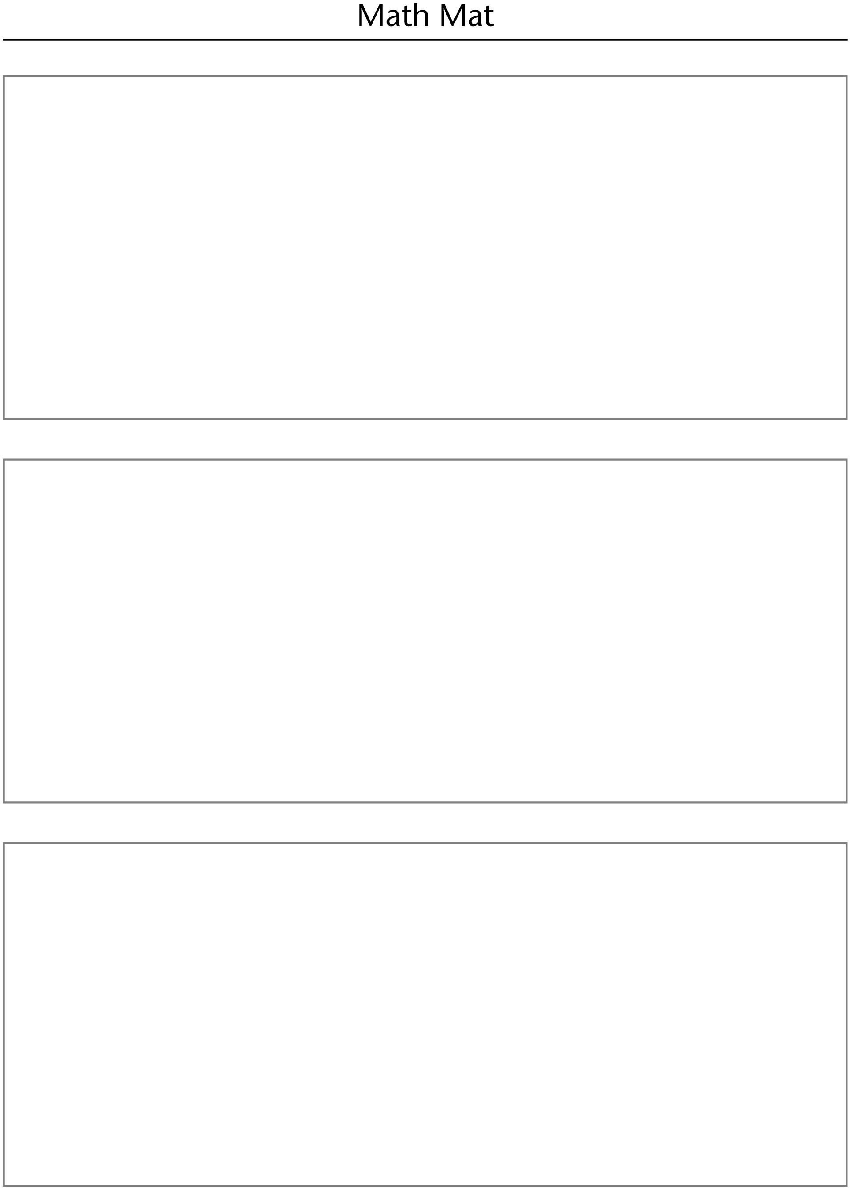

Pattern Attributes Line Master 4

shape | colour
size | direction
shape | colour
size | direction

Numeral Cards Line Master 5–1

5 | 10 | 15
20 | 25 | 30
35 | 40 | 45
50

Numeral Cards Line Master 5–2

55 | 60 | 65
70 | 75 | 80
85 | 90 | 95
100

Hundred Chart Line Master 6
Name: _____________________________

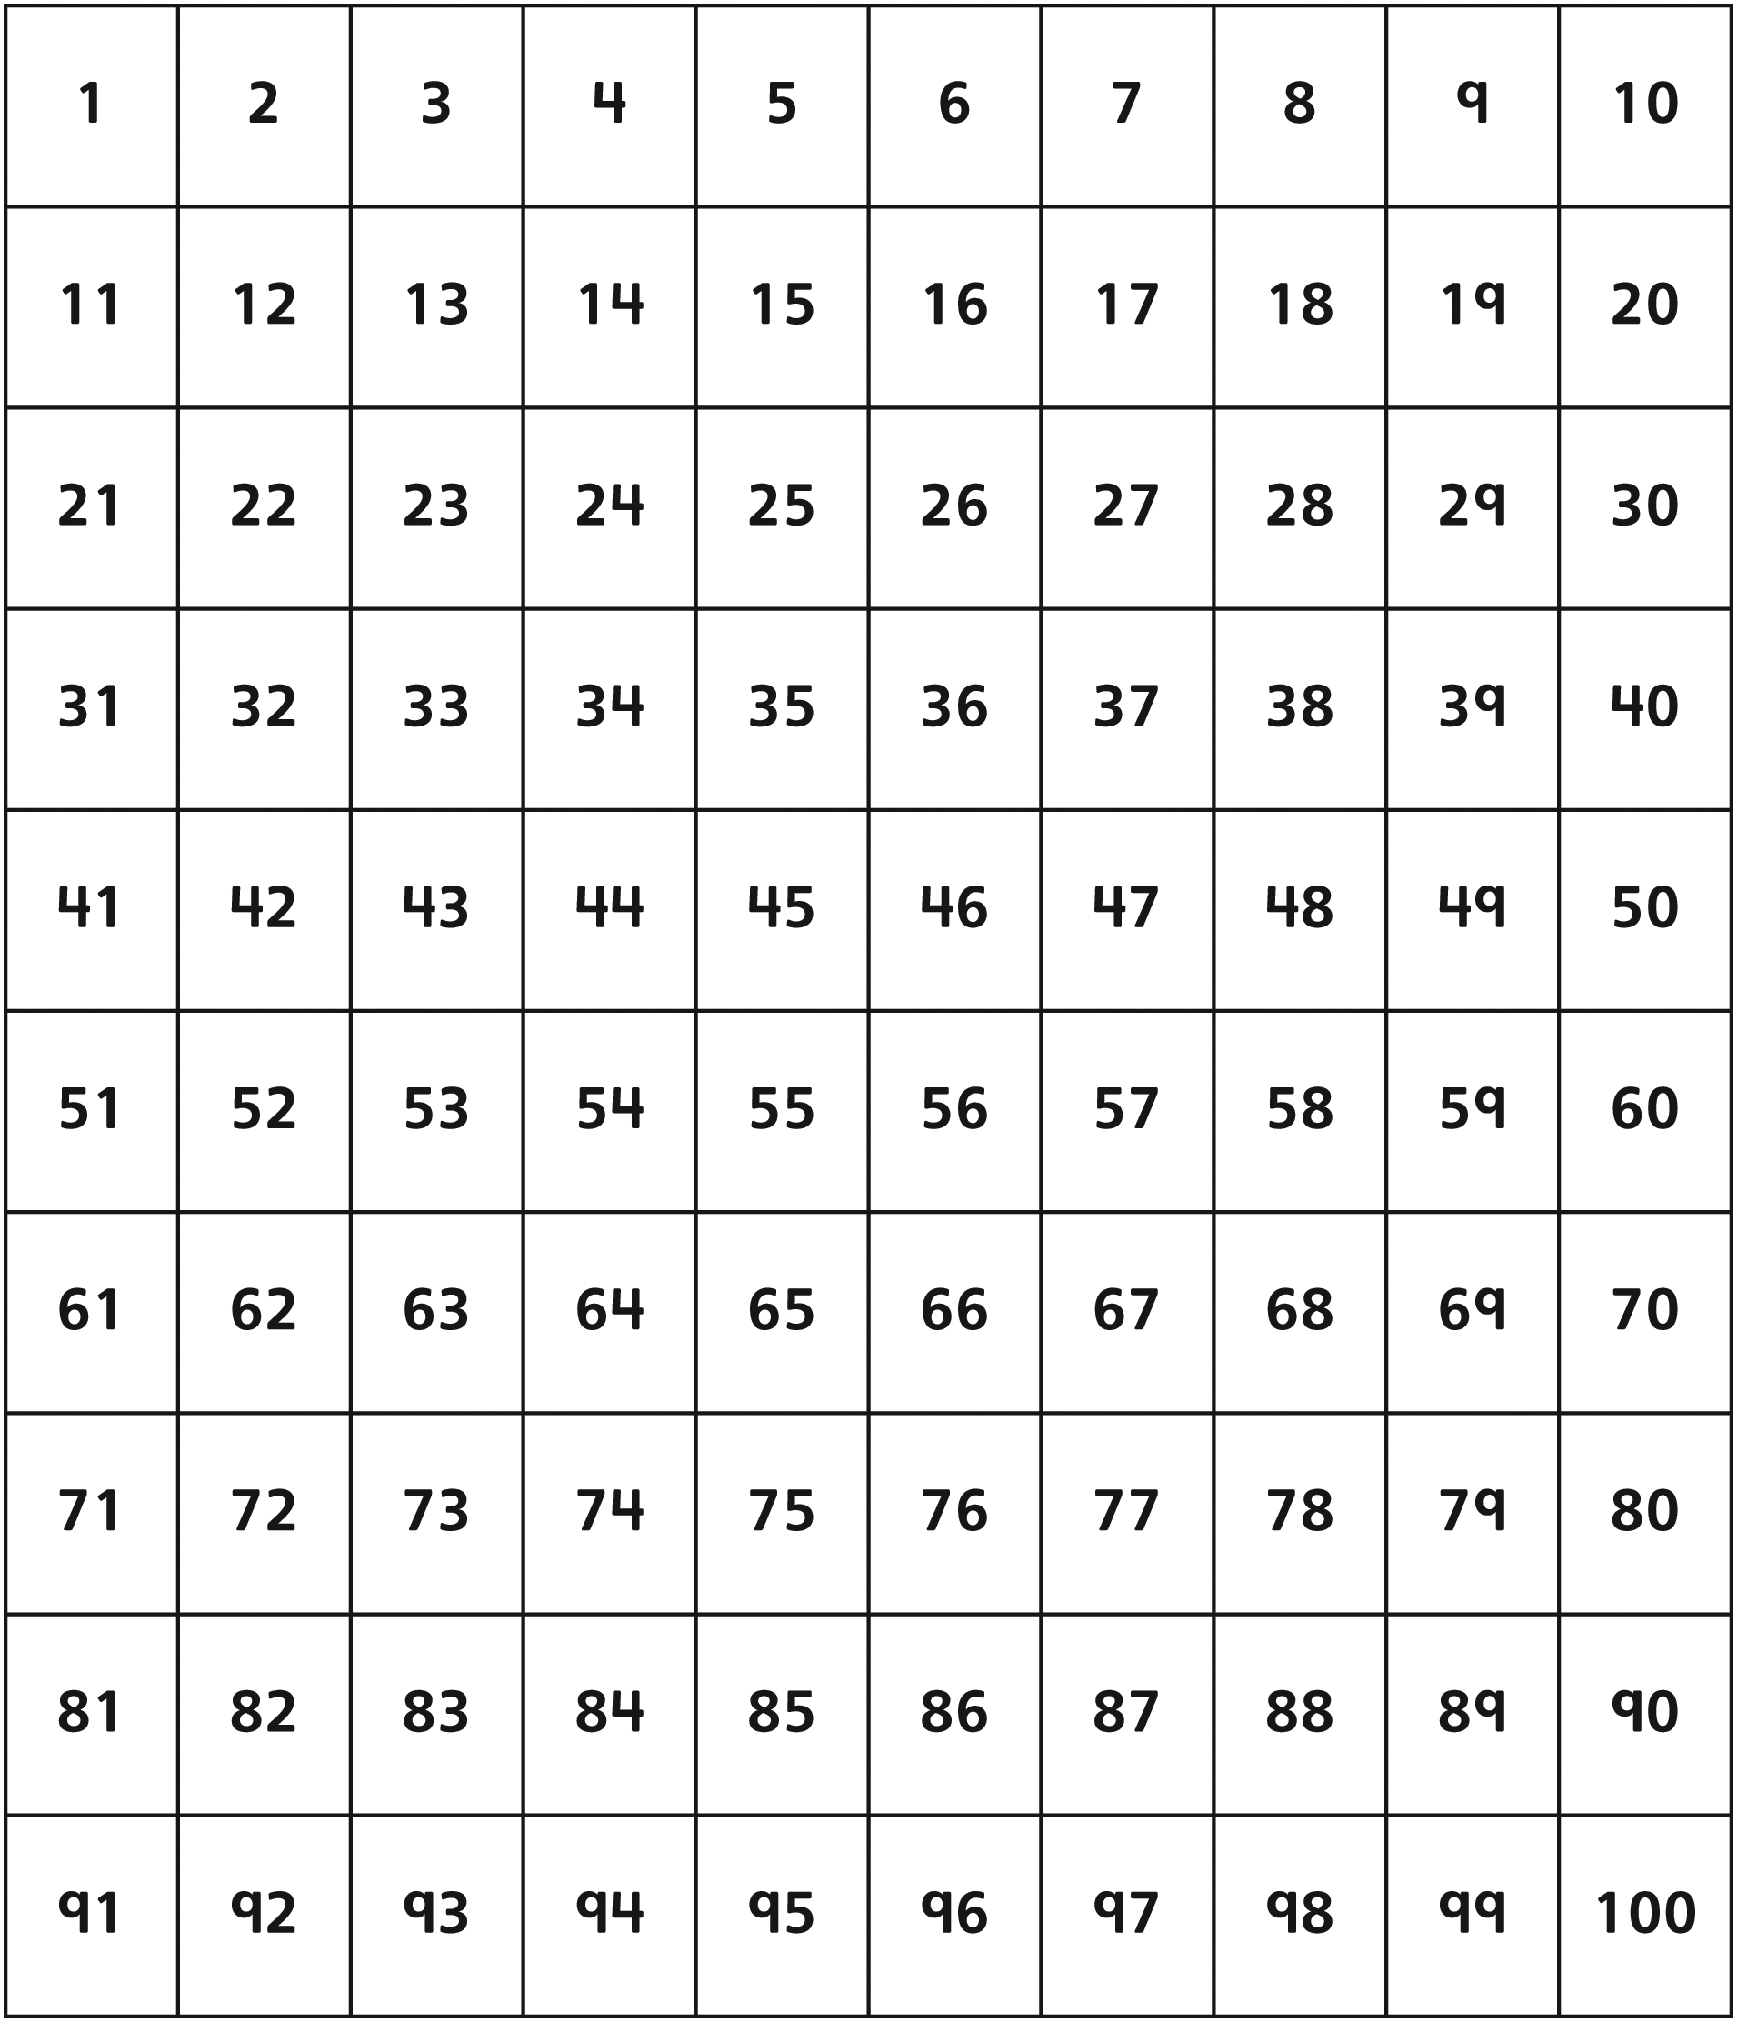

Comparing Patterns Line Master 7
Name: _____________________________

What is the same about our patterns? | What is different about our patterns?

Pattern Cards Line Master 8–1








Pattern Cards Line Master 8–2






big triangle, small triangle

Pattern Cards Line Master 8–3


black line, black line, white star

wide arrow up, thin arrow down

big square, big square, small circle

Pattern Cards Line Master 8–4

black plus sign, white minus sign
2, 4, 6, 8, 10
add 2 each time
1, 2, 4, 8, 16
double the previous number each time

Pattern Cards Line Master 8–5

10, 20, 30, 40, 50
add 10 each time
100, 90, 80, 70, 60
subtract 10 each time
50, 45, 40, 35, 30
subtract 5 each time

Pattern Detectives Line Master 9
Name: _____________________________

Pattern | Location | Pattern Core

Classroom Pattern Quest Line Master 10
Name: _____________________________

My pattern is: ___________________________________________________________
___________________________________________________________________________
___________________________________________________________________________
___________________________________________________________________________
___________________________________________________________________________

Pattern Problems Line Master 11–1

– – – – – – – – – – – – – – – – – – – – – – – – – – – – – – – – – – – – – – – – – –
Extend the pattern.
2, 4, 6, ______, ______, ______, ______, ______, ______, ______
What is the pattern rule?

– – – – – – – – – – – – – – – – – – – – – – – – – – – – – – – – – – – – – – – – – –
Extend the pattern.
25, 50, 75, ______, ______, ______, ______, ______
What is the pattern rule?

– – – – – – – – – – – – – – – – – – – – – – – – – – – – – – – – – – – – – – – – – –

Pattern Problems Line Master 11–2

– – – – – – – – – – – – – – – – – – – – – – – – – – – – – – – – – – – – – – – – – –
Extend the pattern.
100, 90, 80, ______, ______, ______, ______, ______, ______, ______
What is the pattern rule?

– – – – – – – – – – – – – – – – – – – – – – – – – – – – – – – – – – – – – – – – – –
Extend the pattern.
50, 45, 40, ______, ______, ______, ______, ______, ______, ______
What is the pattern rule?

– – – – – – – – – – – – – – – – – – – – – – – – – – – – – – – – – – – – – – – – – –

Pattern Problems Line Master 11–3

– – – – – – – – – – – – – – – – – – – – – – – – – – – – – – – – – – – – – – – – – –
10, 20, 30, ______, ______
Which numbers extend the pattern?

a) 35, 40
b) 40, 50
c) 50, 100

What is the pattern rule?

– – – – – – – – – – – – – – – – – – – – – – – – – – – – – – – – – – – – – – – – – –
25, 20, 15, ______, ______
Which numbers extend the pattern?

a) 10, 5
b) 20, 25
c) 14, 12

What is the pattern rule?

– – – – – – – – – – – – – – – – – – – – – – – – – – – – – – – – – – – – – – – – – –

