The Best Surprise Line Master 1
(Assessment Master)
Name: _____________________________

Explore Growing and Shrinking Patterns | Not observed | Sometimes | Consistently
Identifies and describes increasing and decreasing patterns
Extends increasing and decreasing patterns
Identifies missing terms
Identifies pattern rules
Investigate Number Patterns
Identifies and describes number patterns
Extends and creates number patterns
Identifies missing terms
Identifies pattern rules
Makes connections to addition and subtraction
Strengths:

Next Steps:

Connecting Home and School Line Master 2–1

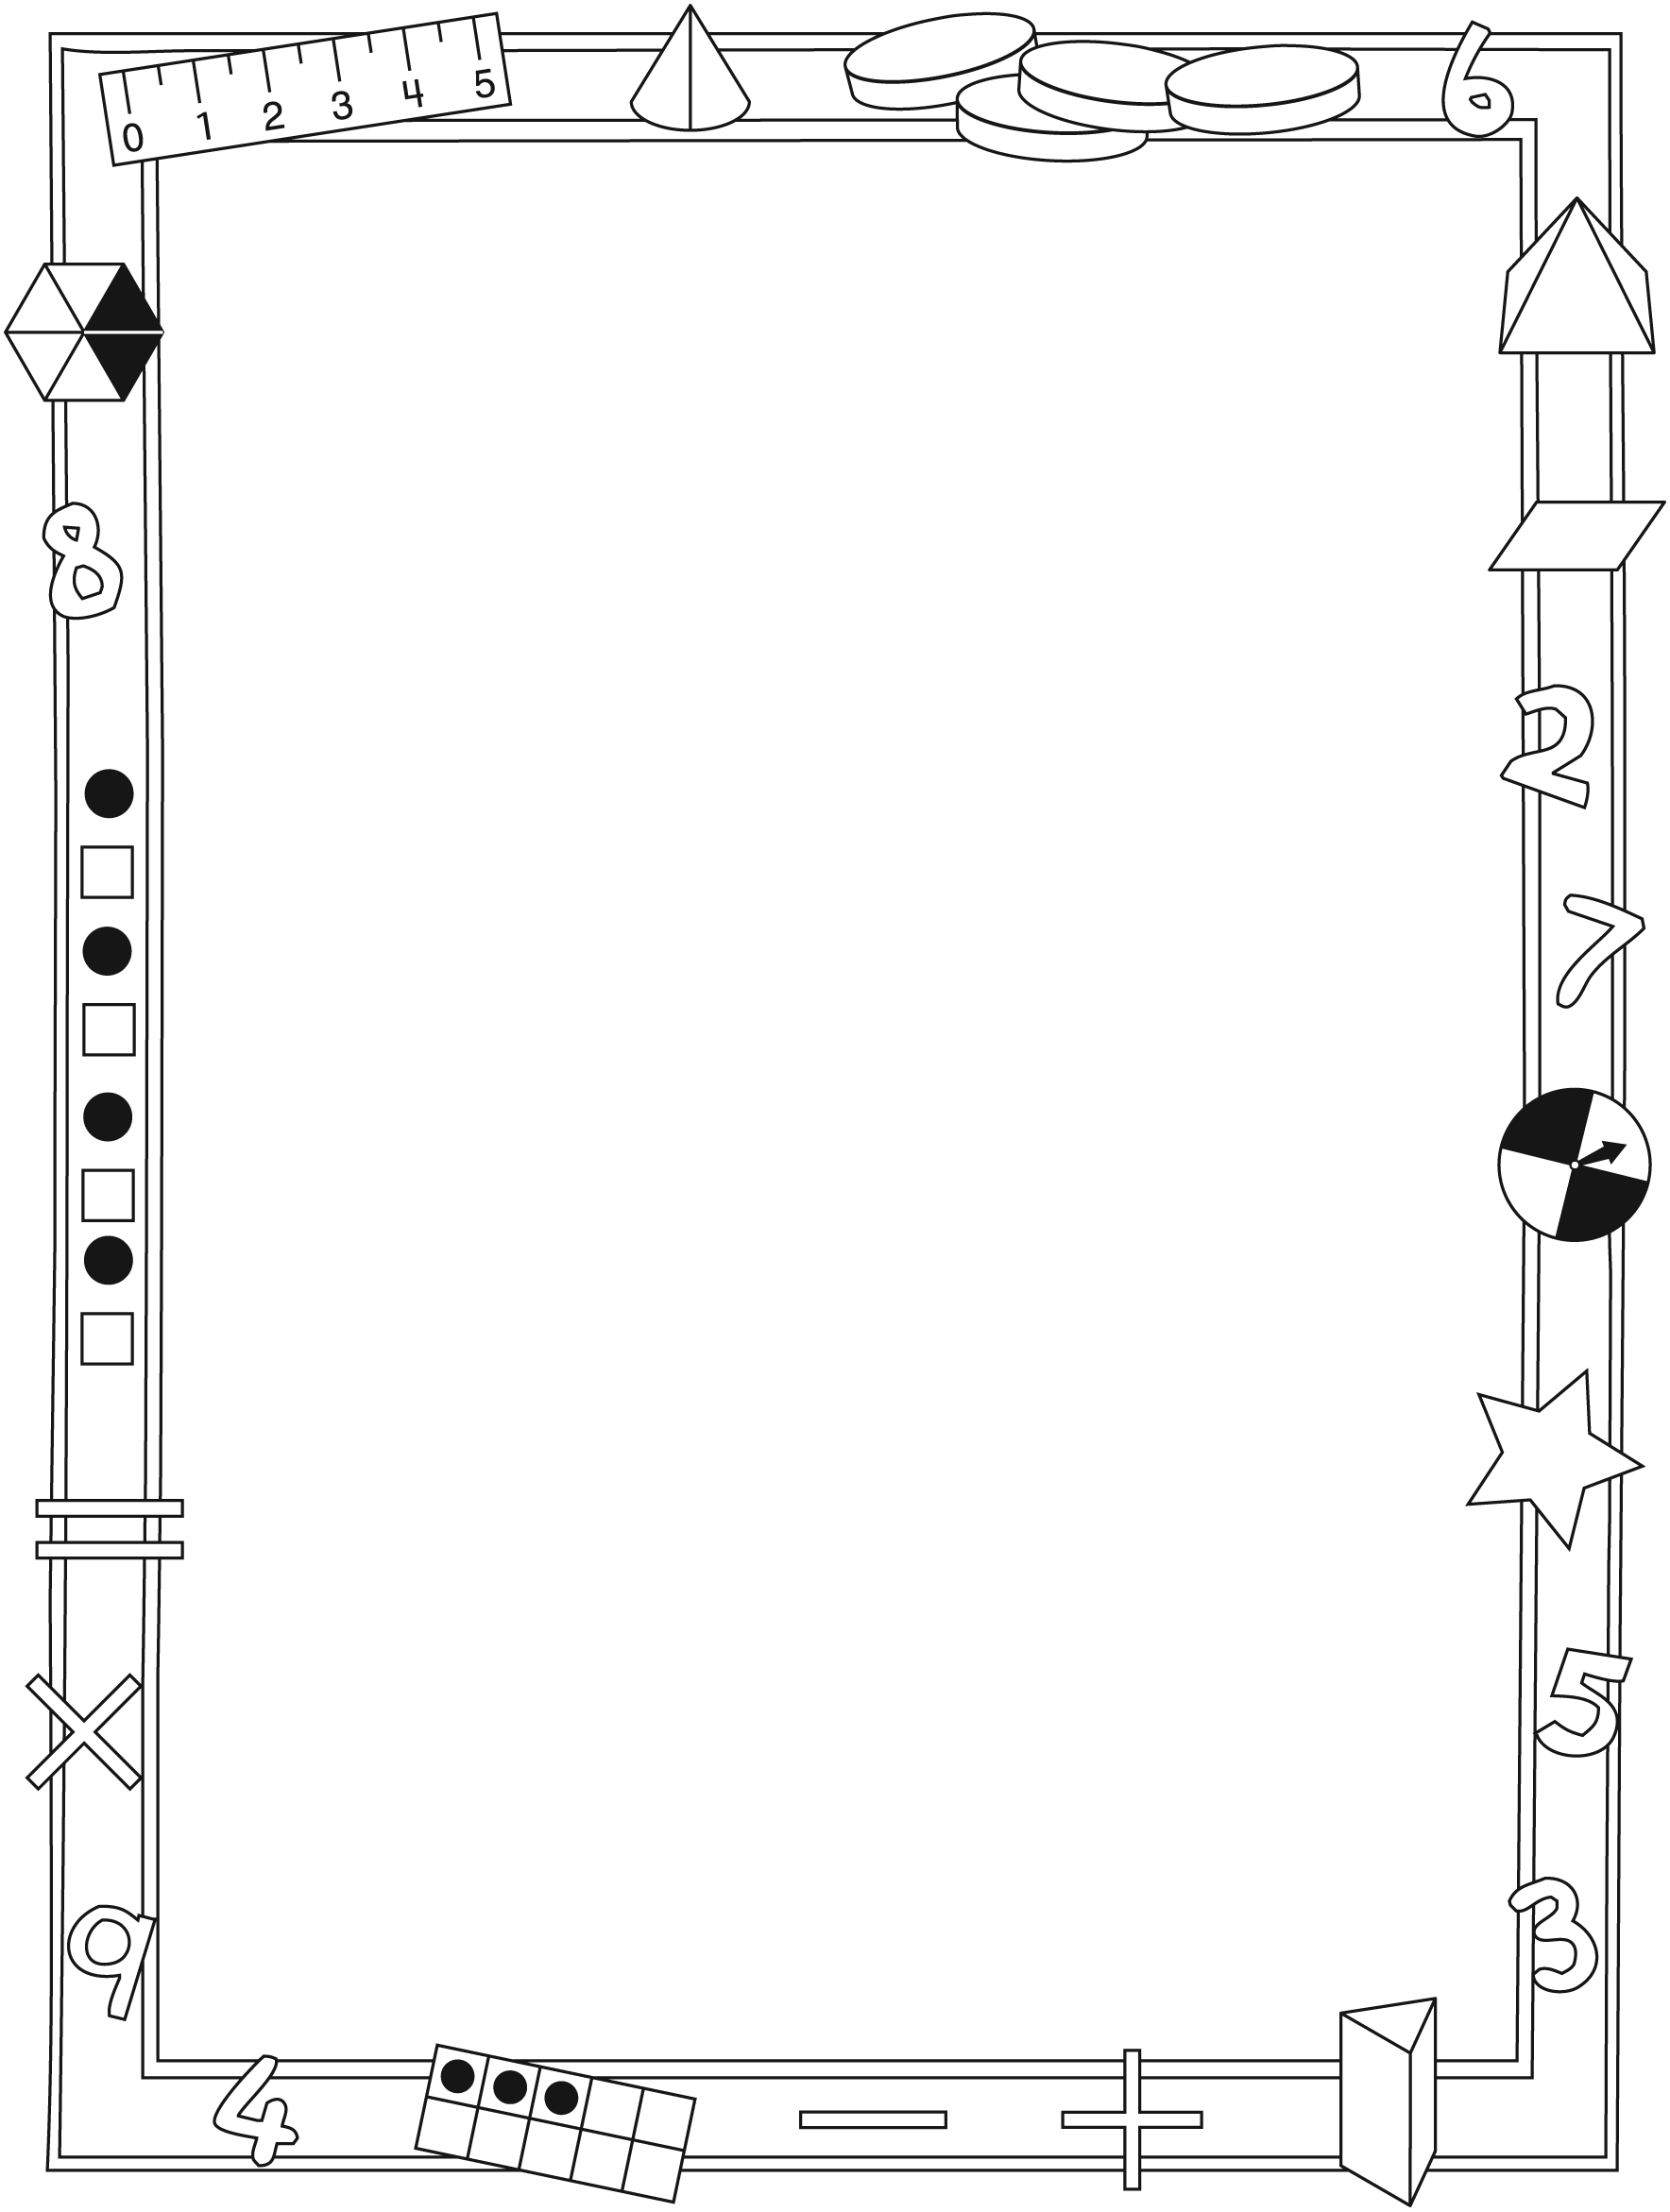

NOTE TO THE TEACHER

You may wish to send families a The Best Surprise letter outlining a familiar activity or two they can do at home with their children.

Create a letter using this template and select one or two activities from the suggestions on the next page. Simply delete these instructions and cut and paste the activities you have selected, adapting them to fit your needs.

Connecting Home and School Line Master 2–2

Dear Family:

We have been working on The Best Surprise, which engages children in conversations, investigations, and activities that help to develop their understanding of the big math idea that “Patterns can be described mathematically.” Particular focus is placed on investigating
increasing/ decreasing patterns, and investigating number patterns.
Try this activity at home with your child.
– – – – – – – – – – – – – – – – – – – – – – – – – – – – – – – – – – – – – – – – – –
Reading the Story: As you read this story together, encourage your child to keep track of the number of tokens and tickets that Ethan and Emma receive and use as they enjoy the fair. In class, we’ve been identifying rules for how patterns grow and/or shrink. Encourage your child to look for and describe patterns in the illustrations and to identify the pattern rules.
– – – – – – – – – – – – – – – – – – – – – – – – – – – – – – – – – – – – – – – – – –
Environmental Patterns: Addresses, apartment numbers, elevator buttons, and calendars can all be examples of number patterns in our environment. Go on number pattern searches with your child or draw his/her attention to patterns you notice. For example, as you walk, focus on house numbers. Chant the numbers aloud, and stop at intervals to ask your child to say the next upcoming house number. Alternatively, while on an elevator or looking at a calendar, cover a number. Then, ask your child to tell the number you covered and to explain how she/he knows.
– – – – – – – – – – – – – – – – – – – – – – – – – – – – – – – – – – – – – – – – – –
Change Machine: With your child, play a round of the game shown on page 16 of The Best Surprise. This game involves a machine that changes numbers according to the rule “add 4.” Say a number that is not on the board, and challenge your child to tell you what number would come out. For example,
say: Suppose 8 goes in the machine. What number comes out? Secretly choose another change rule (e.g., subtract 2). Create an In–Out chart with at least 4 numbers going in and coming out. Invite your child to figure out the new rule. For example, say: This time, 6 goes in the machine. What number will come out? How do you know?
– – – – – – – – – – – – – – – – – – – – – – – – – – – – – – – – – – – – – – – – – –
Sincerely,

___________________________

The Best Surprise Line Master 3
Math Mat

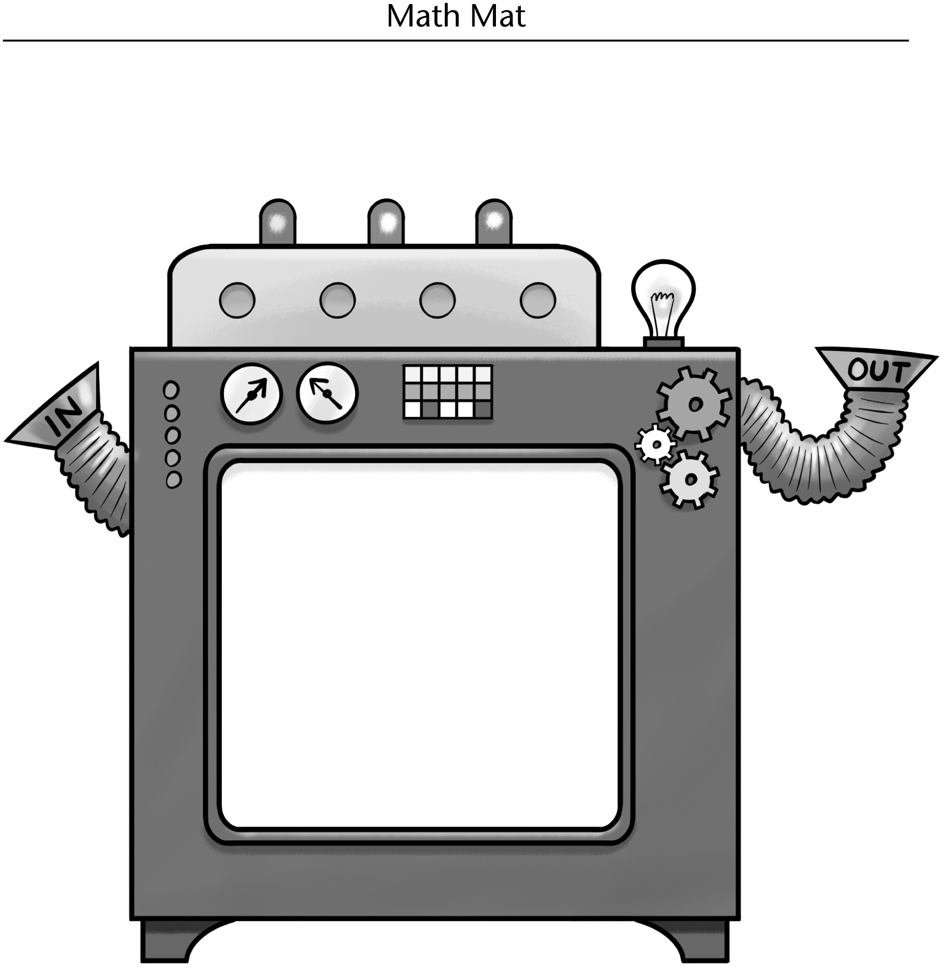

Tokens and Tickets Line Master 4
Name: _____________________________

Tokens | Tickets

1 | 2 | 3 | 4 | 5 | 6 | 7 | 8 | 9 | 10
11 | 12 | 13 | 14 | 15 | 16 | 17 | 18 | 19 | 20
21 | 22 | 23 | 24 | 25 | 26 | 27 | 28 | 29 | 30
31 | 32 | 33 | 34 | 35 | 36 | 37 | 38 | 39 | 40
41 | 42 | 43 | 44 | 45 | 46 | 47 | 48 | 49 | 50

Pattern Starters Line Master 5–1

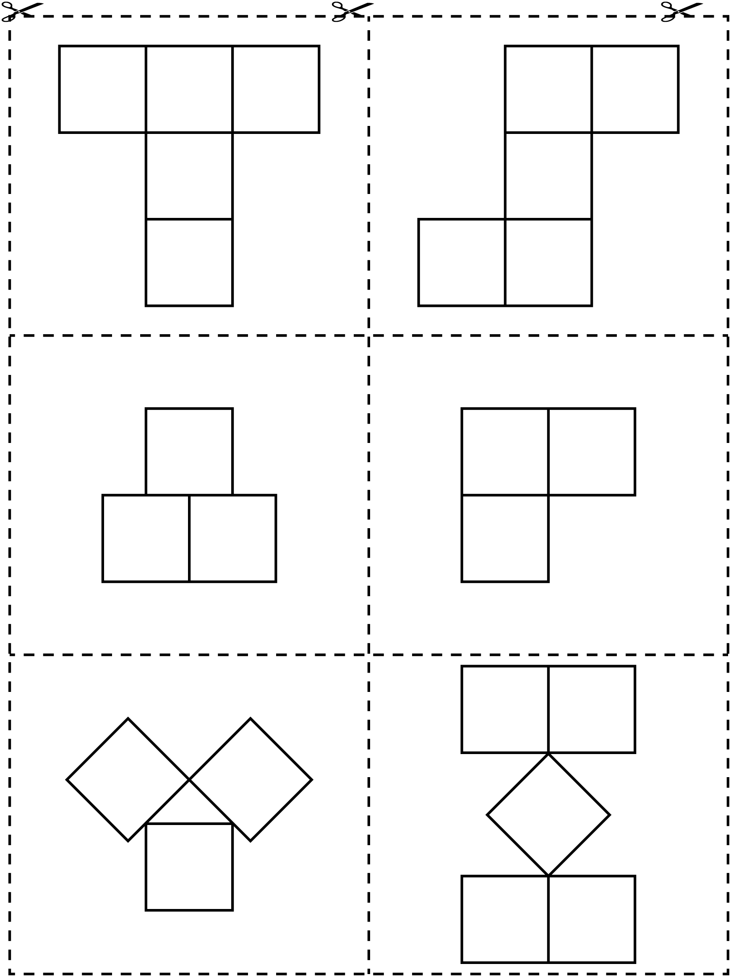

Pattern Starters Line Master 5–2

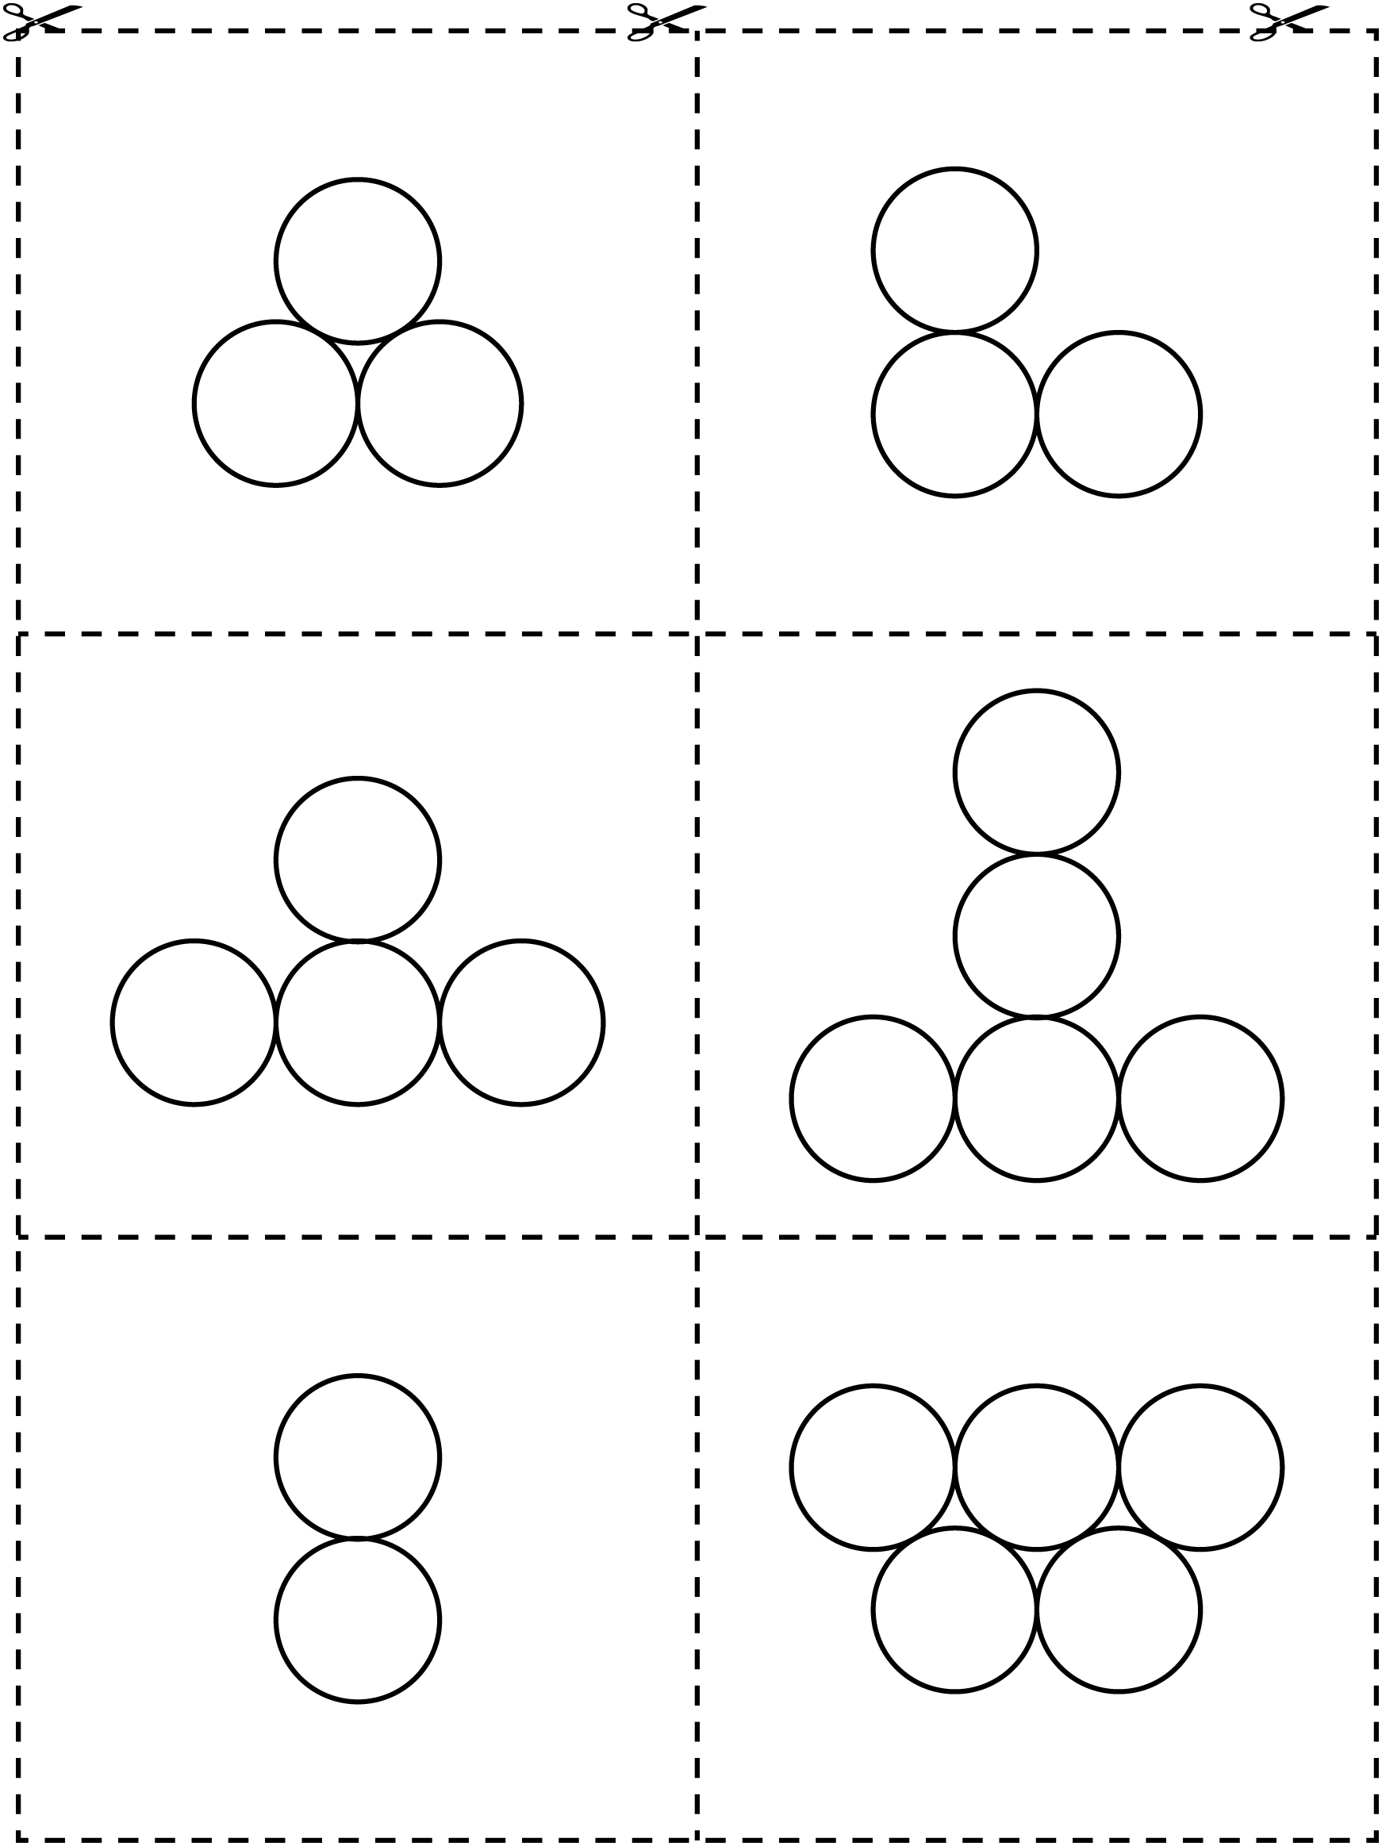

Make a Change Machine Line Master 6–1

Materials
• 2 L beverage carton
• 2 cardstock or tagboard strips, one 7 cm × 28 cm and one 7 cm × 20 cm
• ruler
• masking tape or duct tape
• scissors or utility knife
• contact paper

Instructions
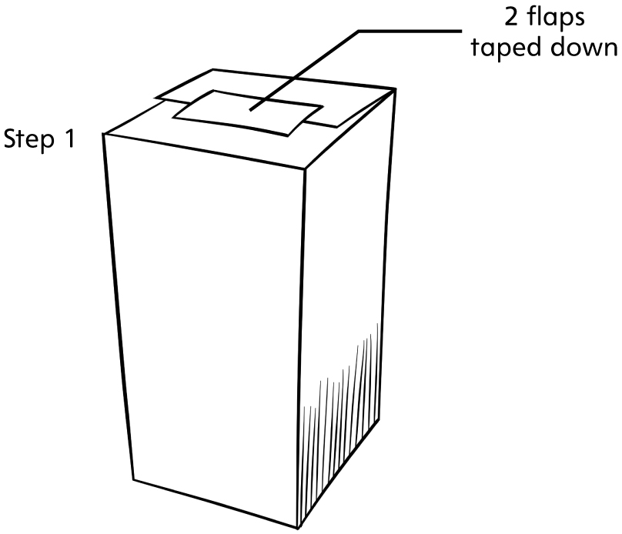Note: Change Machines should be made only by the teacher.
1. Cut the top of the carton open.
Cut off two opposite flaps, and then tape the other two down.

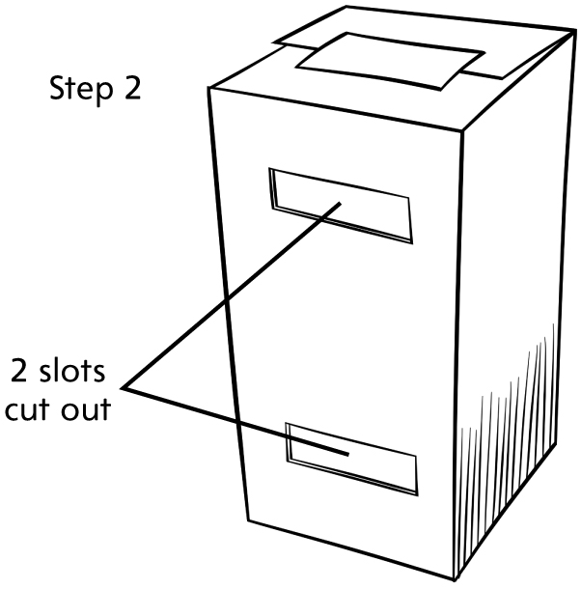
2. Draw two rectangular slots, each about 8 cm by 2 cm, about 6.5 cm apart, on one side of the carton. Cut out the slots.

Make a Change Machine Line Master 6–2

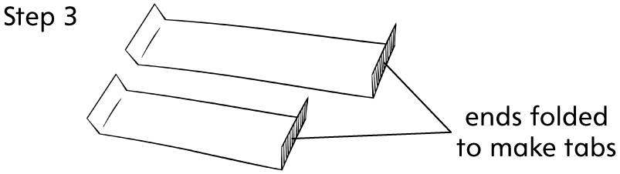3. Fold up about 3 cm on the ends of both strips to make tabs.

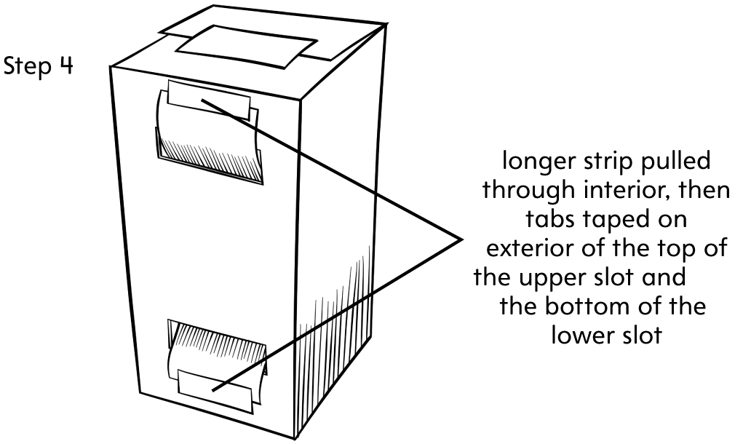
4. Pull the longer strip through the slots in the carton, so that most of the strip is in the interior of the carton and the tabs are on the exterior. On the exterior of the carton, tape the tabs to the top of the upper slot and the bottom of the lower slot.

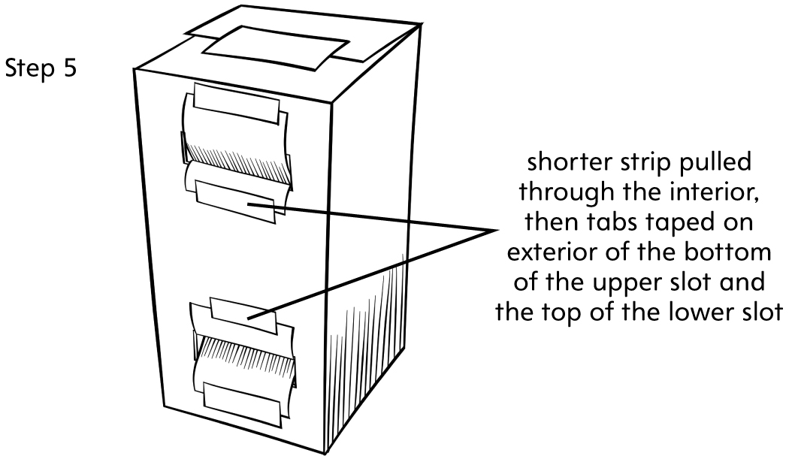
5. Pull the shorter strip through the slots of the carton, so that most of the strip is in the interior of the carton and the tabs are on the exterior. On the exterior of the carton, tape the tabs to the bottom of the upper slot and the top of the lower slot.

6. Decorate the exterior of your change machine with contact paper. Children will enjoy making decorating suggestions.

What’s the Number? Line Master 7

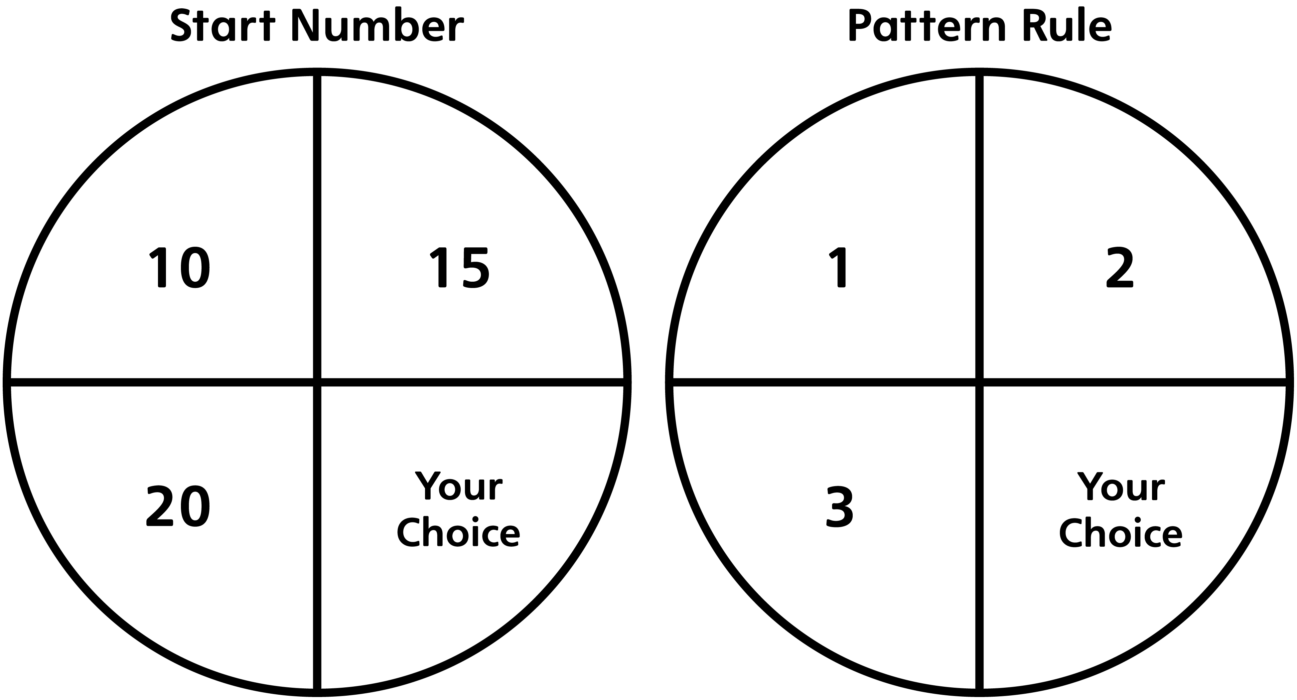

How to play:
1. Find your start number. Write it on a card.

2. Find your pattern rule. Decide if you will make your pattern grow or if you will make your pattern shrink.

3. Create 5 more cards by writing a different number that belongs to your pattern on each card.

4. Put your cards in order in a row beside your start card.

5. Ask your partner, “What’s the number?”

Pattern Challenges Line Master 8–1
– – – – – – – – – – – – – – – – – – – – – – – – – – – – – – – – – – – – – – – – – –
2, 4, 6, 8, 10, 12

The pattern rule is _______________________________________________________ .
– – – – – – – – – – – – – – – – – – – – – – – – – – – – – – – – – – – – – – – – – –
5, 10, 15, 20, 25, 30

The pattern rule is _______________________________________________________ .
– – – – – – – – – – – – – – – – – – – – – – – – – – – – – – – – – – – – – – – – – –
13, 16, 19, 22, 25, 28

The pattern rule is _______________________________________________________ .
– – – – – – – – – – – – – – – – – – – – – – – – – – – – – – – – – – – – – – – – – –
90, 80, 70, 60, 50, 40

The pattern rule is _______________________________________________________ .
– – – – – – – – – – – – – – – – – – – – – – – – – – – – – – – – – – – – – – – – – –
20, 18, 16, 14, 12, 10

The pattern rule is _______________________________________________________ .
– – – – – – – – – – – – – – – – – – – – – – – – – – – – – – – – – – – – – – – – – –
45, 40, 35, 30, 25, 20

The pattern rule is _______________________________________________________ .
– – – – – – – – – – – – – – – – – – – – – – – – – – – – – – – – – – – – – – – – – –

Pattern Challenges Line Master 8–2

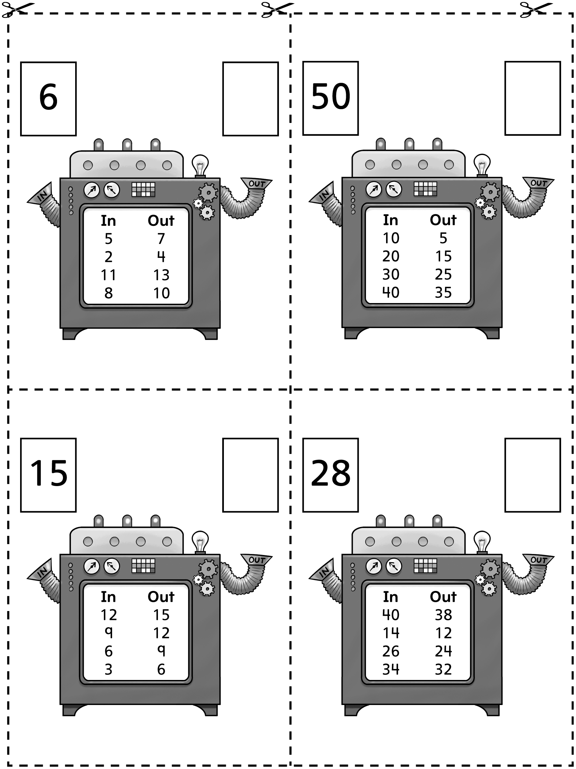

Pattern Challenges Line Master 8–3
– – – – – – – – – – – – – – – – – – – – – – – – – – – – – – – – – – – – – – – – – –
Use the numbers to make a pattern.

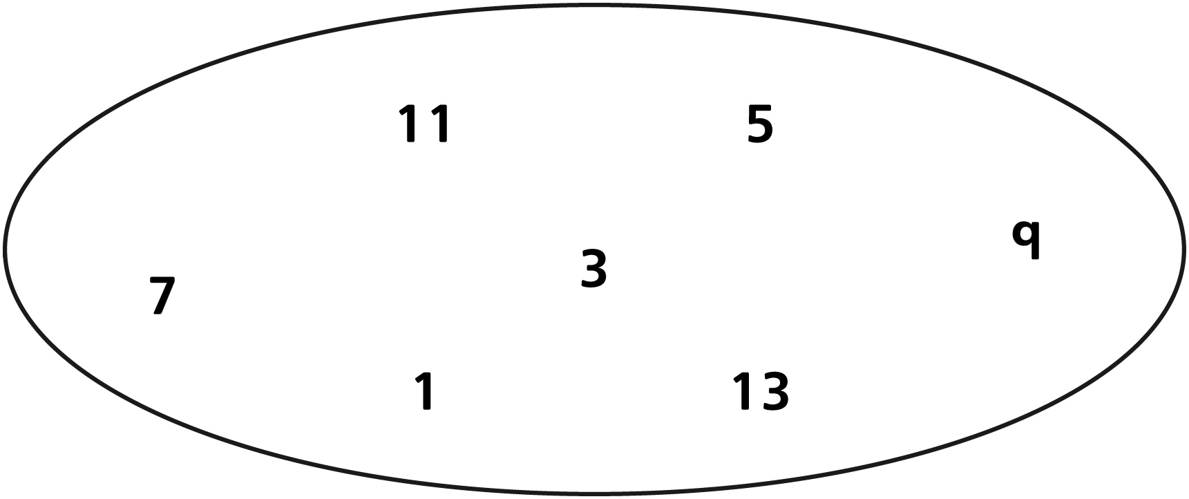

_________ _________ _________ _________ _________ _________ _________
– – – – – – – – – – – – – – – – – – – – – – – – – – – – – – – – – – – – – – – – – –
Use the numbers to make a pattern.

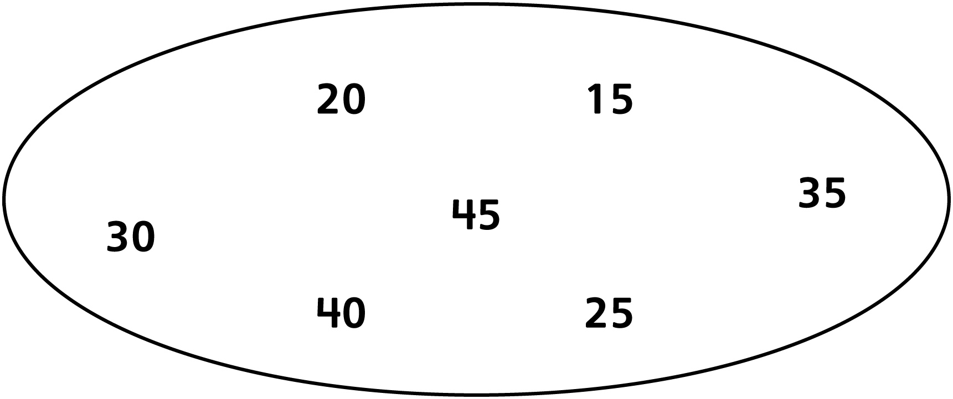

_________ _________ _________ _________ _________ _________ _________
– – – – – – – – – – – – – – – – – – – – – – – – – – – – – – – – – – – – – – – – – –

Pattern Challenges Line Master 8–4
– – – – – – – – – – – – – – – – – – – – – – – – – – – – – – – – – – – – – – – – – –
Use the numbers to make a pattern.

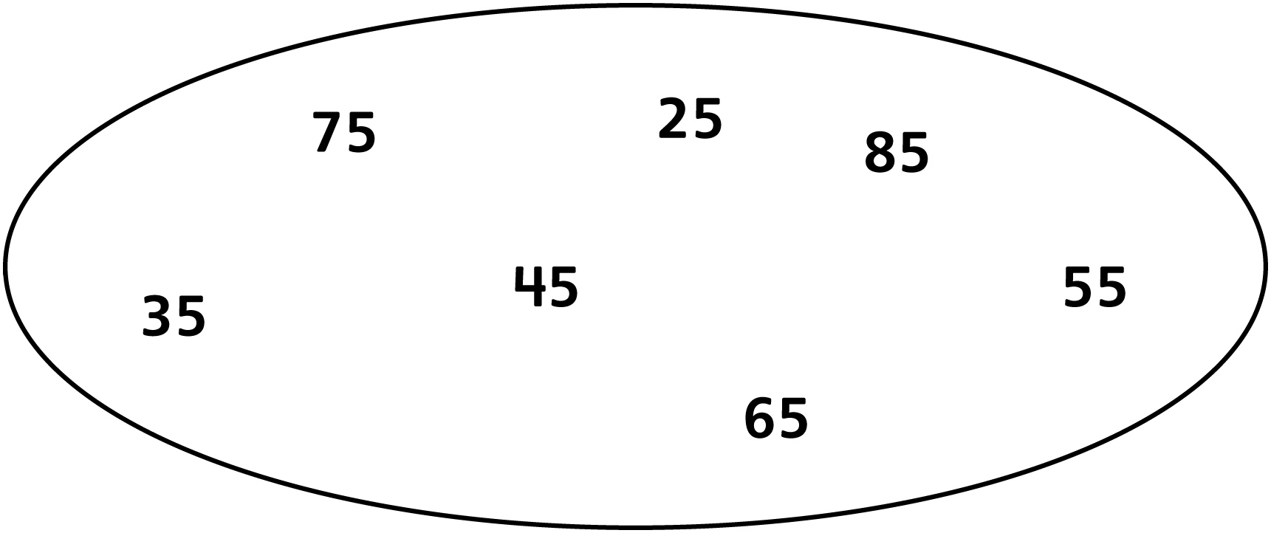

_________ _________ _________ _________ _________ _________ _________
– – – – – – – – – – – – – – – – – – – – – – – – – – – – – – – – – – – – – – – – – –
Use the numbers to make a pattern.

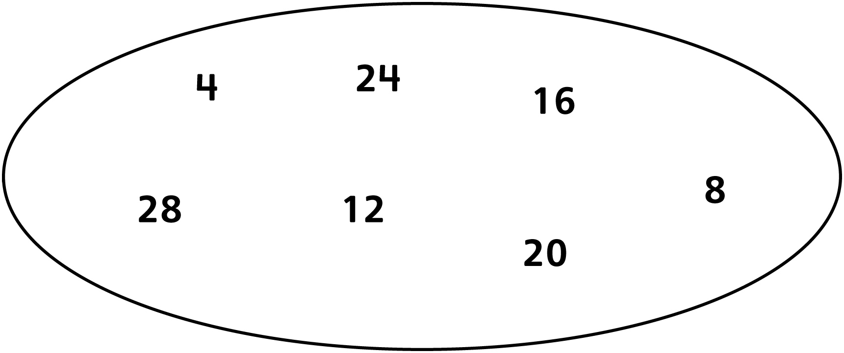

_________ _________ _________ _________ _________ _________ _________
– – – – – – – – – – – – – – – – – – – – – – – – – – – – – – – – – – – – – – – – – –

Pattern Challenges Line Master 8–5
– – – – – – – – – – – – – – – – – – – – – – – – – – – – – – – – – – – – – – – – – –
What comes next?

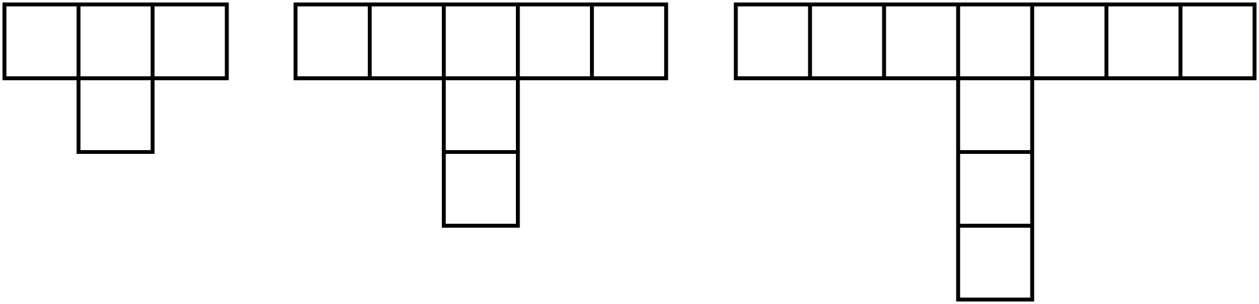
– – – – – – – – – – – – – – – – – – – – – – – – – – – – – – – – – – – – – – – – – –
What comes next?

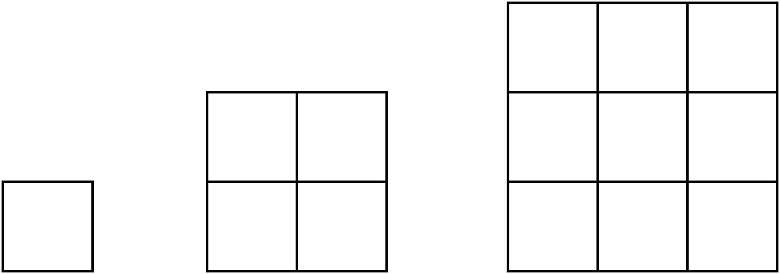
– – – – – – – – – – – – – – – – – – – – – – – – – – – – – – – – – – – – – – – – – –

Pattern Challenges Line Master 8–6
– – – – – – – – – – – – – – – – – – – – – – – – – – – – – – – – – – – – – – – – – –
What comes next?

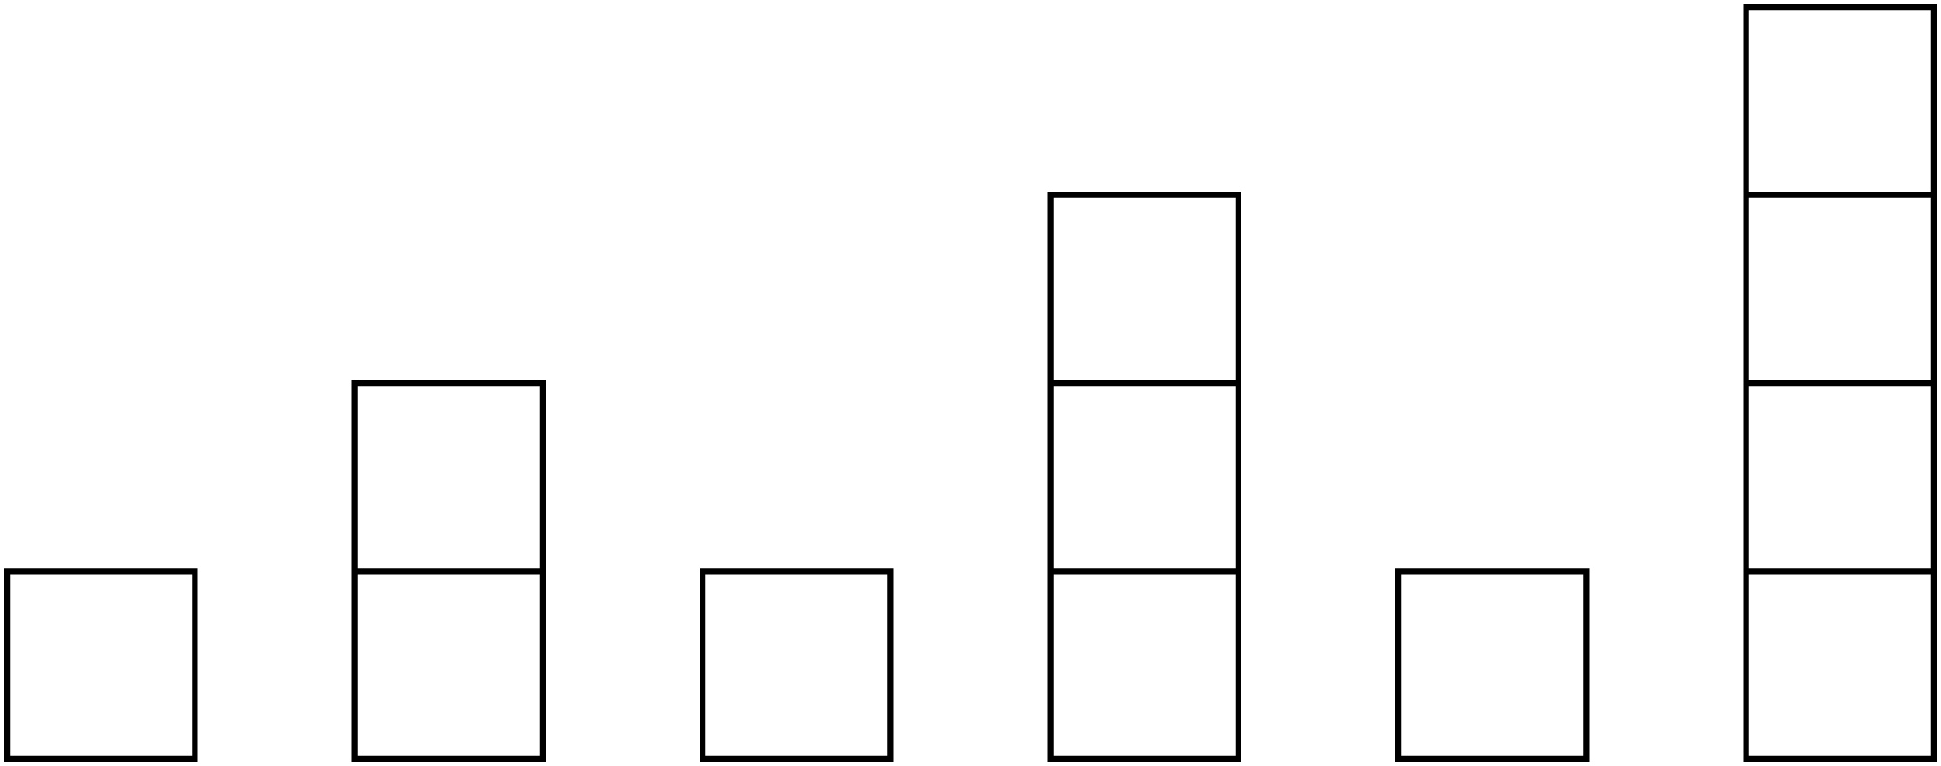
– – – – – – – – – – – – – – – – – – – – – – – – – – – – – – – – – – – – – – – – – –
What comes next?

– – – – – – – – – – – – – – – – – – – – – – – – – – – – – – – – – – – – – – – – – –

Pattern Challenges Line Master 8–7
– – – – – – – – – – – – – – – – – – – – – – – – – – – – – – – – – – – – – – – – – –
What comes next?

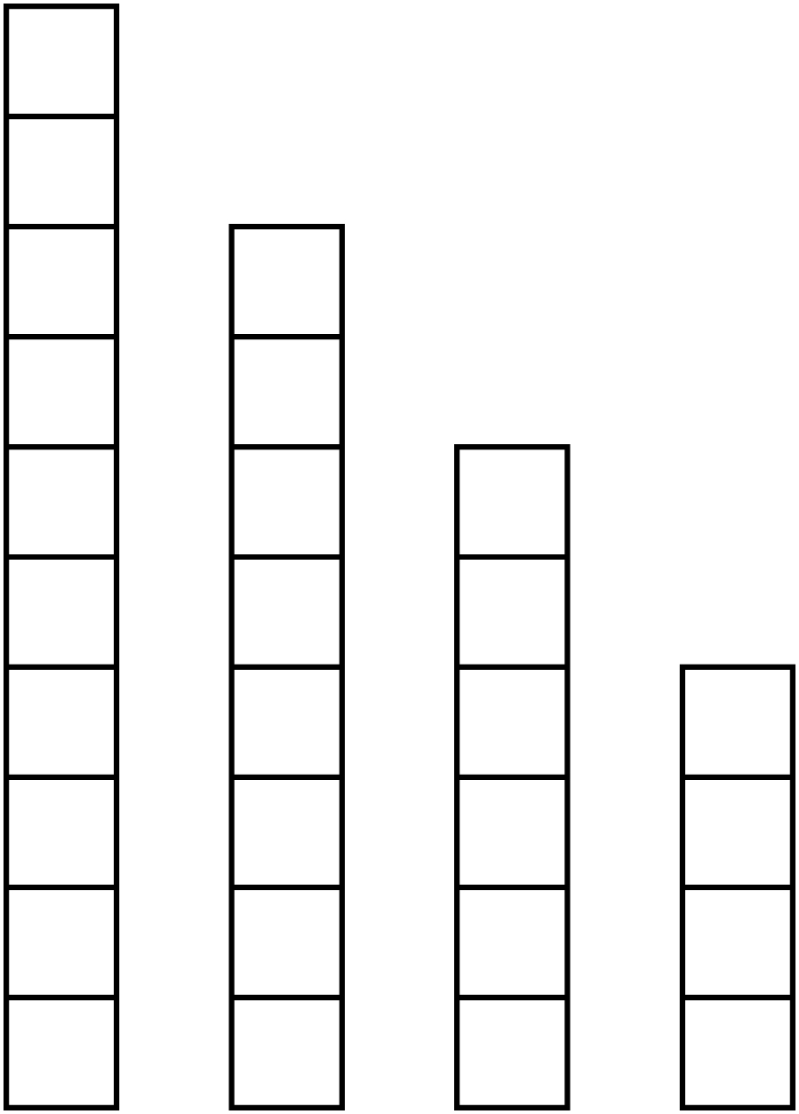
– – – – – – – – – – – – – – – – – – – – – – – – – – – – – – – – – – – – – – – – – –
What comes next?

– – – – – – – – – – – – – – – – – – – – – – – – – – – – – – – – – – – – – – – – – –

