Investigating Geometric Properties of 2-D Shapes
Uses geometric properties to compare and sort shapes  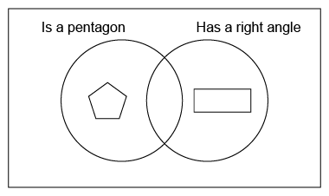  “I need a shape with 5 sides and at least one right angle to go in the overlap.” | Sorts and classifies shapes in more than one way using geometric properties  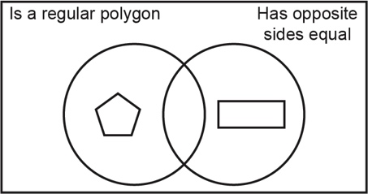  “The sorting rule could also be ‘Is a regular polygon and has opposite sides equal.’” | Investigates the relationships between the sides and between the vertices of a polygon  “A rectangle has 2 pairs of parallel sides. The connected sides are perpendicular, so it has four 90° angles. It is an irregular polygon.” | Notices that geometric properties of a polygon do not change after a transformation  “After a rotation, the image faces a different way but still has 4 equal sides and opposite angles equal.”
Observations/Documentation

