Measuring Length and Perimeter
Uses benchmarks to estimate in standard units (m, cm, mm)  “I used a big step as a referent for one metre. The classroom is about 7 big steps, or 7 m wide.  Its perimeter is about 30 big steps, or 30 m.” | Measures using standard units (m, cm, mm)  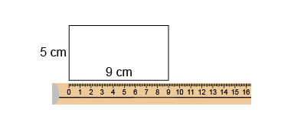  “The perimeter is 28 cm.” | Selects and uses appropriate standard units  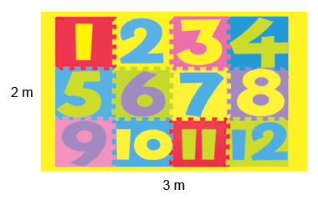  “I would use m because cm and mm are too small. The perimeter is 10 m because 3 + 2 + 3 + 2 = 10.”
Observations/Documentation

Measuring Length and Perimeter (con’t)
Relates standard units of length  (1 m = 100 cm, 1 cm = 10 mm, 1 m = 1000 mm)  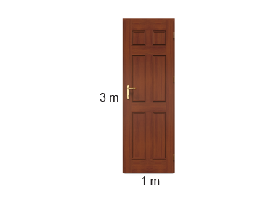  “The door has a perimeter of 8 m.  Since 1 m = 100 cm, 8 m = 800 cm.  Since 1 m = 1000 mm, 8 m = 8000 mm.”  “The door has a perimeter of 8 m.  Since 1 m = 100 cm, 8 m = 800 cm.  Since 1 m = 1000 mm, 8 m = 8000 mm.” | Measures using imperial units (inch, foot, yard)  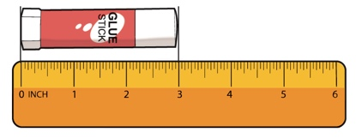  “The glue stick is 3 inches long.” | Flexibly approximates conversions among imperial units and between metric and imperial units  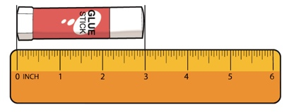  “There are about 2 cm in 1 inch.  So, 3 inches is about 3 × 2 cm, or 6 cm.  The glue stick is about 6 cm long.”
Observations/Documentation

