Using Measurement of Time
Understands relationships among time units (hours, minutes, seconds)  “1 h = 60 min  Or, 1 min = $\frac{1}{60}$ of an hour | Uses relationships among time units to represent equivalent lengths of time  The movie takes 2 h. How many minutes is that?  “1 h = 60 min  So, 2 h = 120 min” | Uses intervals to say the time (e.g., to the nearest minute)  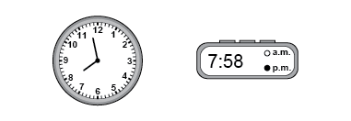  “Both the analogue and digital clocks read: Seven fifty-eight p.m., or 2 minutes before 8 p.m.”
Observations/Documentation

Using Measurement of Time (con’t)
Tells time in more than one way  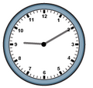  “It is 10 min after 9, or 50 min before 10.” | Tells time using 24-hour clocks  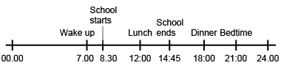  “I created a timeline to record the times of my daily activities using a 24-hour clock. I converted 12-hour p.m. times to 24-hour times.” | Flexibly solves problems involving time using various strategies and the relationships among units  Student A arrived at a party at 1:40 p.m.  Student B arrived at 25 min to 2 in the afternoon. Student C arrived at 14:05.  Who arrived first? Who arrived last?  “Student A: 1:40 p.m.  Student B: 1:35 p.m.  Student C: 2:05 p.m.  Student B arrived first. Student C arrived last.”
Observations/Documentation

