Rounding Numbers
Uses the first digit to round, not considering the other digits  “To the nearest thousand, 3632 rounds to 3000.  I kept the 3 and changed all the other digits to 0.” | Identifies benchmark numbers (multiples of 10, 100, 1000, or 10 0000)  “3632 is between 3000 and 4000.” | Compares to benchmark numbers (multiples of 10, 100, 1000, or 10 000)  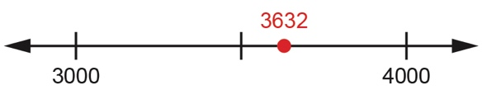  “3632 is closer to 4000 than to 3000.”
Observations/Documentation

Rounding Numbers (con’t)
Uses benchmark numbers to round to the nearest ten, hundred, thousand, or ten thousand  “Since 3632 is closer to 4000 than to 3000,  3632 rounded to the nearest thousand is 4000.” | Flexibly rounds numbers to different places  “34 528 rounded to the nearest ten thousand is 30 000, to the nearest thousand is 35 000, to the nearest hundred is 34 500, and to the nearest 10 is 34 530.” | Identifies situations where rounding numbers is appropriate  “The driving distance between Calgary and Edmonton is about 300 km. The exact number is not needed.”
Observations/Documentation

