Comparing and Ordering Quantities
Models numbers and compares blocks  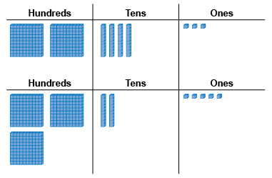  “325 has one more hundred flat,  so it is greater than 243.” | Compares numbers with benchmarks  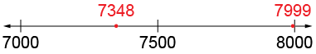  “I compared the numbers to 7500. 7348 is less than 7500 and 7999 is almost 8000.  So, 7999 is greater.” | Visualizes benchmarks on a number line to compare  “I picture 7999 farther to the right on the line than 7348. So, 7999 is greater than 7348.”
Observations/Documentation

Comparing and Ordering Quantities (cont’d)
Uses place value understanding to compare numbers, digit by digit  “Both start with 5.  4 thousands is less than 6 thousands,  both have 3 hundreds,  2 tens is greater than 0 tens,  and 0 ones is less than 2 ones.  So, 54 320 is less than 56 302.” | Compares and orders three or more numbers using a variety of strategies  54 320 56 302 35 560  “I first compare using ten thousands,  then compare 54 320 and 56 302 using thousands.” | Compares numbers flexibly and records comparisons symbolically (<, =, >)  54 320 < 56 302  “Both numbers have 5 ten thousands,  but 56 302 has more thousands.”
Observations/Documentation

