Developing Meaning of Addition and Subtraction
Models concretely to add and subtract  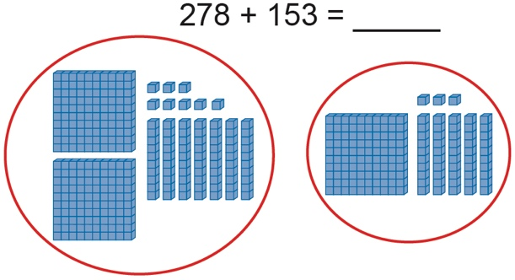  “278” “378, 388, 398, 408, 418, 428, 429,  430, 431” | Models and symbolizes addition and subtraction  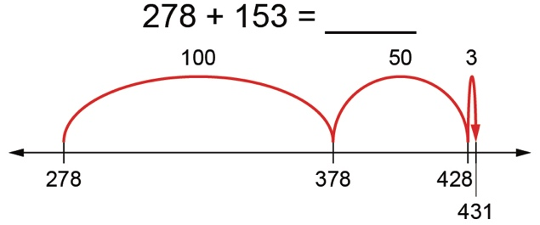  “I add 5 tens and 3 ones.  78 + 53 = 78 + 50 + 3, or 131” | Uses standard algorithm to add and subtract  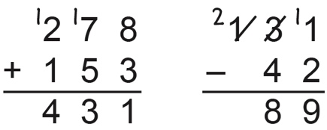
Observations/Documentation

Developing Meaning of Addition and Subtraction (con’t)
Estimates sums and differences to check reasonableness  131 – 42 = 89  “130 – 40 = 90, which is close to  89 so my answer is reasonable.” | Creates and solves problems  “There are 131 birds in the tree.  Some birds flew away.  Now there are 42 birds in the tree.  How many birds flew away?”  131 − = 42  89 birds flew away. | Uses properties and inverse operations of addition and subtraction to solve problems  131 − = 42  “I can think addition to help me solve the problem:  42 + = 131”
Observations/Documentation

