Dividing 1-Digit Numbers
Models using equal sharing  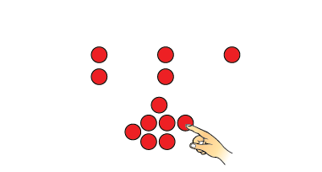 | Models using equal grouping, counting by 1s  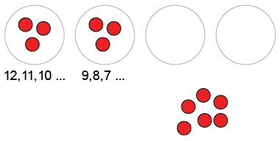  “I know 3 go in each group.” | Models using equal grouping, skip-counting backward  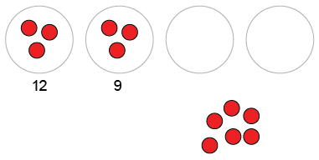 | Uses repeated subtraction  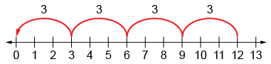  “4 jumps of 3 backward is the same as 12 – 3 – 3 – 3 – 3 = 0.”
Observations/Documentation

Dividing 1-Digit Numbers (con’t)
Models using multiplicative thinking, and uses division symbol  “12 divided into groups of 3 is  4 groups  12 ÷ 3 = 4.” | Divides fluently  “I know 12 ÷ 4 = 3,  so 12 ÷ 3 = 4.” | Creates and solves problems involving equal sharing and grouping  “There are 12 wheels  on tricycles in the shed.  How many tricycles are there? | Understands relationships among operations  “I know 12 – 3 – 3 – 3 – 3 = 0,  so I also know that 12 ÷ 3 = 4.  I also know that 4 × 3 = 12”
Observations/Documentation

