Fluency with Multiplication and Division
Recalls and demonstrates multiplication and divisions facts to 5 × 5  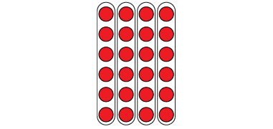  “I know that 4 × 6 = 24  and that 24 ÷ 6 = 4.  The array shows both facts.” | Uses inverse operations to solve multiplication and division problems  “I can rewrite 24 ÷ 6 = ?  as 6 × ? = 24.” | Uses known facts to determine unknown facts  “I can use the distributive property to split the multiplication into facts that I know, then add.”  5 × 9 = 5 × 5 + 5 × 4  25 + 20 = 45  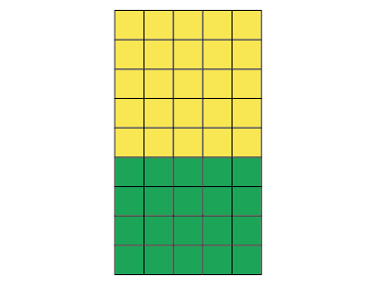
Observations/Documentation

Fluency with Multiplication and Division (con’t)
Solves division problems involving remainders  I counted 33 photographs to put in an album.  Each page can hold 6 photographs. How many pages will I need?  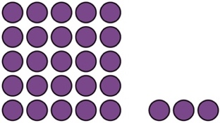  33 ÷ 6 = 5 R3  I round up to 6 pages to be sure all photos will fit. | Estimates to determine if answer to multiplication or division problem is reasonable  33 ÷ 6 = ?  33 is close to 30.  30 ÷ 6 = 5  5 is close to the answer I calculated, 5 R3.  So, my answer is reasonable. | Fluently creates and solves whole number multiplication and division problems, with and without remainders  There are 56 basketballs with the same number on each of 8 shelves.  8 × □ = 56, so 56 ÷ 8 = □  8 × 7 = 56  Or  8 × 7 = 4 × 7 + 4 × 7  = 28 + 28  = 56  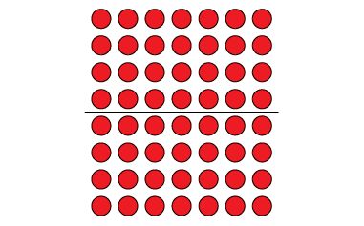
Observations/Documentation

