Developing Fluency with Multiplication and Division Facts
Models with concrete materials and counts by 1s  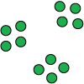 | Uses skip-counting forward and backward  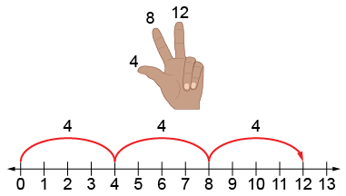 | Works flexibly with numbers (e.g., uses repeated addition or subtraction, familiar facts)  4 + 4 + 4 = 12  I know 2 × 4 = 8 and one more group of 4 is 12, so 3 × 4 = 12.  I know 4 × 3 = 12, so 3 × 4 also  equals 12. | Fluently multiplies and divides  “I just know that 3 × 4 = 12.”
Observations/Documentation

