Solving One-Step Addition and Subtraction Equations
Understands balance as equality  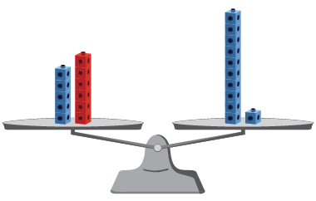  “5 + 6 equals 11.” | Uses concrete materials to solve for unknown  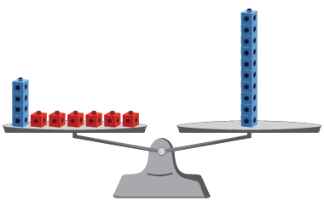  4 + = 10  “I added red cubes, one at a time, until the pans balanced; = 6.” | Uses number relationships (inverse operations)  28 = − 15  “I rewrote the equation as an  addition equation: 28 + 15 = .”
Observations/Documentation

Solving One-Step Addition and Subtraction Equations (con’t)
Decomposes and recomposes numbers (uses associative property)  28 + 15 = 28 + 2 + 13  28 + 2 + 13 = 30 + 13  30 + 13 = 43 | Describes a situation for a given equation with an unknown  20 − = 13  “I had $20. I spent some money and  now I have $13.  How much did I spend?” | Uses strategies efficiently and flexibly to solve equations of different types (start, result, and change unknown)  27 = ∆ − 18  “I rewrote using addition: 27 + 18 = ∆.  Then, I used mental math: 27 + (18 + 2) = 47,  and 47 – 2 = 45.”
Observations/Documentation

Variables and Symbols
Uses equal sign as balance (left side equals right side) and not equal sign as imbalance  18 + 16 = 10 + 24  18 + 16 ≠ 24 – 10  “The equal sign means that the numbers on both sides are worth the same amount.” | Uses symbols to represent unknown quantities  18 + = 34  “I used a box to represent the unknown, but I could have used a different shape.” | Understands the unknown represents one quantity/value  18 + = 34  “The box represents a number that would be added to 18 to make 34. No matter what  the symbol is, it will always represent 16.” | Solves equations flexibly  18 + = 34  34 − = 18  34 – 18 =  “In all of these equations, the symbol represents the same number, 16.”
Observations/Documentation

