Broken Rulers
Master 46a

Ruler A

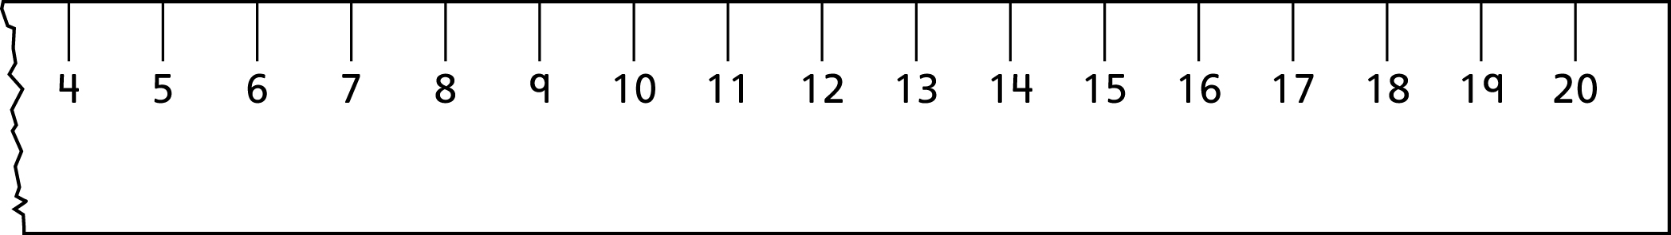

Broken Rulers
Master 46b

Ruler B

