**Perimeter Shapes**

**Master 53a**

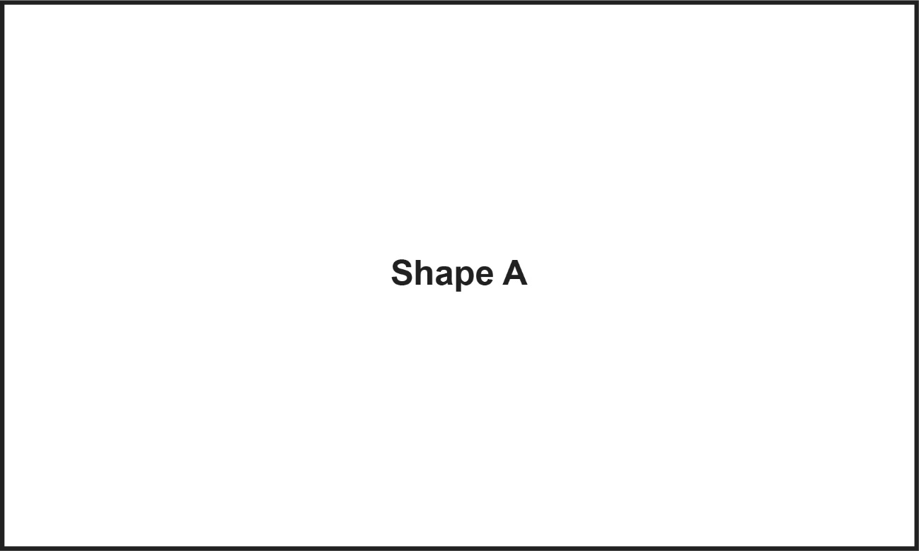

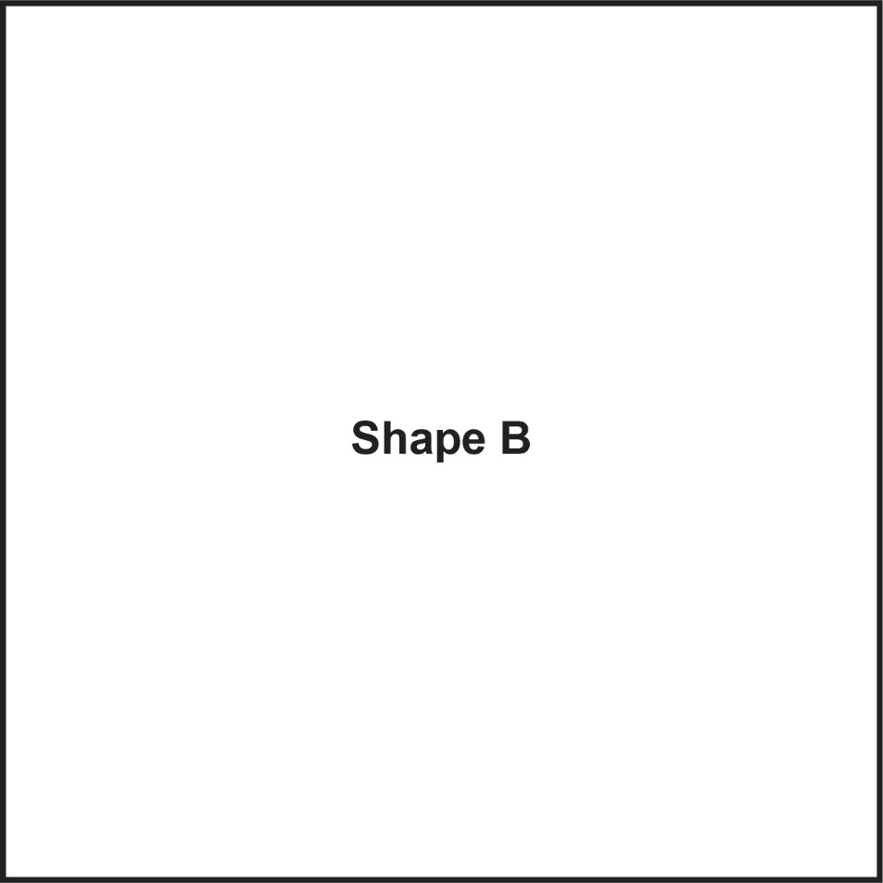

**Perimeter Shapes**

**Master 53b**

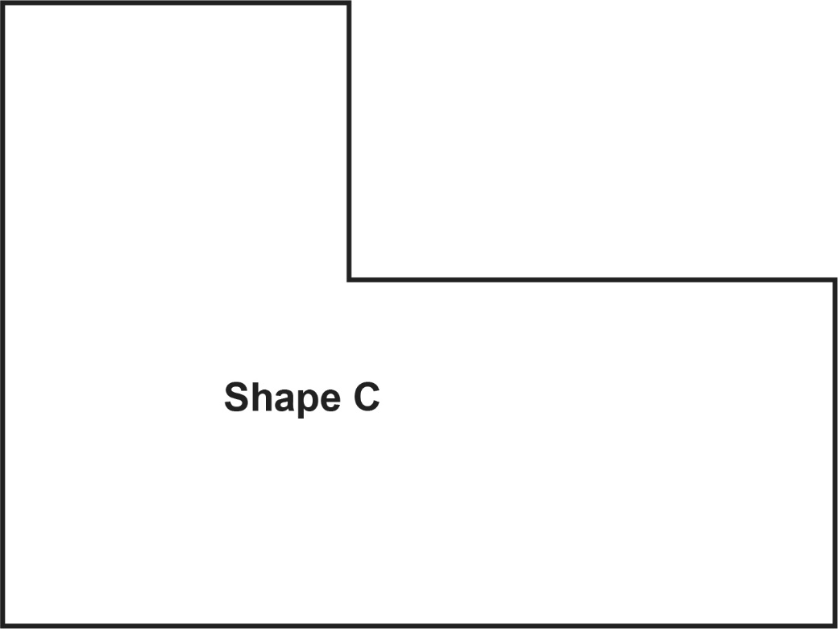

**Perimeter Shapes**

**Master 53c**

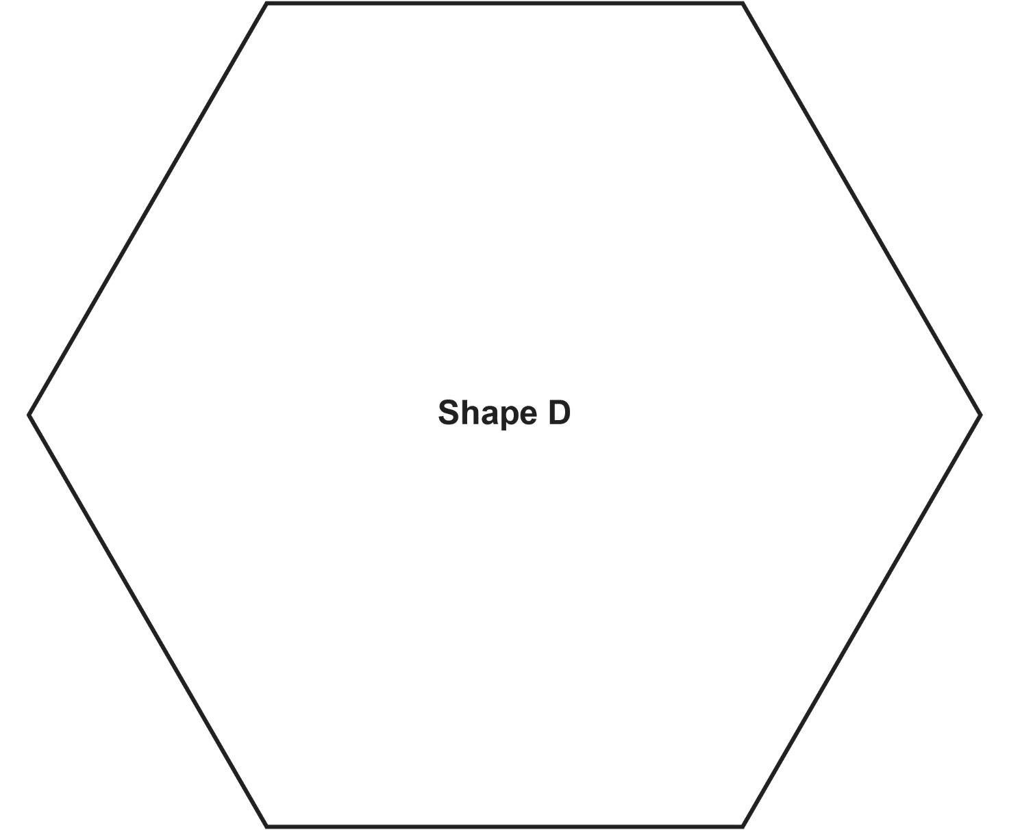

**Perimeter Shapes**

**Master 53d**

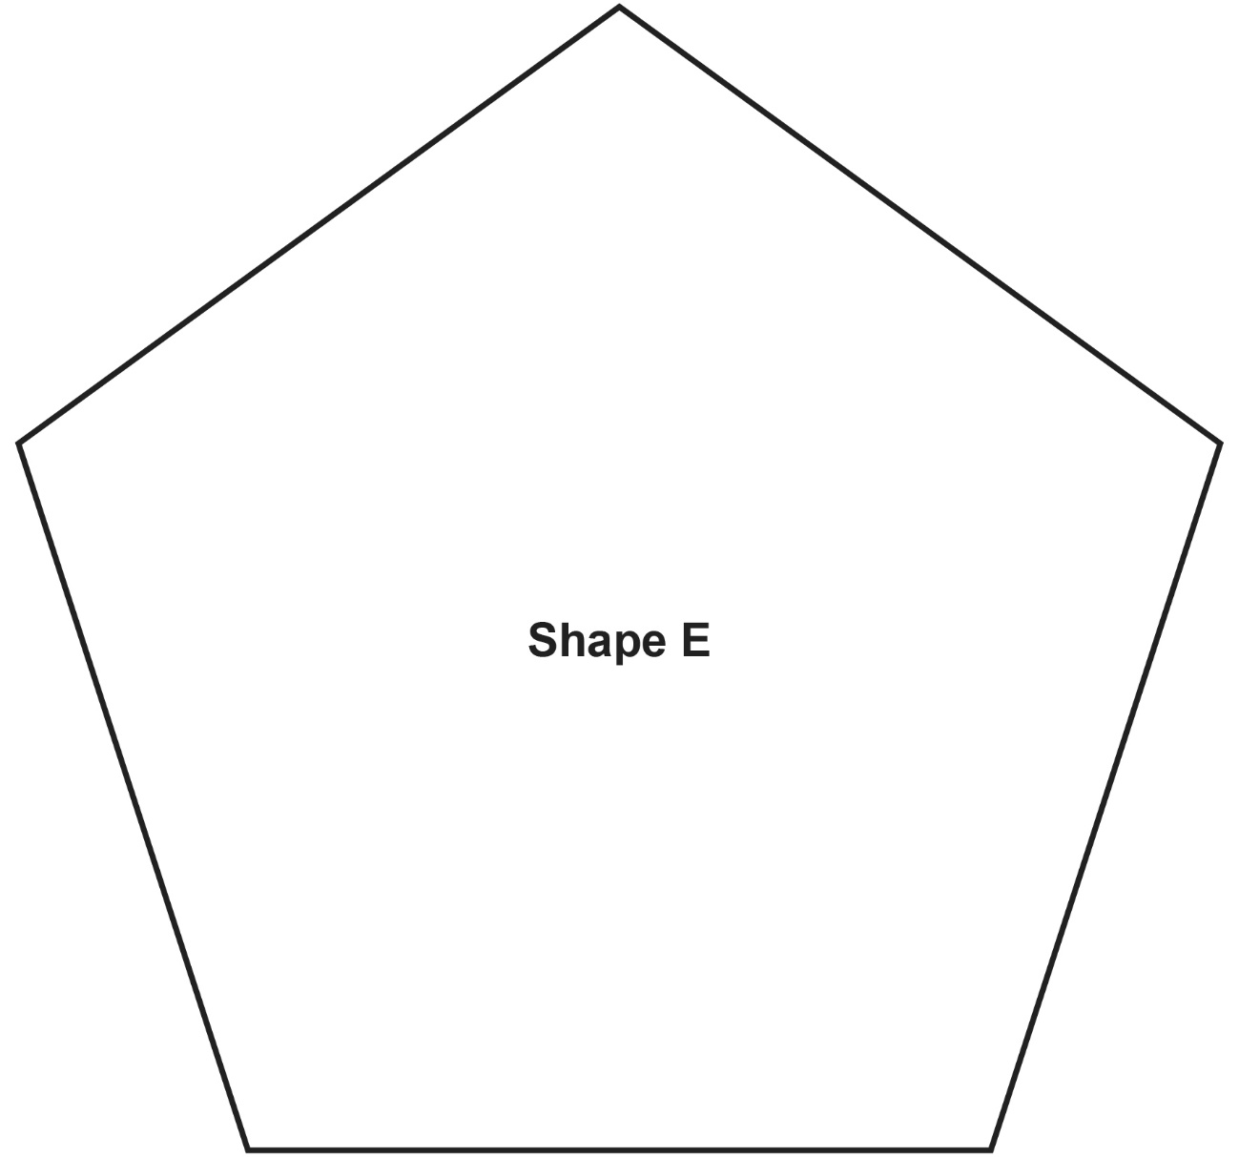

**Perimeter Shapes**

**Master 53e**

