Place-Value Charts
Master 1a

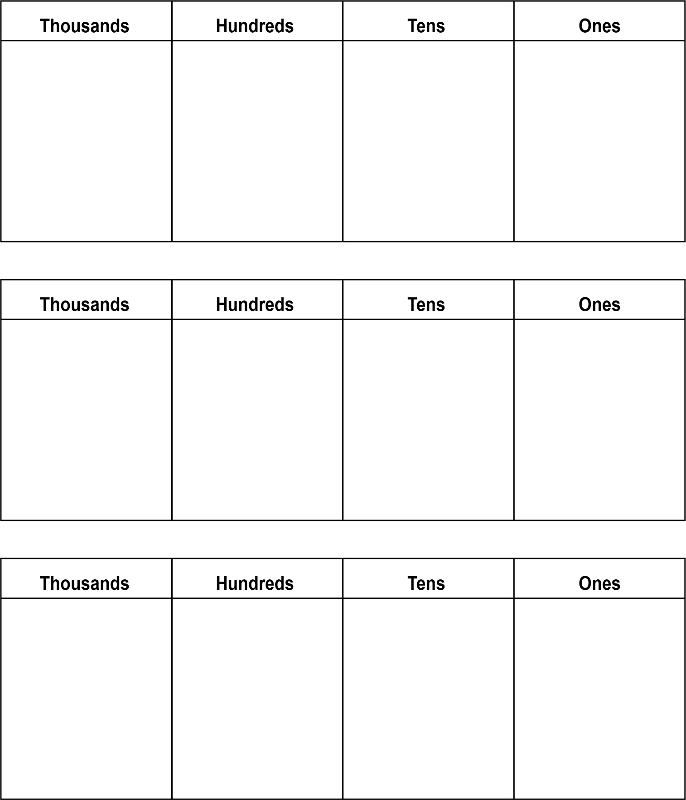
Place-Value Charts (cont’d)
Master 1b

Ten Thousands | Thousands | Hundreds | Tens | Ones
Ten Thousands | Thousands | Hundreds | Tens | Ones
Ten Thousands | Thousands | Hundreds | Tens | Ones

