Filling Fractions! Instructions
Master 31

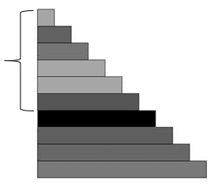
Group size: 2
Materials:
• Student Card 5: Filling Fractions! (2 per pair)
• Paper bags of Relational Rods (1 of each of the first 6 rods per bag,
2 bags per pair)
• Dry-erase markers (2 per pair)
1 of each of the
first 6 rods per bag

Goal: To be the first to colour all your fraction parts

Instructions:
Player A: Without looking, take one rod from each bag.
Put the shorter rod on top of the longer rod, aligned at one end.
The longer rod is the whole.
What fraction have you modelled?
Colour parts of strips on your game board to show that fraction.
For example, for $\frac{3}{5}$, colour three parts of a strip showing fifths.
Player B: Take a turn.

Continue to take turns until one of you colours all your fraction parts.

