Division Problems
Master 16a

Equal-Grouping Problems
Priya has 12 ride tickets.  Each ride is 3 tickets.  How many rides can Priya  go on? | Ben has 10 scoops of ice cream. He puts 2 scoops on a cone. How many ice cream cones can he make?
Mother robin brought 8 worms to the nest to feed her babies. Each baby gets 2 worms.  How many babies can she feed? | Twelve children are in line for the Ferris wheel. Each car holds 4 children. How many cars do they need?

Equal-Sharing Problems
At summer camp, 9 girl campers need to share 3 tents equally. How many girls will be in each tent? | Ben has 10 strawberries to share equally among 5 fruit smoothies. How many strawberries can he put in each?
12 students want to divide themselves into 4 equal teams to play a game. How many students will be on each team? | Felix has 6 toy cars to share equally among 3 loot bags. How many toy cars will be in each bag?

Division Problems
(Accommodation)
Master 16b

Equal-Grouping Problems
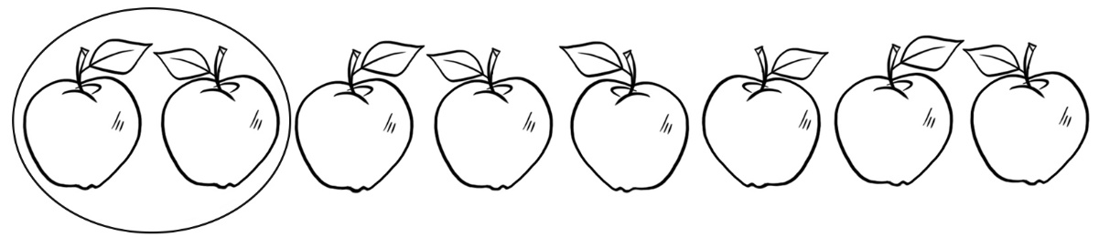
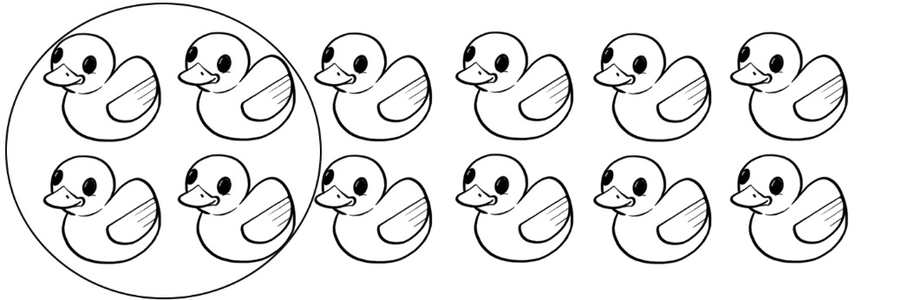

Equal-Sharing Problems
