**Pawty Planning**

**Master 17**

It’s time to plan a Birthday Pawty for **10** adorable dogs.

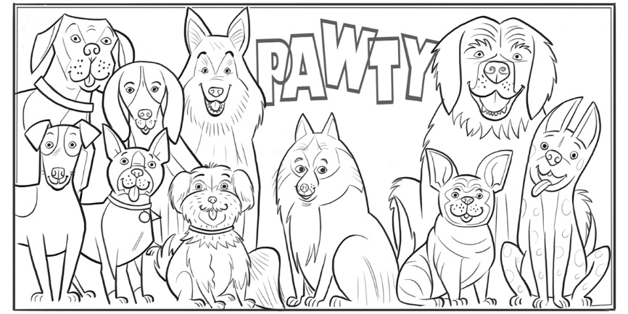

To play party games, divide dogs into equal teams.

**Games**

Tug of War: Teams of 2

Go Fetch: Teams of 3

Obstacle Course: Teams of 5

Hide-and-Seek: Teams of 4

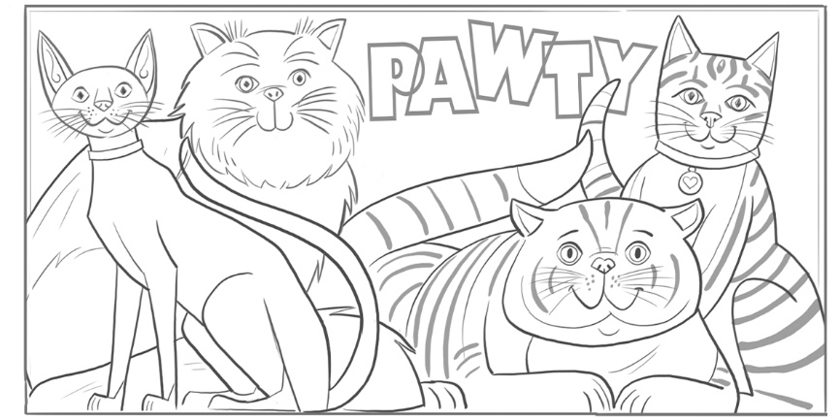It’s time to plan a Birthday Pawty for **4** playful cats.

To make loot bags, share treats among 4 bags.

**Treats**

8 Toy Mice

20 Cat Treats

15 Toy Feathers

12 Dental Treats

5 Play Balls