Creating Graphical Displays
Creates graph using on-to-one correspondence  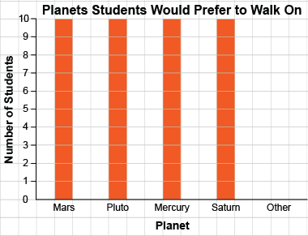  “I ran out of room for  Mars and Pluto” | Creates graphs but omits labels, title, or scale/key  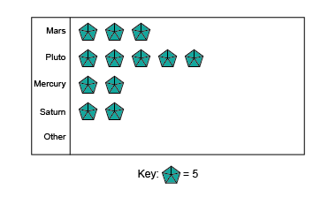 | Successfully creates graphs (always of same type)  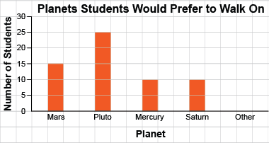 | Creates graphs flexibly; shows same data on different graph types and using different scales  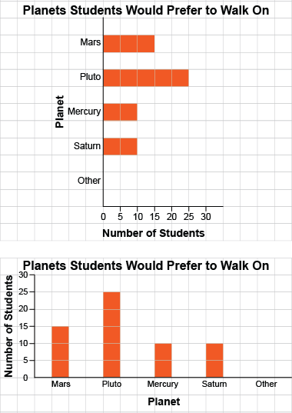
Observations/Documentation

