Reading and Interpreting Data Displays
Notices basic shape of graph  “This bar is the longest. This bar is the shortest.” | Skip-counts symbols or squares to read data  “2, 4, 6, …, 16, 18, 20 squares are shaded. Bonnie laid 20 eggs in October.” | Uses scale to read data  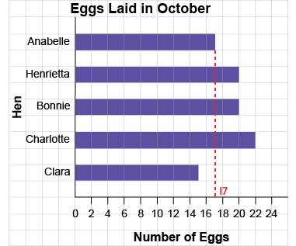  “It is halfway between 16 and 18,  so the bar has length 17.”
Observations/Documentation

Reading and Interpreting Data Displays (con’t)
Makes direct comparisons between data  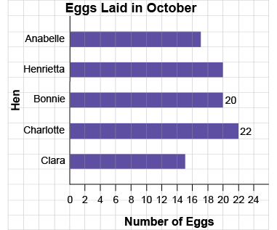  “Charlotte laid 2 more eggs than Bonnie.” | Describes shape of data (e.g., identifies mode)  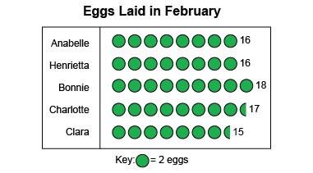  “16 eggs were laid most often.”  Or 13, 1, 1, 1, 2, 2, 2, 2, 3, 4  “The mode shoe size is 2.” | Answers questions and draws conclusions from data  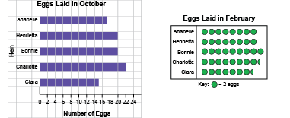  “More eggs were laid in October than in February.”
Observations/Documentation

