Investigating Geometric Attributes of 2-D Shapes
Recognizes and names familiar 2-D shapes  “The top of my desk has the shape  of a rectangle.” | Groups shapes that share the same geometric attributes  “The first four shapes all have 5 sides, so they are pentagons. The last shape doesn’t belong.  It has 6 sides.” | Compares attributes to identify congruent shapes  “The size and shape of these two pentagons match exactly. They have matching sides  and matching angles.”
Observations/Documentation

Investigating Geometric Attributes of 2-D Shapes (con’t)
Analyzes geometric attributes of 2-D shapes (e.g., number and length of sides, number of vertices)  "The first two are irregular pentagons as not all sides are equal. The third one is regular because all sides are equal.” | Uses attributes to compare and sort shapes  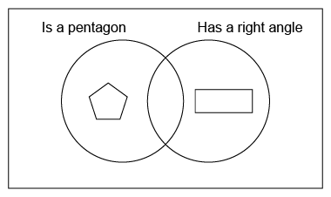  “I need a shape with 5 sides and at least  one right angle to go in the overlap.” | Sorts, classifies, and names shapes flexibly using geometric attributes  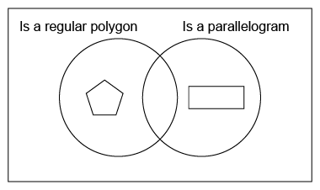  “The sorting rule could be ‘Is a regular polygon and is a parallelogram.’”
Observations/Documentation

