Using Non-Standard Units to Estimate and Measure Mass and Capacity
Compares objects by mass with non-standard units but thinks a larger object has a greater mass  “The blue block is heavier because it’s bigger.” | Measures and compares objects by mass with non-standard units, but thinks the heavier object is in the higher pan of the pan balance  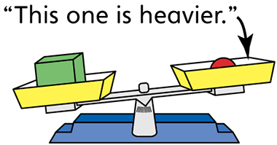 | Measures and compares objects by mass with non-standard units, but thinks the arrangement of objects in the pans will impact the mass  “I rearranged the objects in this pan. I'd better compare the masses again.”
Observations/Documentation

Using Non-Standard Units to Estimate and Measure Mass and Capacity (con’t)
Estimates and measures objects by mass with non-standard units  “I measured the mass of each unit  using linking cubes.” | Estimates, measures, compares, and orders objects by mass with non-standard units  “The mass of the object differs depending on which unit I use to measure.” | Estimates, measures, compares, and orders objects by mass with non-standard units, and sees a relationship between the units  “The mass of a linking cube is greater than the mass of a centicube, so it takes more centicubes to balance the object.”
Observations/Documentation

