Using Non-Standard Units to Compare, Estimate, and Measure Capacity
Uses non-standard units to estimate objects by capacity but estimates are extreme/ unreasonable  “About 100 cups!” | Uses non-standard units to measure objects by capacity, but randomly fills containers, paying no attention to the count | Uses non-standard units to measure objects by capacity, but does not fill the containers  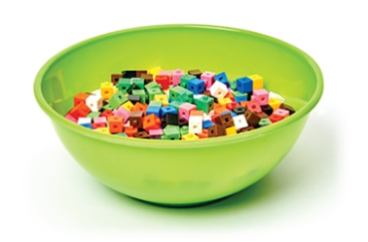
Observations/Documentation
Uses non-standard units to measure objects by capacity but is unsure how to deal with  a partial cup  “There is still room for more cubes,  but a whole cup won’t fit.” | Uses non-standard units to measure objects by capacity but has difficulty ordering the containers from least to greatest capacity  “How do I order the containers?” | Uses non-standard units to estimate measure, compare, and order objects by capacity  “The container that holds the fewest cubes has the least capacity. The container that holds the most cubes has the greatest capacity.”
Observations/Documentation

