Estimating Quantities
Guesses or counts  “About 500!” | Creates a referent of 10  “There are lots of groups of 10.” | Creates a referent of 100  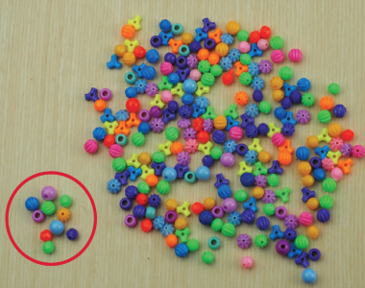  “I counted out 100.”
Observations/Documentation

Estimating Quantities (con’t)
Compares to a referent (more or less)  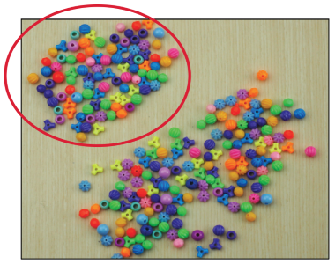  “More than 200.” | Gives estimate as a range (physically groups)  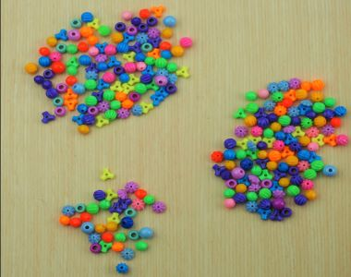  “Between 200 and 300.” | Estimates using visual strategies  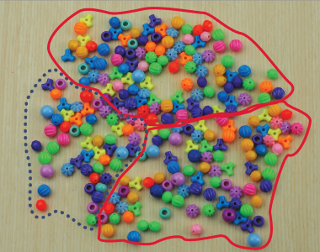  “About 250: 2 groups of 100  and half of another 100.”
Observations/Documentation

