Exploring Fractions
Partitions whole (area or length) into equal parts  “I folded the line into 4 equal parts.” | Counts parts using unit fractions  “1 one-fourth, 2 one-fourths,  3 one-fourths, 4 one-fourths” | Understands the meaning of the numerator and denominator  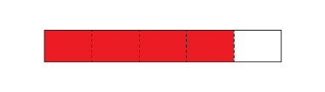  “I counted 4 one-fifths, which tells me I have $\frac{4}{5}$ altogether.  4 is the number of parts shaded and 5 is the total number of equal parts.” | Compares unit fractions  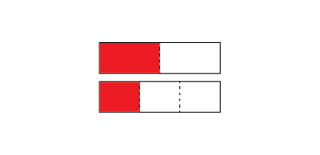  “One-half is bigger than one-third of the same whole.”
Observations/Documentation

Partitioning Quantities to Form Fractions (con’t)
Understands relationship between number of parts and size of parts  “When I divide the whole into more parts, the parts get smaller. | Understands that, for the same whole, equivalent fractions represent the same quantity  “$\frac{2}{3}$ and $\frac{4}{6}$ represent the same amount, but $\frac{4}{6}$ has twice as many parts as $\frac{2}{3}$.” | Solves equal-grouping problems that result in fractional amounts  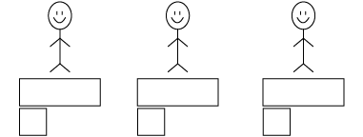  “I cut the leftover bar into 3 equal parts. Each person got 1$\frac{1}{3}$ bars.” | Flexibly solves equal-grouping problems that result in fractional amounts  “When the leftover bar is cut into 6 equal parts, each person gets  1$\frac{2}{6}$ bars. 1$\frac{1}{3}$ and 1$\frac{2}{6}$ are equivalent.”
Observations/Documentation

