Developing Meaning of Addition and Subtraction
Recognizes addition and subtraction situations  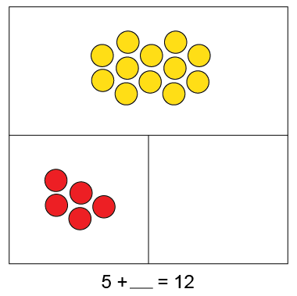  Join Part-part-whole  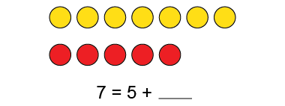  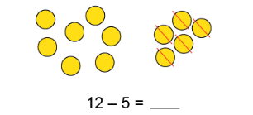  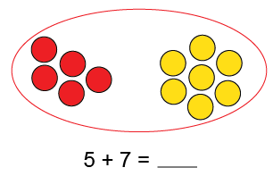  Separate Compare | Models concretely to add and subtract  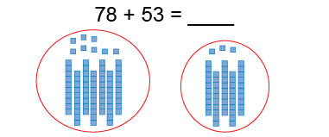  “78” “88, 98, 108, 118, 128, 129, 130, 131” | Models and symbolizes addition and subtraction  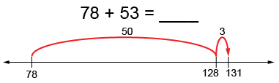  “I add 5 tens and 3 ones.  78 + 53 = 78 + 50 + 3, or 131”
Observations/Documentation

Developing Meaning of Addition and Subtraction (con’t)
Estimates sums and differences to check reasonableness  231 – 142 = 89  “230 – 140 = 90, which is close to  89 so my answer is reasonable.” | Creates and solves problems  “There are 231 birds in the tree.  Some birds flew away.  Now there are 142 birds in the tree.  How many birds flew away?”  231 − = 142  89 birds flew away. | Uses properties and inverse operations of addition and subtraction to solve problems  231 − = 142  “I can think addition to help me solve the problem:  142 + = 231”
Observations/Documentation

Developing Fluency for Addition and Subtraction
Fluently adds and subtracts within 5  “I know 4 + 1 = 5 and 5 – 1 = 4.” | Fluently adds and subtracts to 10  “I know 8 + 2 = 10 and 10 – 2 = 8.”  (complements to 10) | Fluently adds and subtracts to 20  “I can use doubles.  I know 9 + 9 = 18 and 18 – 9 = 9.”
Observations/Documentation

Uses known sums and differences to solve addition and subtraction equations  “25 + 37 =  I know 25 + 30 = 55, and 55 plus 5 is 60,  and 2 more makes 62.”  (decomposing, known facts) | Develops mental strategies and algorithms  129 + 232 =  I take 1 from 32 and give it to 129  to get 130 + 231.  130 + 230 = 360, and 1 more is 361.”  (compensation) | Estimates sums and differences  149 + 138 =  “149 is close to 150.  138 is close to 140.  150 + 140 = 290”  (using benchmarks)
Observations/Documentation

