Generalizing and Representing Increasing and Decreasing Patterns
Recognizes that a pattern increases or decreases  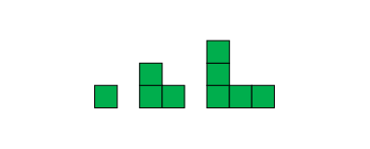  “The terms are getting bigger.” | Identifies how a pattern changes (describes rule)  “It grows by 2 tiles each time.” | Represents patterns symbolically and writes rules using addition or subtraction  1, 3, 5, …  “Start at 1 and add 2 each time.”  17, 14, 11, …  “Start at 17 and take away 3  each time.” | Extends patterns using repeated addition and subtraction  357 – 9 = 348  357 – 12 = 345  357 – 15 = 342  357 – 18 = 339  “I added 3 to the number taken away and subtracted 3 from the difference.”
Observations/Documentation

Finds missing terms or errors in patterns  3, 8, 13, 18, 22, 28, ….  “Start at 3 and add 5 each time.  18 + 5 = 23, so 22 should be 23.”  32, 28, ★, 20, 16, 12, 8, ….  “Start at 32 and subtract 4 each time. 28 – 4 = ★, so ★ is 24.” | Creates patterns and explains pattern rules  “85, 75, 65, 55, ….  I started with my house number and took away 10 each time.” | Uses patterns to solve problems  “If I save 2 quarters a day, when will  I have 10 quarters?  2, 4, 6, 8, 10  I will have 10 quarters after 5 days.” | Identifies and extends patterns involving multiplication  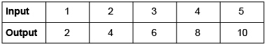  “Each input number is  multiplied by 2.”
Observations/Documentation

